Single threaded

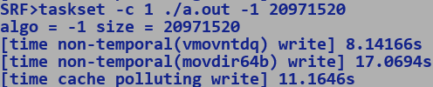

Integer, fill kernel.

1024x1024x10x2x4 bytes = 80mb

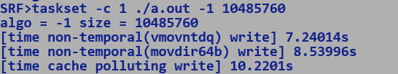

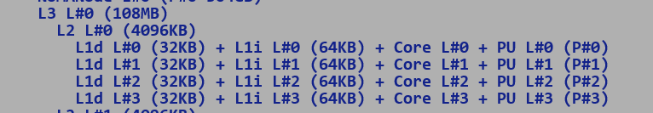

1024x1024x10x4 bytes = 40mb

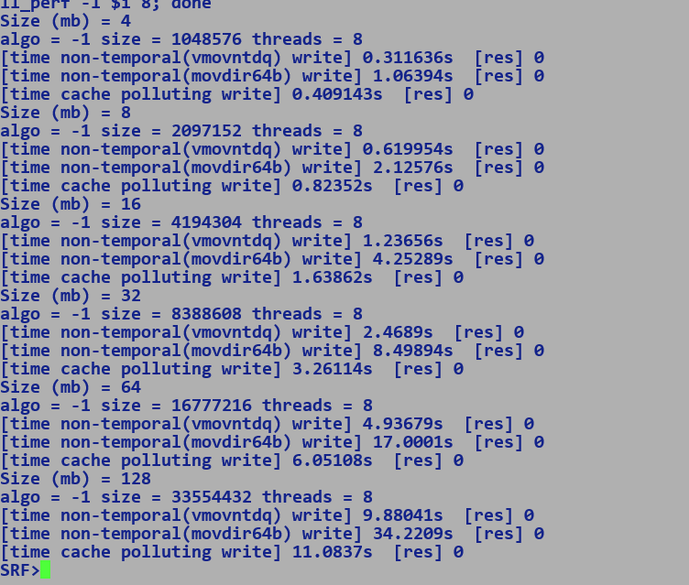

Multi-threaded kernel will mimic real world noisy neighbour cache pollution.

Configurations: -

* Thread scaling.
* Different block size.
* Frequency scaling
* Thread binding – same model (4)
* Same socket (numactl –cpunodebind=1 -l)
* Active cores
  + LLC slice is still accessible for disabled cores.
  + RDT can be used to scale down accessible cache ways.

SRF>source bm.sh

Size (mb) = 4

algo = -1 size = 1048576 threads = 4

[time non-temporal(vmovntdq) write] 0.843797s [res] 0

[time non-temporal(movdir64b) write] 2.90121s [res] 0

[time cache polluting write] 0.897378s [res] 0

Size (mb) = 8

algo = -1 size = 2097152 threads = 4

[time non-temporal(vmovntdq) write] 1.75611s [res] 0

[time non-temporal(movdir64b) write] 5.79799s [res] 0

[time cache polluting write] 1.84646s [res] 0

Size (mb) = 16

algo = -1 size = 4194304 threads = 4

[time non-temporal(vmovntdq) write] 3.54044s [res] 0

[time non-temporal(movdir64b) write] 11.5981s [res] 0

[time cache polluting write] 3.50875s [res] 0

Size (mb) = 32

algo = -1 size = 8388608 threads = 4

[time non-temporal(vmovntdq) write] 6.73481s [res] 0

[time non-temporal(movdir64b) write] 23.2072s [res] 0

[time cache polluting write] 6.777s [res] 0

Size (mb) = 64

algo = -1 size = 16777216 threads = 4

[time non-temporal(vmovntdq) write] 13.4769s [res] 0

[time non-temporal(movdir64b) write] 46.7188s [res] 0

[time cache polluting write] 12.005s [res] 0

Size (mb) = 128

algo = -1 size = 33554432 threads = 4

[time non-temporal(vmovntdq) write] 26.9911s [res] 0

[time non-temporal(movdir64b) write] 93.4827s [res] 0

[time cache polluting write] 20.7124s [res] 0

Size (mb) = 4

algo = -1 size = 1048576 threads = 8

[time non-temporal(vmovntdq) write] 0.423627s [res] 0

[time non-temporal(movdir64b) write] 1.45175s [res] 0

[time cache polluting write] 0.502192s [res] 0

Size (mb) = 8

algo = -1 size = 2097152 threads = 8

[time non-temporal(vmovntdq) write] 0.844224s [res] 0

[time non-temporal(movdir64b) write] 2.90039s [res] 0

[time cache polluting write] 0.992373s [res] 0

Size (mb) = 16

algo = -1 size = 4194304 threads = 8

[time non-temporal(vmovntdq) write] 1.6849s [res] 0

[time non-temporal(movdir64b) write] 5.80056s [res] 0

[time cache polluting write] 1.95804s [res] 0

Size (mb) = 32

algo = -1 size = 8388608 threads = 8

[time non-temporal(vmovntdq) write] 3.36767s [res] 0

[time non-temporal(movdir64b) write] 11.6021s [res] 0

[time cache polluting write] 3.85007s [res] 0

Size (mb) = 64

algo = -1 size = 16777216 threads = 8

[time non-temporal(vmovntdq) write] 6.73531s [res] 0

[time non-temporal(movdir64b) write] 23.2086s [res] 0

[time cache polluting write] 7.24291s [res] 0

Size (mb) = 128

algo = -1 size = 33554432 threads = 8

[time non-temporal(vmovntdq) write] 13.4829s [res] 0

[time non-temporal(movdir64b) write] 46.7215s [res] 0

[time cache polluting write] 13.1396s [res] 0

Size (mb) = 4

algo = -1 size = 1048576 threads = 16

[time non-temporal(vmovntdq) write] 0.216151s [res] 0

[time non-temporal(movdir64b) write] 0.726379s [res] 0

[time cache polluting write] 0.278177s [res] 0

Size (mb) = 8

algo = -1 size = 2097152 threads = 16

[time non-temporal(vmovntdq) write] 0.427052s [res] 0

[time non-temporal(movdir64b) write] 1.45043s [res] 0

[time cache polluting write] 0.53129s [res] 0

Size (mb) = 16

algo = -1 size = 4194304 threads = 16

[time non-temporal(vmovntdq) write] 0.846781s [res] 0

[time non-temporal(movdir64b) write] 2.89887s [res] 0

[time cache polluting write] 1.04467s [res] 0

Size (mb) = 32

algo = -1 size = 8388608 threads = 16

[time non-temporal(vmovntdq) write] 1.689s [res] 0

[time non-temporal(movdir64b) write] 5.79705s [res] 0

[time cache polluting write] 2.06458s [res] 0

Size (mb) = 64

algo = -1 size = 16777216 threads = 16

[time non-temporal(vmovntdq) write] 3.37337s [res] 0

[time non-temporal(movdir64b) write] 11.593s [res] 0

[time cache polluting write] 4.09848s [res] 0

Size (mb) = 128

algo = -1 size = 33554432 threads = 16

[time non-temporal(vmovntdq) write] 6.7417s [res] 0

[time non-temporal(movdir64b) write] 23.189s [res] 0

[time cache polluting write] 7.61399s [res] 0

Size (mb) = 4

algo = -1 size = 1048576 threads = 32

[time non-temporal(vmovntdq) write] 0.206199s [res] 0

[time non-temporal(movdir64b) write] 0.364789s [res] 0

[time cache polluting write] 0.243014s [res] 0

Size (mb) = 8

algo = -1 size = 2097152 threads = 32

[time non-temporal(vmovntdq) write] 0.413989s [res] 0

[time non-temporal(movdir64b) write] 0.727102s [res] 0

[time cache polluting write] 0.318279s [res] 0

Size (mb) = 16

algo = -1 size = 4194304 threads = 32

[time non-temporal(vmovntdq) write] 0.843268s [res] 0

[time non-temporal(movdir64b) write] 1.45204s [res] 0

[time cache polluting write] 0.662147s [res] 0

Size (mb) = 32

algo = -1 size = 8388608 threads = 32

[time non-temporal(vmovntdq) write] 1.67661s [res] 0

[time non-temporal(movdir64b) write] 2.89973s [res] 0

[time cache polluting write] 1.32707s [res] 0

Size (mb) = 64

algo = -1 size = 16777216 threads = 32

[time non-temporal(vmovntdq) write] 3.30135s [res] 0

[time non-temporal(movdir64b) write] 5.80379s [res] 0

[time cache polluting write] 2.45204s [res] 0

Size (mb) = 128

algo = -1 size = 33554432 threads = 32

[time non-temporal(vmovntdq) write] 6.61691s [res] 0

[time non-temporal(movdir64b) write] 11.5974s [res] 0

[time cache polluting write] 4.98076s [res] 0

SRF>

A) Competitive Benchmarking of JMH Micros on following targets:-

-----------------------------------------------------------------------------------------------

- Graviton3 (GVT3)

- Genoa

- Granite Rapids (GNR)

- Sierra Forest (SRF)

B) Objectives:

--------------------

- Collect performance data for various JMH micros at nearly ISO configuration for above targets. [Vladimir] - First cut shared

- Root cause performance degradations seen in micros [Jatin and Vladimir] - WIP

- Enhance JVM to fill the gaps. [Jatin] - TBD

C ) Benchmark Categories.

--------------------------------------

a) Data Copy / Comparison Operations:

- Copy

- Clone

- Mismatch

- Fill

b) Core Lib APIs:

- Math Bench

- Strings

- Arrays

c) Panama-Vector

- Vector API

- Arithmetic Ops

- Conversion Ops

- Reduction Ops

- Shuffle Ops

- Compress / Expand

- Cross lane movements.

- FFM

- Memory Segment

d) GC Performance oriented (high allocation rates)

e) Concurrency Benchmarks

- Locks

- Atomics

f) Crypto

Notes:

---------

[C.a] - Masked stores have almost double latency on GENOA vs GNR. This results in 50% throughput loss for partially inlined small copy operations.

- Large copy operations ( > 64 bytes) incurs penalties due to peel / tail handling involving masked stores, bulk copy happens at full vector granularity.

- ARM benefitted from our partial in-lining optimization and hence GVT3 show 4x performance improvement over SRF (AVX2) where

stub call overhead dominates cycles spent in actual copy.

AI : Enable partial in lining for AVX2 targets using Conditional SIMD Packed Loads and Stores.

[C.b] - SVE ISA has direct instruction for bit reversal of vector lanes

- For X86 we do this in two steps for multi-byte data types like Long

- Reverse bits using GFNI affine instruction.

- Shuffle bytes within a quad word vector lane.

- This results into 50% performance drop on SRF / GNR and GENOA w.r.t to GVT3.

AI for micros:-

VectorFPtoIntCastOperations.microDouble128ToLong128

* Enable intrinsification.
  + 128-bit vector
    - Check performance of instruction sequence composed of scalar instructions. [AT&T syntax]

vcvtsd2si xmm0, xmm1

vshufpd $2, xmm0, xmm2

vcvttsd2si xmm2, xmm1

vpsrldq $64 xmm2, xmm2

vpor xmm2, xmm1

* + 256-bit vector

vcvtsd2si xmm0, xmm1

vshufpd $2, xmm0, xmm2

vcvttsd2si xmm2, xmm1

vpsrldq $64 xmm2, xmm2

vpor xmm2, xmm1

…..

extract higher 128 bit, repeat above, merge the results back.

Predicated stores, on non-predicated targets.

* In-range stores where indices lie within valid array address space will never generate memory faults.
* VMASKMOVDQU can be used for sub-word type predicated vector stores.
* Partial inlining of sub-word types.
  + Length 10 (char) => 20 bytes.
    - floor size to multiple of 4.
    - Generate mask.
    - Copy tail using scalar move.

Rounding:

LDMXSCR <round to -ve inf> [floor]

ADD VAL + 0.5

CVTTSD2SI

SPECIAL_CASES (NAN, INF => 0x8000000)

Q. Why we cannot use ROUNDPD directly?

A. Rounded result is in floating point format which will again need to casted to integer.

0.5 is incorrectly rounded to 1.0 due to rounding semantics.

Existing scalar implementation mimic java implementation in toto. Scope of improvement using above sequence.

CVTPD2QQ needs AVX512DQ feature, not available on SRF.

**PARTIAL INLINING OF small sized (< 32 bytes) SUB_WORDS fill / copy.**

SRF>perf stat -e cycles,instructions,cpu/name=MACHINE_CLEARS.ANY,event=0xc3,umask=0x0/ ./pload_mc

[time] 0.00628076 s

0 , 0 , 0 , 0 , 0 , 0 , 0 , 0 , 0 , 0 , 0 , 0 , 0 , 0 , 0 , 0 , 0 , 0 , 0 , 0 , 0 , 0 , 0 ,

Performance counter stats for './pload_mc': SRC = PRELOADED YMM REG

12,871,223 cycles

54,521,035 instructions # 4.24 insn per cycle

410 MACHINE_CLEARS.ANY

0.017470208 seconds time elapsed

0.014182000 seconds user

0.003545000 seconds sys

SRF>vi test.c

SRF>g++ test.c -o pload_mc

SRF>perf stat -e cycles,instructions,cpu/name=MACHINE_CLEARS.ANY,event=0xc3,umask=0x0/ ./pload_mc

[time] 0.0871268 s

0 , 0 , 0 , 0 , 0 , 0 , 0 , 0 , 0 , 0 , 0 , 0 , 0 , 0 , 0 , 0 , 0 , 0 , 0 , 0 , 0 , 0 , 0 ,

Performance counter stats for './pload_mc': SRC = 0x1

513,388,243 cycles

55,023,554 instructions # 0.11 insn per cycle

2,000,516 MACHINE_CLEARS.ANY

0.283061165 seconds time elapsed

0.283236000 seconds user

0.000000000 seconds sys

SRF>vi test.c

SRF>g++ test.c -o pload_mc

SRF>perf stat -e cycles,instructions,cpu/name=MACHINE_CLEARS.ANY,event=0xc3,umask=0x0/ ./pload_mc

[time] 0.00878826 s

1 , 1 , 1 , 1 , 0 , 0 , 0 , 0 , 1 , 1 , 1 , 1 , 1 , 1 , 1 , 1 , 1 , 1 , 1 , 1 , 1 , 1 , 43 ,

Performance counter stats for './pload_mc': SRC = 23 byte data

16,995,365 cycles

70,554,170 instructions # 4.15 insn per cycle

416 MACHINE_CLEARS.ANY

0.022722841 seconds time elapsed

0.022869000 seconds user

0.000000000 seconds sys

Partial inline of subworlds

* Rounding of length to multiple of 4 will require additional mask to chop off additional bytes
* Effective length (rounded to multiple of 4) – actual length.

Enable intrinsification for conversions b/w Double Precision and long vector on AVX2.

* Needs AVX512DQ
* Suppressing Intrinsification also incurs argument boxing penalties.
* Using scalar conversion instruction we can optimized existing handling.

Copy performance on GNR vs SRF:-

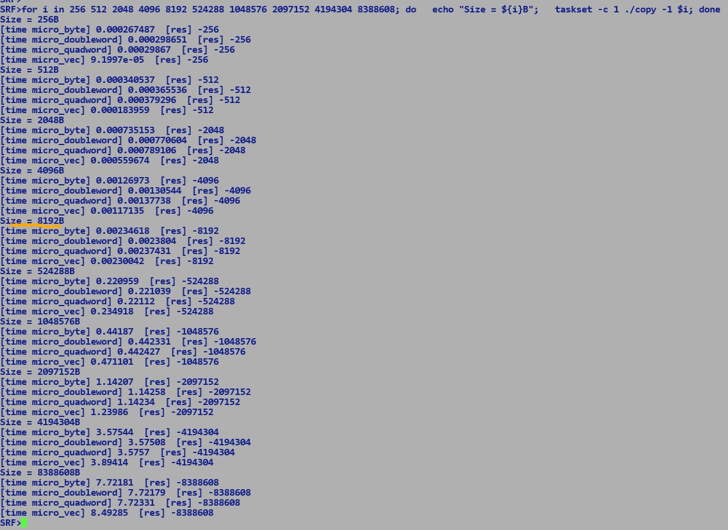

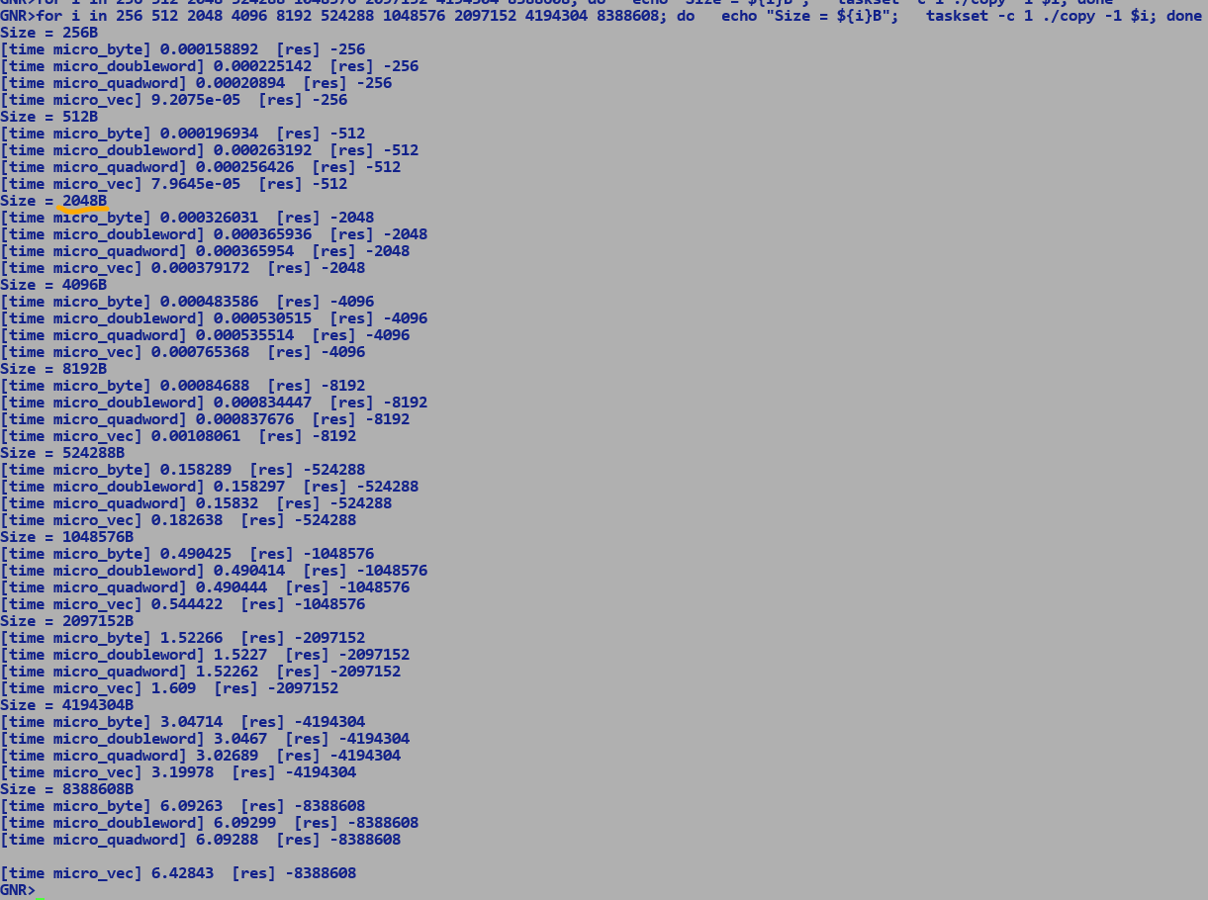

Graviton4

-------------

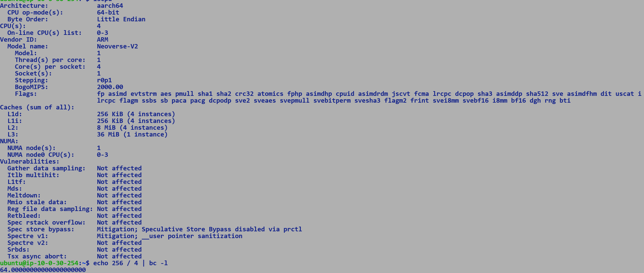



Graviton3



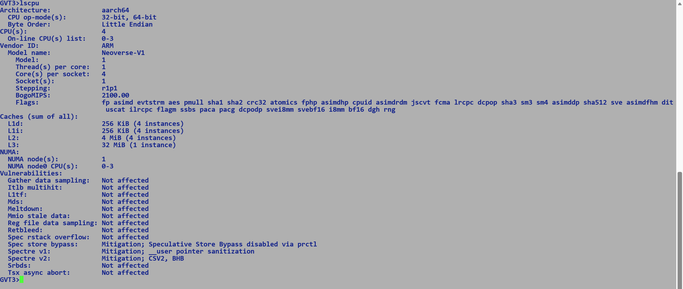

Gvt4 doubles L2 caches to 2M per vCPU vs 1M per vCPU on GV3, increase in LLC cache by 4 MB i.e 32 MB on GVT4.

Neoverse-v2 (GVT4) vs Neoverse-v1 (GVT3)

Sierra Forest:-

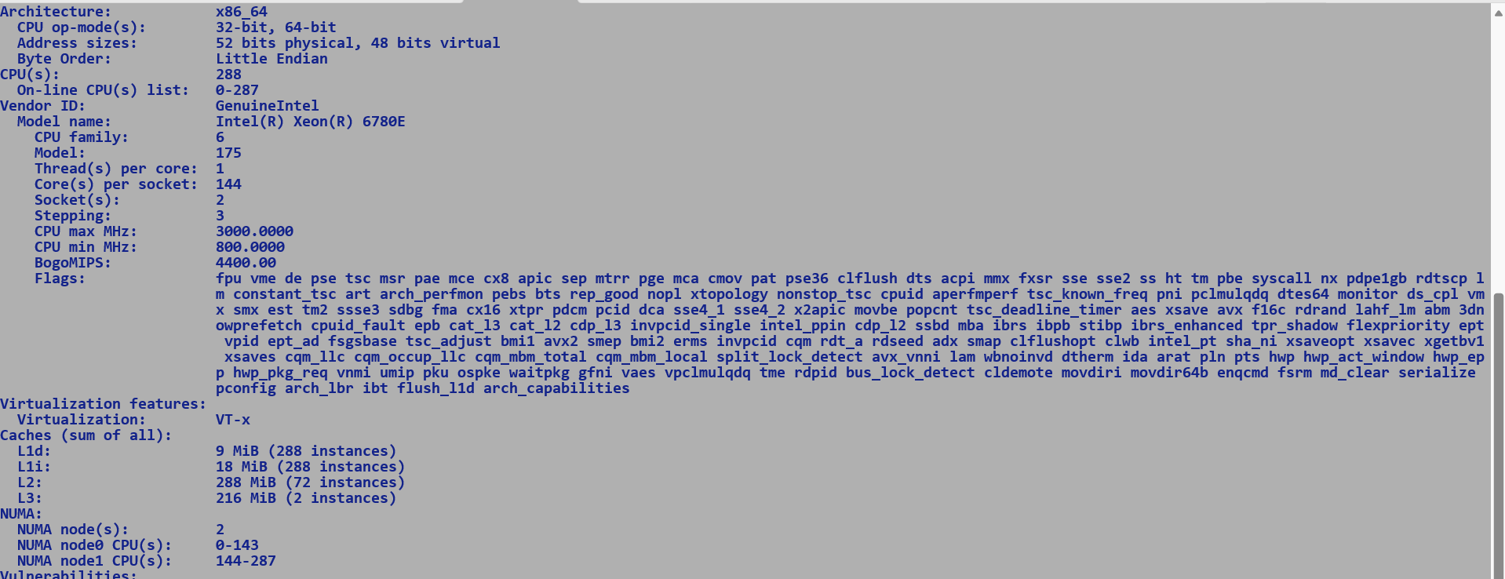

L1D = 9 x 1024 / 288 = 32 KB per core.

L1I = 18 x 1024 / 288 = 64 KB per core.

L2 = 4MB perf module (shared across 4 E-cores)

L3 = 108 MB per socket.

GVT3

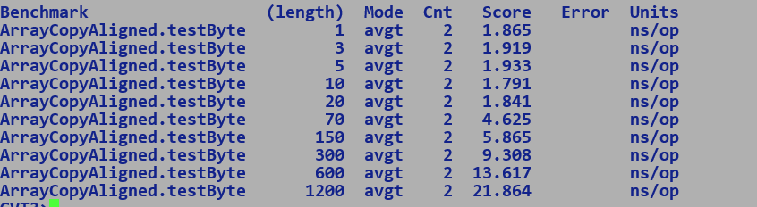

GVT4

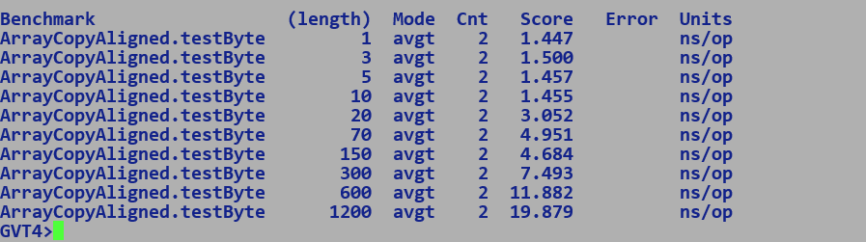

SRF

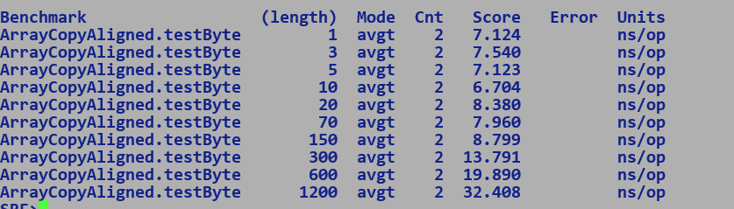

GVT3 (large copy)

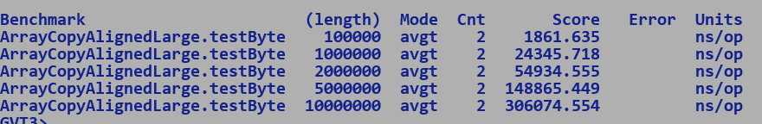

GVT4 (large copy)

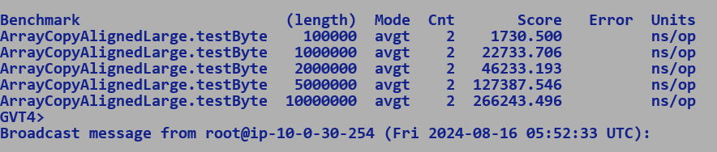

SRF (large copy)

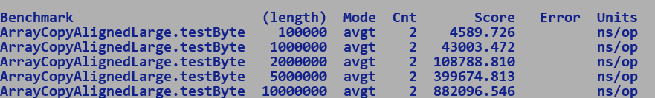

Branch Target Buffer:-

* Captures the target of conditional taken branch OR unconditional branch.

Branch History Table:-

* Used for prediction.
* Adaptive two bit saturating counter per branch history entry.
* Global vs local pattern history table.

Two-bit adaptive predictor with local history table with 2 bit saturating counter per entry.

(n-bit adaptive predictor, maintains history of last n occurrences of that branch)

Local branch History table

Pattern of branch 00 11 00 11 00 11 00 11 [ state of predictor at this point]

2-bit history 2 bit saturating counter. (11(strongly taken) 10 01 00 (not-taken))

00 11 (next branch is strongly taken)

01 11 (next branch is strongly taken)

10 00 (next branch is strongly not taken)

11 00 (next branch is strongly not taken)

Thus, it starts making perfect predictions with above behaviour of a branch.

On Cascadelake branch misprediction:-

A small number of history bits cannot infer long branching patterns, For example a conditional branch not taken in the first 37 iterations will not be able to predict the taken branch in 38th iteration with only 36-bits history... i.e local branch history table entry corresponding to branching pattern 0000...36times will have its saturating counter pointing to strongly not taken (00), thus for 37th iteration also it will predict strongly not taken since last 36 bit history pattern will point to same previous history entry, in 38th iterations it will again predict incorrect not take branch. Had local prediction been maintaining 37-bit history then entry corresponding to branching pattern 100000...36times will always predict the next branch to be strongly taken.

Its an interplay of global and local history tables and history bits used to index those tables, certain prediction algorithm uses a hybrid approach where in the predictor book keeps both local and global history of branches for improved accuracy, I think most x86 mainly uses hybrid approach and granite rapids predictor is using wider prediction registers which translates into superior predictions over legacy Xeons

TAgged GEometric history length predictor (used in latest Intel processors).

<https://inria.hal.science/hal-03408381/document>

* TAGE
* ITTAGE - TAGE extension for Indirect branches.
* COTTAGE - Space efficient amalgamation of TAGE and ITTAGE predictor, combines conditional and indirect branch prediction into one circuit comprising of base predictor and multiple partially tagged predictors. Final prediction is a function of base and farthest partially tagged predictor, each partially tagged register index is based on the hash value of history register, different predictors have different history register lengths, these lengths form a geometric series, this helps in capturing long range dependencies b/w branch histories and significantly improves the prediction accuracy.

Front-end

If Branch

Check_Branch_Predictor

If (true)

Target = BTB [Branch_Addr]

Else if (Branch Hints && Branch.not_taken)

Target = Branch.false_path.

Else [ Apply static prediction]

Target = Static Prediction target.

Branch Hints:-

* Adds additional branch hint byte to JMPs, increases overall code size.
* Is consulted only if branch prediction table has no entry for a branch.

C2:

* Frequency based block layout, adding branch hints is overkill.
* Stubs, are hand crafted, loops will anyways be predicted accurately and will incur one misprediction at exit.
* conditional block if not laid out based on frequence may benefit from branch hints.
  + TBD

MLC experimentation: -

Sierra Forest, Xeon 6 , Birch Stream Platform, Sierra Glen Core (aka Crestmont core) :-

Frequency fixed at 2.8GHz

Uncore-frequency adjusts propositionally due to fixed power budget.

* Increases latency of mesh traffic, thereby lowering memory bandwidth.

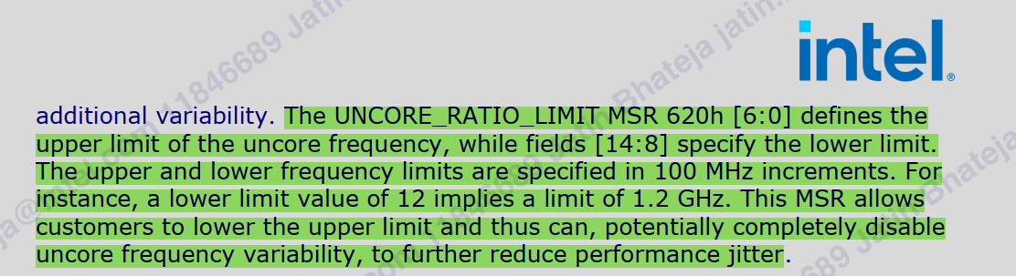

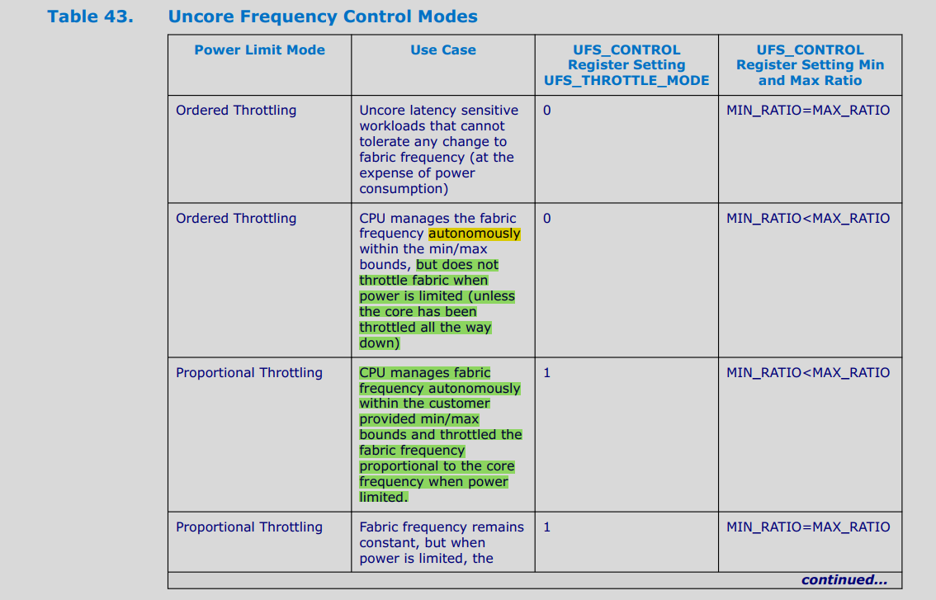

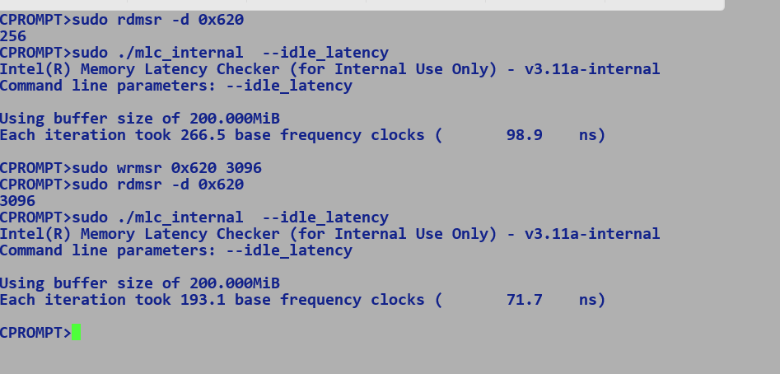



Impact of uncore on memory access latency.

Performance impact of macro fusion – 1-2 %

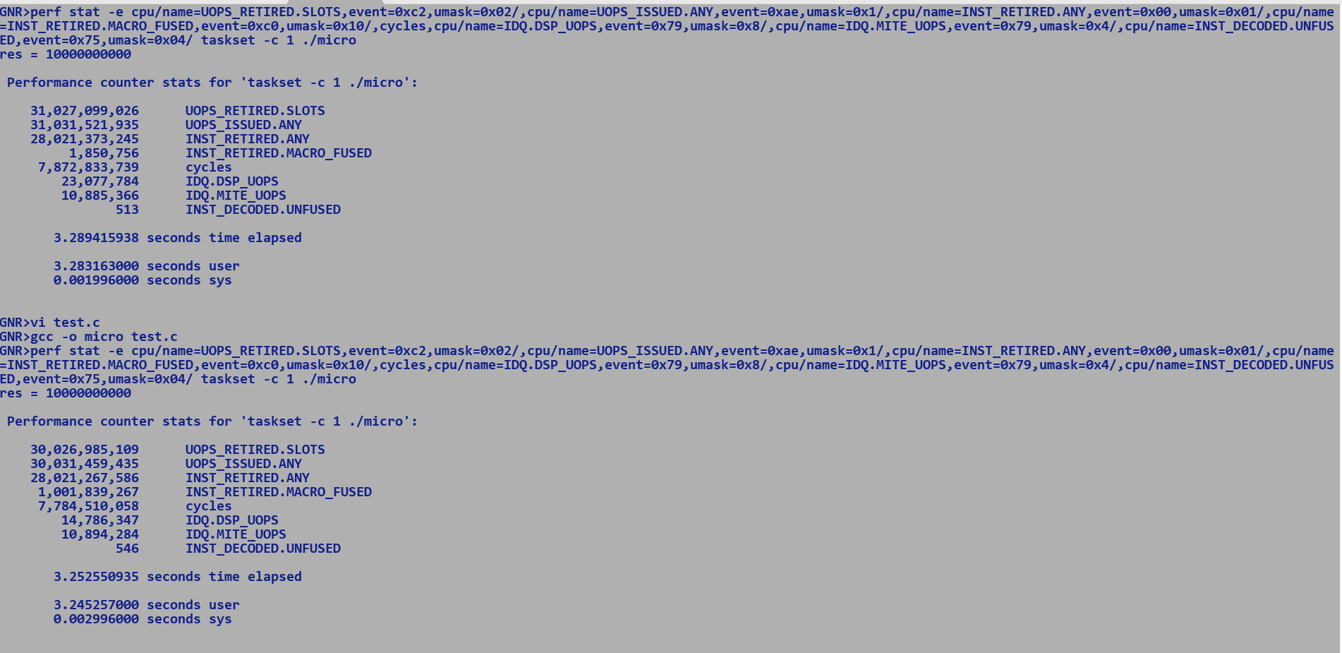

Fused SUB + JE Unfused SUB + JO

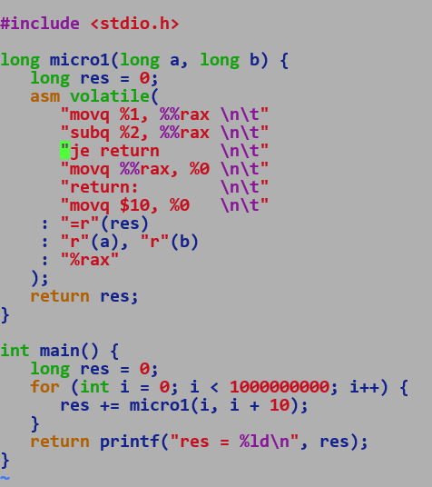 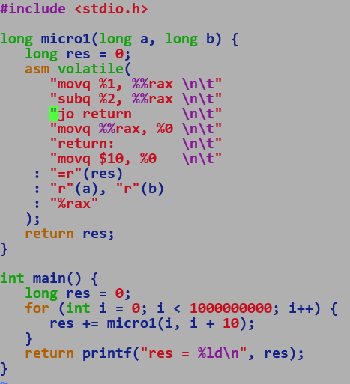

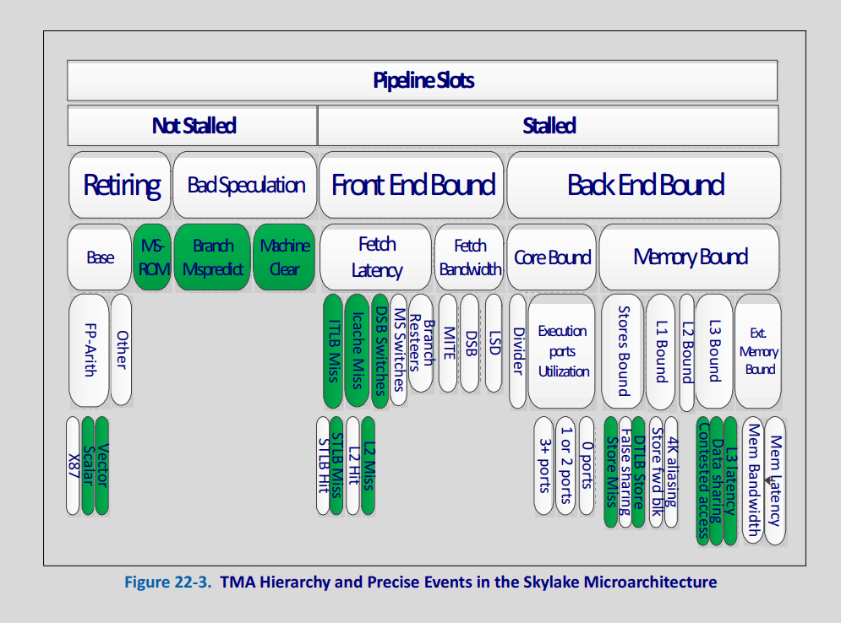

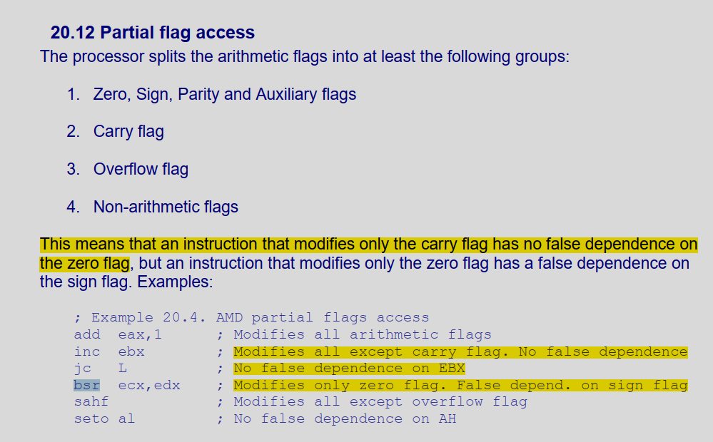

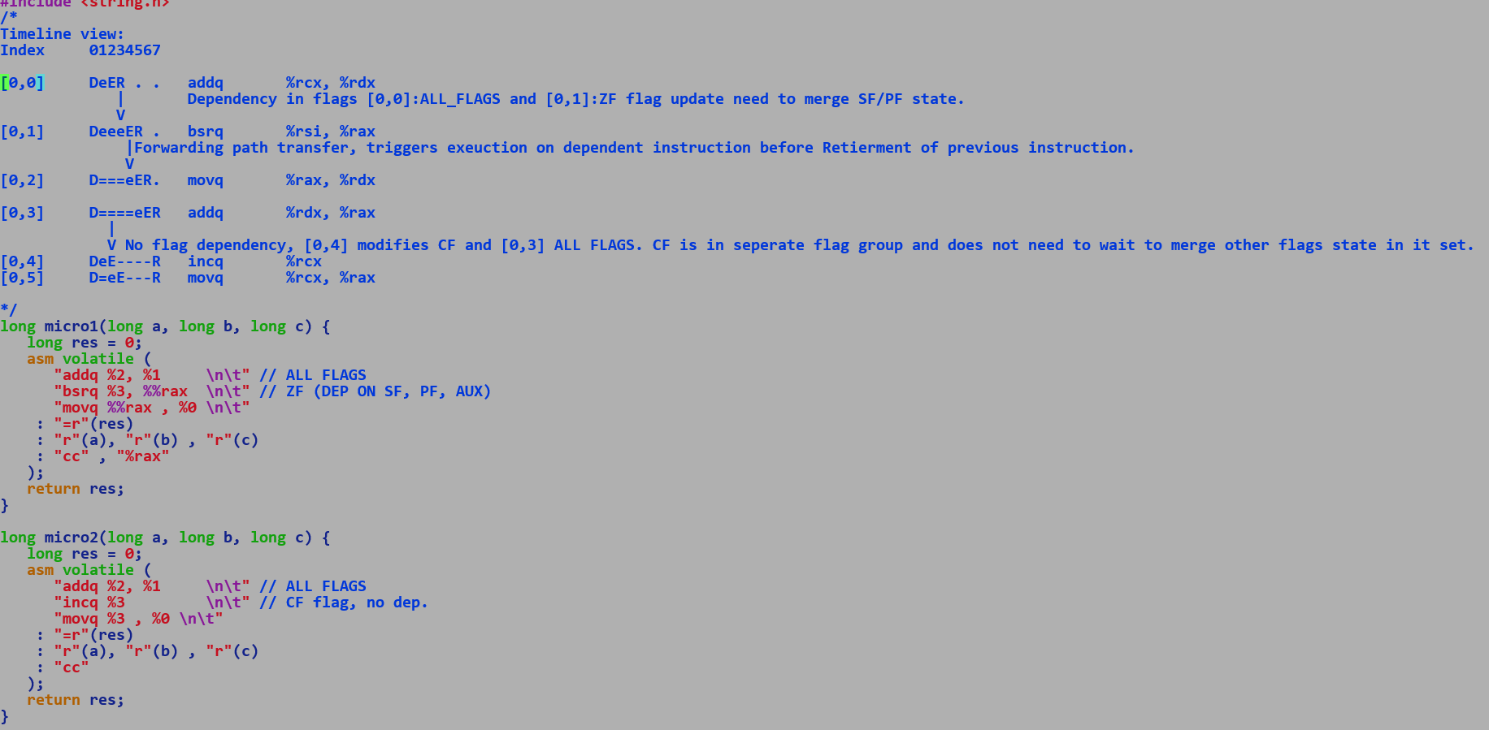

DSB (Decoded UOP cache) | MITE (L1I) => IDQ

Small loop of UOPs => LSD

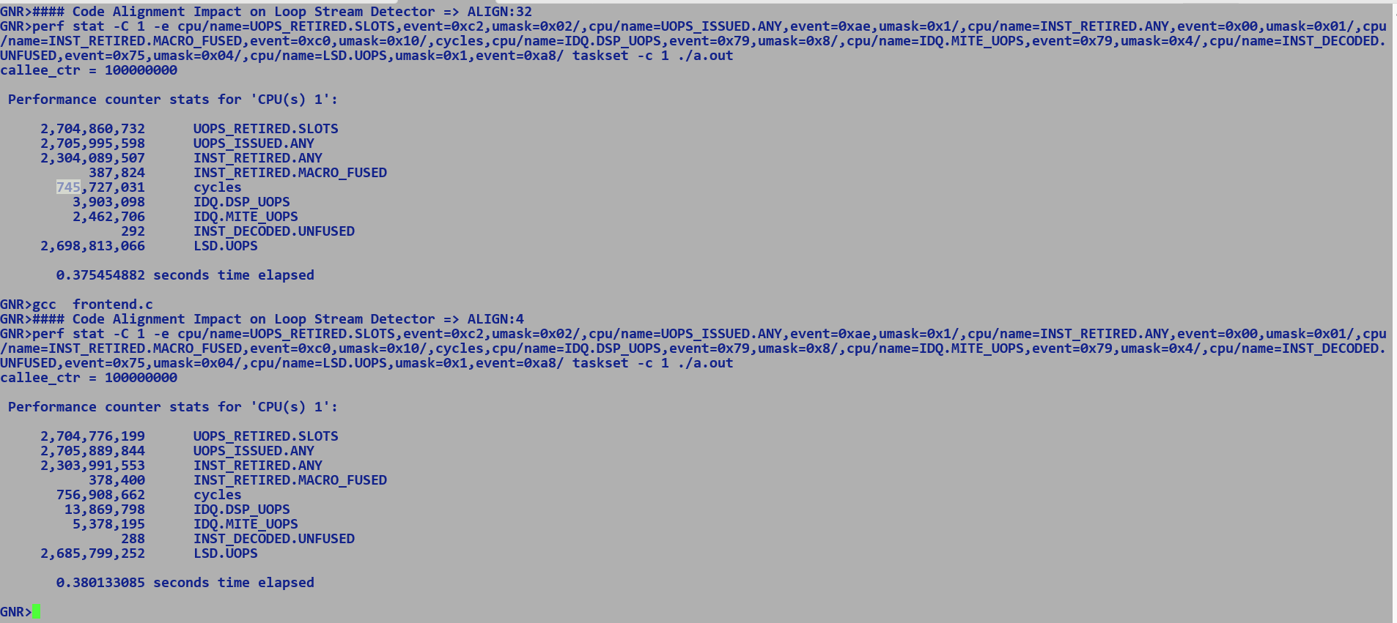

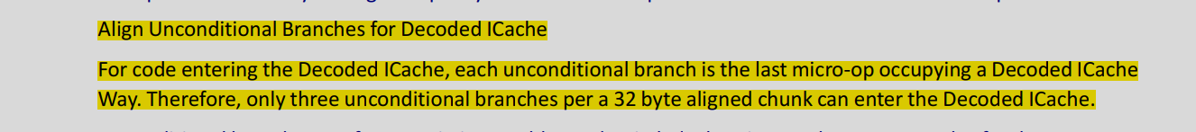

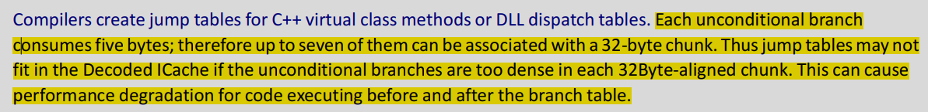

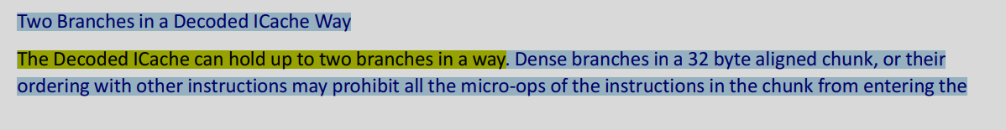

GNR – Macro Fusion

No macro-fusion for MOV + OP pair.

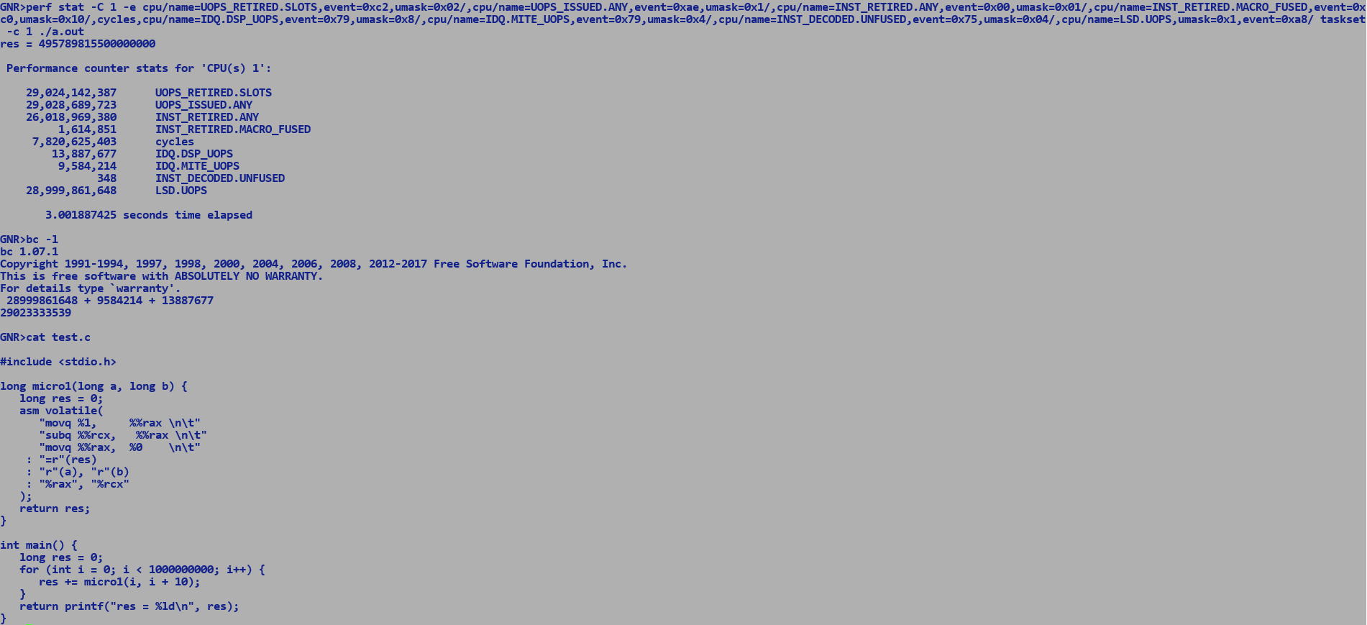

Existing SUB + JMP patterns does get macro-fused.

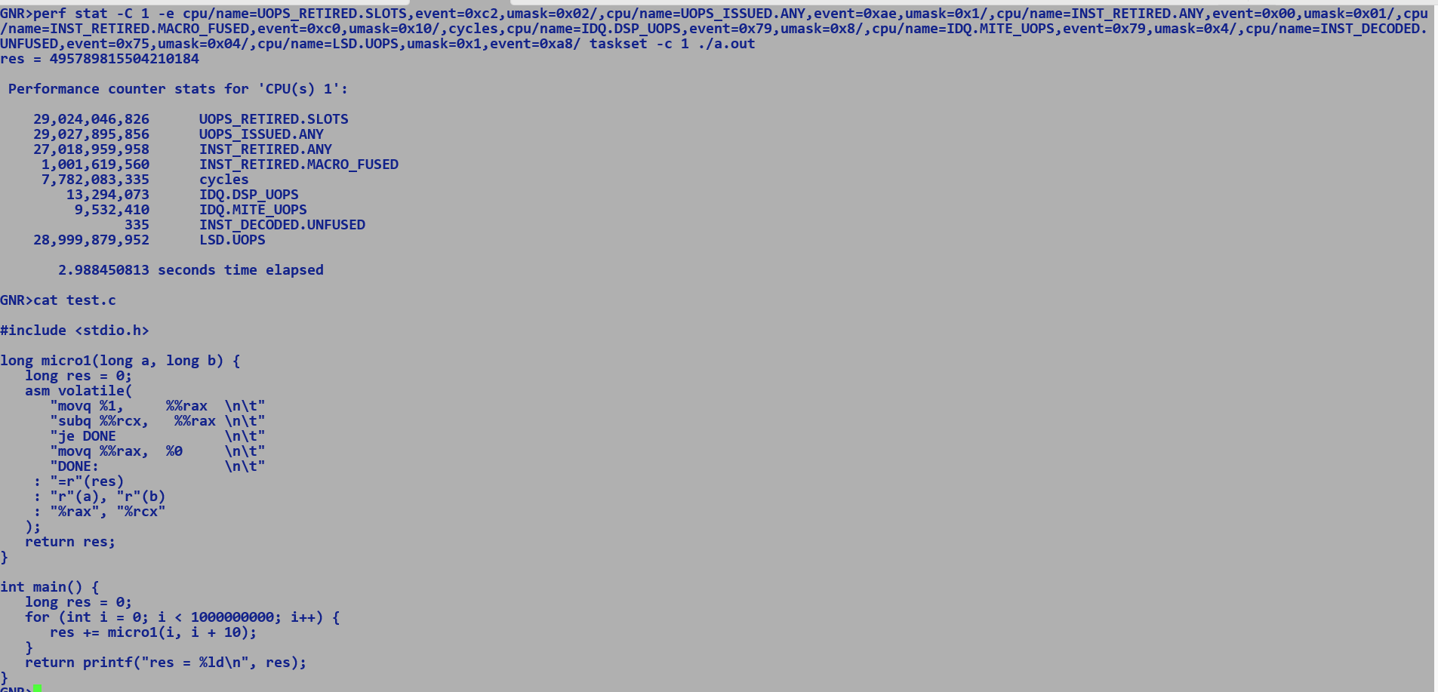

Macro-fusion :- Multiple instruction to one 1 uop, Manual defines the instruction patterns which trigger this fusion.

Micro-fusion :- Multiple uops1 to one 1 uop, e.g. memory flavour instruction load + op is micro fused.

GNR Prefetchers: - AOP + LLC Next Page prefetcher.

LLC Page Prefetcher through bit 6 of MSR 0x1A4

AOP Prefetcher engine (for example, exceeded memory bandwidth due to redundant prefetch requests) can deactivate it through bit 7 of MSR 0x1A4 (MSR_PREFETCH_CTRL).

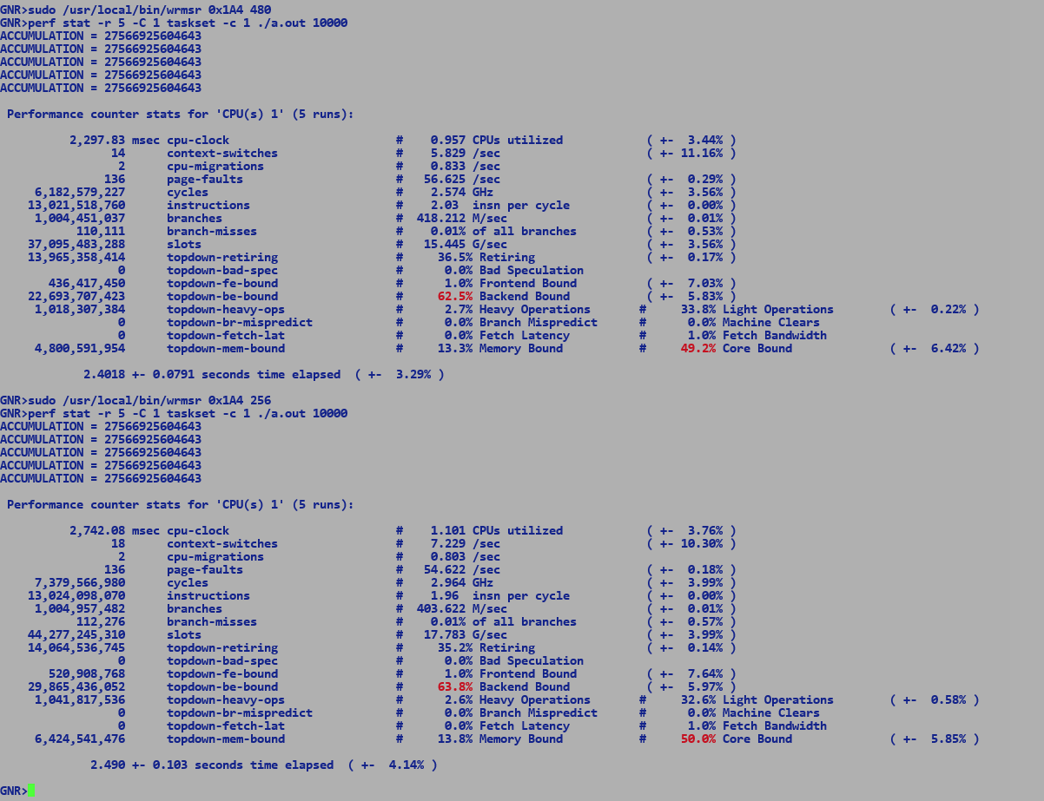

#include <stdio.h>

#include <string.h>

#include <stdlib.h>

typedef struct _link_list {

struct _link_list* next;

int data;

} link_list;

link_list* populate_list(int node_count) {

link_list* head = NULL;

while (node_count) {

link_list* node = (link_list*)malloc(sizeof(link_list));

node->data = node_count;

node->next = head;

head = node;

node_count--;

}

return head;

}

void free_list(link_list* head) {

link_list* next = NULL;

while(head) {

next = head->next;

free(head);

head = next;

}

}

long micro_scan_and_acc(link_list* node) {

long res = 0;

while (node) {

res += node->data;

node->data = res;

node = node->next;

}

return res;

}

int main(int argc, char* argv[]) {

if (argc != 2) {

return fprintf(stderr, "./app <num_of_nodes> \n");

}

int node_count = atoi(argv[1]);

long res = 0;

link_list* head = populate_list(node_count);

for (int i = 0; i < 100000; i++) {

res += micro_scan_and_acc(head);

}

free_list(head);

fprintf(stdout, "ACCUMULATION = %ld\n" , res);

}

ROTATE PERFORMANCE ON GVT4 vs GNR

=================================

128-bit max vector size

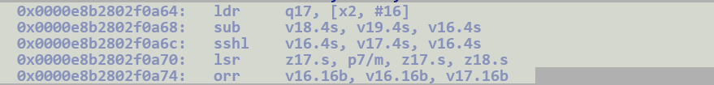

Cannot find ROR instruction.

Integer / Long rotates will always be performant GNR (232) vs GVT4(800) due to direct rotate instruction.

Byte level Rotate: With variable and immediate shifts.

GVT3

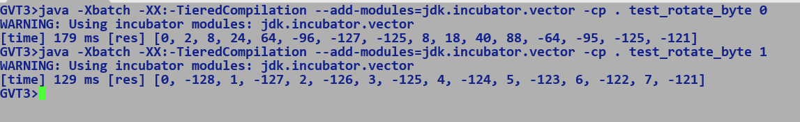

GNR

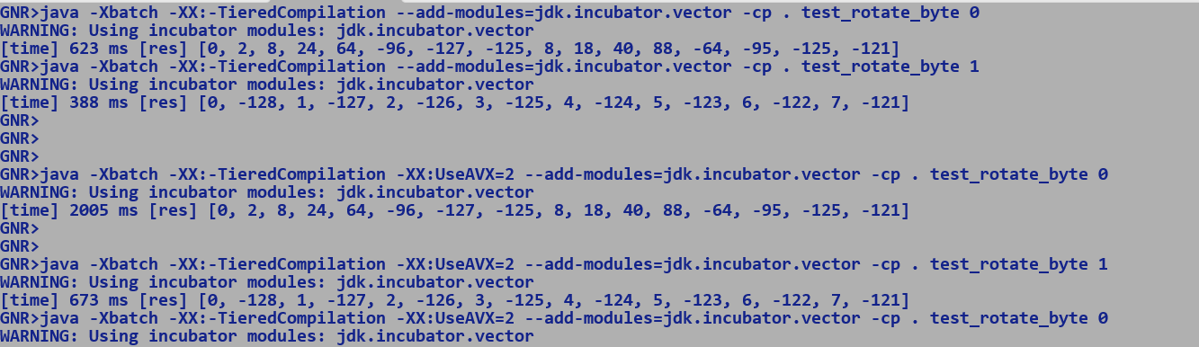

GVT 3

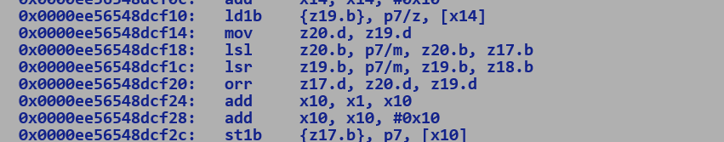



Supports direct byte level left / right shifts and logical OR operations.

Z[0:32] : SVE VECTOR REGISTERS

P[0:31] : SVE PREDICATE REGISTERS

LD1B -> Byte level load with P7/z [x14] -> X[0:32] 64 bit GPR

Since ARM is a RISC instruction set hence they use simple address modes, X14 = < LOAD ADDRESS>

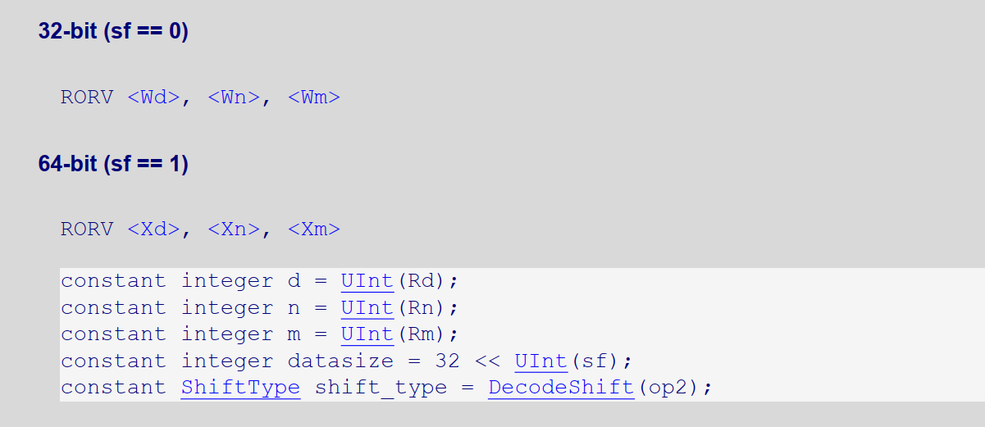

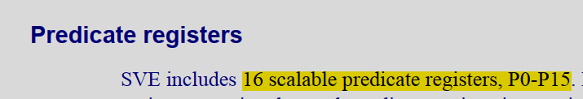

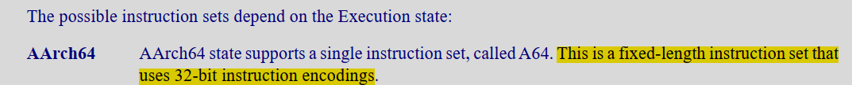

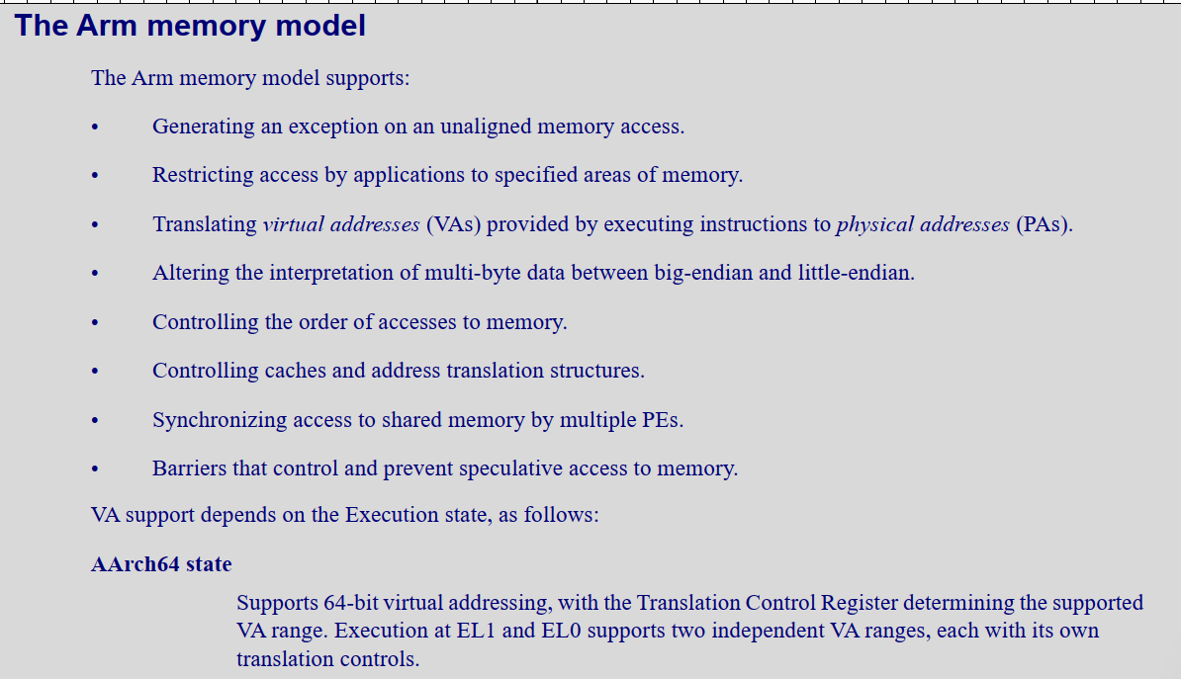

A) Competitive Benchmarking of JMH Micros on following targets :-

-----------------------------------------------------------------------------------------------

- Graviton3 (GVT3)

- Genoa

- Granite Rapids (GNR)

- Sierra Forest (SRF)

B) Objectives:

--------------------

- Collect performance data for various JMH micros at nearly ISO configuration for above targets. [Vladimir] - First cut shared

- Root cause performance degradations seen in micros [Jatin and Vladimir] - WIP

- Enhance JVM to fill the gaps. [Jatin] - TBD

C ) Benchmark Categories.

--------------------------------------

a) Data Copy / Comparison Operations:

- Copy

- Clone

- Mismatch

- Fill

b) Core Lib APIs:

- Math Bench

- Strings

- Arrays

c) Panama-Vector

- Vector API

- Arithmetic Ops

- Conversion Ops

- Reduction Ops

- Shuffle Ops

- Compress / Expand

- Cross lane movements.

- FFM

- Memory Segment

d) GC Performance oriented (high allocation rates)

e) Concurrency Benchmarks

- Locks

- Atomics

f) Crypto

Notes:

---------

[C.a] - Masked stores have almost double latency on GENOA vs GNR. This results in 50% throughput loss for partially inlined small copy operations.

- Large copy operations ( > 64 bytes) incurs penalties due to peel / tail handling involving masked stores, bulk copy happens at full vector granularity.

- ARM benefitted from our partial in-lining optimization and hence GVT3 show 4x performance improvement over SRF (AVX2) where

stub call overhead dominates cycles spent in actual copy.

AI : Enable partial in lining for AVX2 targets using Conditional SIMD Packed Loads and Stores.

[C.b] - SVE ISA has direct instruction for bit reversal of vector lanes

- For X86 we do this in two steps for multi-byte data types like Long

- Reverse bits using GFNI affine instruction.

- Shuffle bytes within a quad word vector lane.

- This results into 50% performance drop on SRF / GNR and GENOA w.r.t to GVT3.

KPIs

* JIT code size emitted
  + ARM has 4 byte fixed encoding for each instruction.
  + OPCODEs are shared across scalar and vector instructions, only the register encoding varies.
* Latency of operation.
  + <https://github.com/ocxtal/insn_bench_aarch64/blob/master/results/aws_graviton3.md>
* Throughput
  + Ops / second for a benchmark.

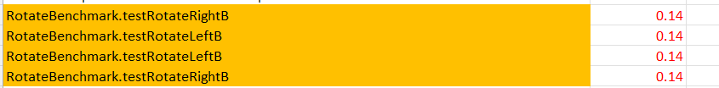

Rotate

* AVX512 has direct ROTATE instructions for Integer / Long
* In other case C2 dismantles rotation into left / right shift and logical ORs.
  + AVX2 have direct instruction for shift[s] and logical OR for int / long ONLY while AVX512 does support short vector shifts under AVX512BW feature.
  + For byte type we currently unpack to short vector and use above direct instructions and pack result back to byte vector
    - There is an overhead of packing / unpacking for both left and right shift operations

Src1 : 32 byte vector

Unpack to 16 lane short vector1

Unpack to 16 lane short vector2

Src2

Unpack to 16 lane short vector3

Unpack to 16 lane short vector4

Res1 = vector1 << vector3

Res2 = vector2 << vector2

Pack Res1 Bres1

Pack Res2 Bres2

Src1 : 32 byte vector

Unpack to 16 lane short vector5

Unpack to 16 lane short vector6

Src2

Unpack to 16 lane short vector7

Unpack to 16 lane short vector8

Res3 = vector5 >>> vector7

Res4 = vector6 >>> vector8

Pack Res3 Bres3

Pack Res4 Bres4

OR BRES1 BRES3

OR BRES2 BRES4

There is a scope of saving one additional unpacking operation after loading source vectors

It’s a very fine optimization, but we cannot match ARM’s performance given that has no overhead of packing/unpacking.

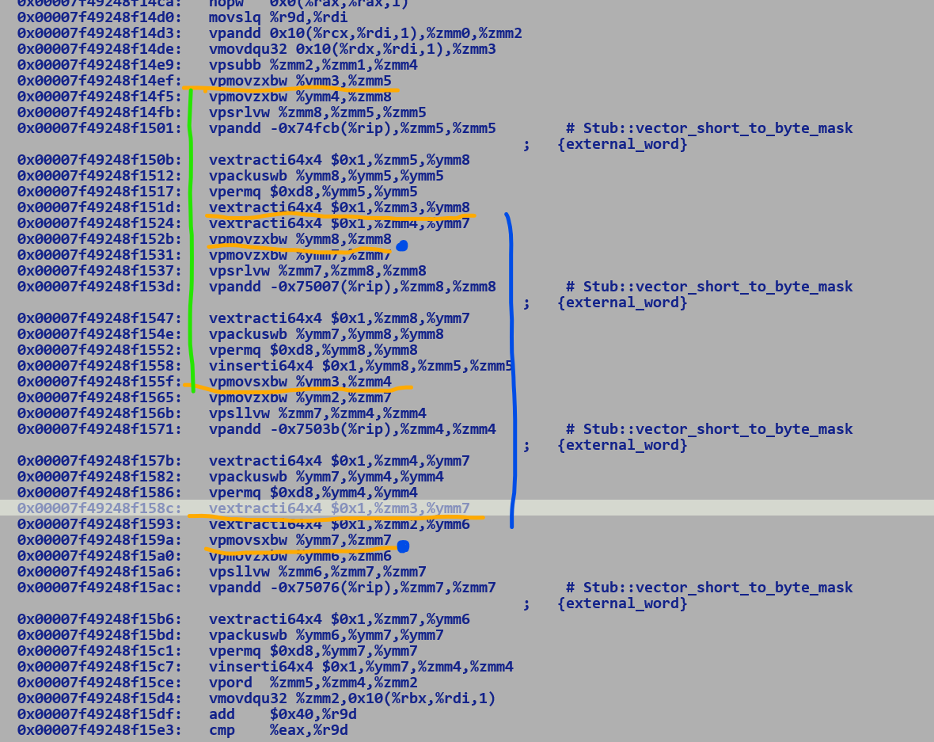

The above instruction sequence corresponds to the Byte512 rotation on the AVX512 target.



Since AVX2 does not support short type shifts hence we perform shifts at the granularity of int type, thus a 256-bit ByteVector rotate is dismantled across 4 Integer left and right shifts followed by a vector logical OR.

The current solution lowers rotate IR into multiple Shift and OR IR nodes, which is a cleaner way to handle if the target does not support direct rotate instructions.

Another solution is to write a bulky macro assembly routine for Byte Vector rotate which removes redundant unpacking operations, it

AVX2

ZXBD / SXBD = 3 cycles

ExtractI128 (upper 128-bit extract) = 3 cycles

Savings

* 2 SXBD + 2 EXTACTI129 = 2 x 3 + 2 x 3 = 12 cycles per operation.

Projected cycles savings ~11%

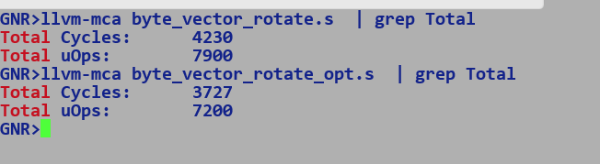

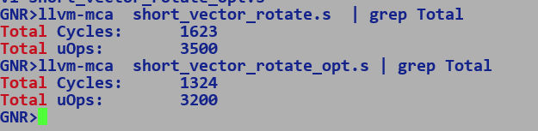

Approximately ~19 % improvement in cycle count.

All in all for Integer / Long rotates on AVX512 we are way ahead of ARM

For other cases

* Both Byte and Short rotates
  + We can remove additional unpacking penalties from source vectors.

This roughly translates into 10% and 20 % gains in terms of cycle count.

Various memory clustering configurations on Granite Rapids.

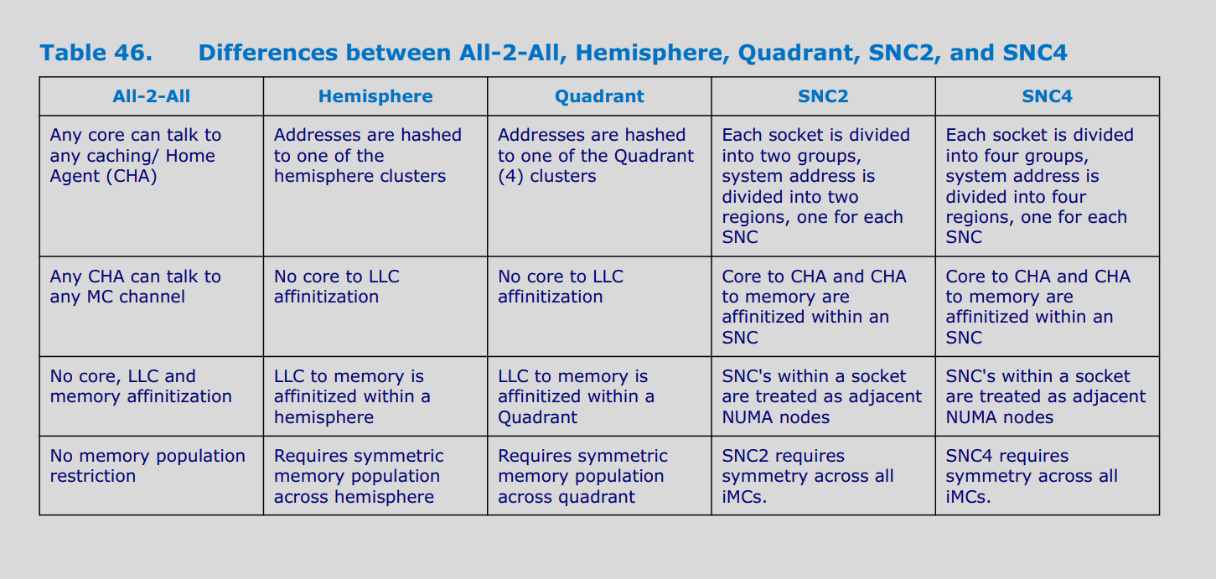

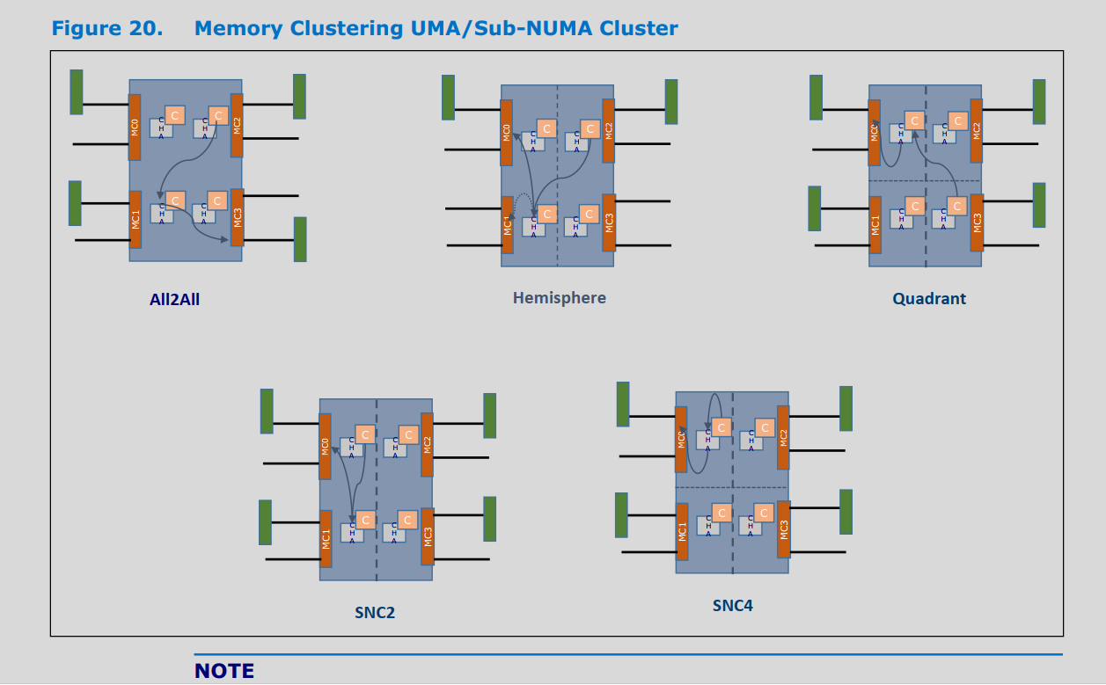

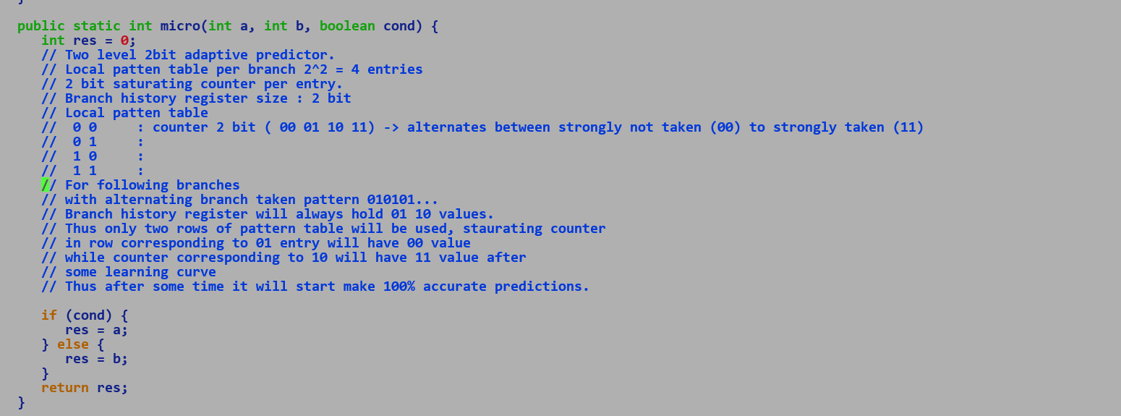

CPROMPT>cat test_adapative_two_level_branch_predictor_local_history.c

#include <stdio.h>

#include <string.h>

#include <stdlib.h>

/*

CPROMPT>perf stat task set -c 1 ./app 37

[res] 260000

Performance counter stats for 'task set -c 1 ./app 37':

3,302.90 msec task-clock # 1.000 CPUs utilized

9 context-switches # 0.003 K/sec

1 cpu-migrations # 0.000 K/sec

115 page-faults # 0.035 K/sec

10,54,43,22,564 cycles # 3.192 GHz

10,03,26,78,976 instructions # 0.95 in per cycle

2,00,10,56,769 branches # 605.848 M/sec

50,846 branch-misses # 0.00% of all branches

3.303564249 seconds elapsed

3.303489000 seconds user

0.000000000 seconds sys

CPROMPT>perf stat task set -c 1 ./app 38

[res] 220000

Performance counter stats for 'task set -c 1 ./app 38':

3,790.49 msec task-clock # 1.000 CPUs utilized

11 context-switches # 0.003 K/sec

1 cpu-migrations # 0.000 K/sec

118 page-faults # 0.031 K/sec

12,10,09,11,387 cycles # 3.192 GHz

10,03,25,06,942 instructions # 0.83 in per cycle

2,00,11,51,333 branches # 527.940 M/sec

2,86,75,097 branch-misses # 1.43% of all branches

3.791023383 seconds elapsed

3.790950000 seconds user

0.000000000 seconds sys

*/

// Between Lspy 37 and 38 there is a huge increase in branch misprediction.

// resulting in a 20% increase in cycle count.

// This indicates usage of two-level adaptive either 37-bit / 74-bit branch predictor with local/global history table.

// spy branch experiences high misprediction ratio after 37 branch history i.e. history of last 37 branches

// cannot predict spy branch direction.

// Since the spy branch is part of the loop hence it is preceded by a loop exit condition and succeeded by a loopback

// jump instruction.

// ENTRY SPY JMP

// Loop has a static trip count of 100000, and thus 99999 loop entry conditional branches will be accurately

// predicted with one misprediction for the loop exit case.

// Thus branching pattern for the loop entry condition is

// 1 1 1 1 1 1 1....999999 time.....0

// This can be easily predicted with a two-level 2-bit adaptive predictor with a local history table with 2-bit saturating

// counter per table entry. The saturating counter varies between 00 to 11 with 00 being strongly not taken and 11 being strongly taken.

//Similarly spy branch with a spy width of 37 has the following branching pattern

// 0 0 0 0 0 .....36 times.. 1

//

// Similar to above, a bit of local branch history register can accurately predict a spy branch.

//

// 0 0 00 (strongly not taken), when the spy branch is visited 36th time its local history register will have 0 0

// and will mis-predict since 37 times it should take a fallthrough path.

// 0 1 01 (weekly not taken)

// 1 0

// 1 1

//

//Let's insert 74 taken branches before the spy branch and if the misprediction rate goes high then it's a clear indication of

// global branch history based on two two-level adaptive predictors.

//

// Branching pattern for loop entry and spy branch should loop like the following.

// 1 0 1 0 1 0 .......thus with 4-bit global history register...we see a strongly not taken prediction after 36 iterations of loop and

// branch history contains 1010

// 0000

// ...

// 1010 11

// 0101 00

// ...

// 1011 00

// ..

// 1111

int micro(int Lspy) {

int a = 0;

for (int i = 0; i < 100000; i++) {

if (i % Lspy == 0) a = 0;

a++;

}

return a;

}

/*

CPROMPT>perf stat task set -c 1 ./app2 37

[res] 1380000

Performance counter stats for 'task set -c 1 ./app2 37':

23,834.19 msec task-clock # 1.000 CPUs utilized

79 context-switches # 0.003 K/sec

1 cpu-migrations # 0.000 K/sec

118 page-faults # 0.005 K/sec

76,09,02,85,345 cycles # 3.192 GHz

2,32,05,18,45,789 instructions # 3.05 in per cycle

76,00,40,65,406 branches # 3188.868 M/sec

1,39,871 branch misses # 0.00% of all branches

23.835355337 seconds elapsed

23.834603000 seconds user

0.000000000 seconds sys

CPROMPT>perf stat task set -c 1 ./app2 38

[res] 1380000

Performance counter stats for 'task set -c 1 ./app2 38':

24,139.88 msec task-clock # 1.000 CPUs utilized

87 context-switches # 0.004 K/sec

1 cpu-migrations # 0.000 K/sec

121 page-faults # 0.005 K/sec

77,06,61,07,101 cycles # 3.192 GHz

2,32,05,15,17,451 instructions # 3.01 in per cycle

76,00,41,33,852 branches # 3148.488 M/sec

2,64,15,280 branch-misses # 0.03% of all branches

24.141069052 seconds elapsed

24.140283000 seconds user

0.000000000 seconds sys

With 74 conditional taken brancher with a branching pattern of 1111....74 times.... next branch is predicted to be taken

But, with Lspy of 37 spy branch must not taken for the first 36 times, in this case, with lspy 37 we can see a low misprediction

rate this indicates the presence of a low local histroy register with width 37 since with lspy 38 we see a 2000x increase in

branch misprediction count. Thus local history register can no longer predict spy branches..

*/

int micro2(int Lspy) {

int a = 0;

for (int i = 1; i < 100000; i++) {

if (i > 0) a = 1;

if (i > 0) a = 2;

if (i > 0) a = 3;

if (i > 0) a = 4;

if (i > 0) a = 5;

if (i > 0) a = 6;

if (i > 0) a = 7;

if (i > 0) a = 8;

if (i > 0) a = 9;

if (i > 0) a = 10;

if (i > 0) a = 11;

if (i > 0) a = 12;

if (i > 0) a = 13;

if (i > 0) a = 14;

if (i > 0) a = 15;

if (i > 0) a = 16;

if (i > 0) a = 17;

if (i > 0) a = 18;

if (i > 0) a = 19;

if (i > 0) a = 20;

if (i > 0) a = 21;

if (i > 0) a = 22;

if (i > 0) a = 23;

if (i > 0) a = 24;

if (i > 0) a = 25;

if (i > 0) a = 26;

if (i > 0) a = 27;

if (i > 0) a = 28;

if (i > 0) a = 29;

if (i > 0) a = 30;

if (i > 0) a = 31;

if (i > 0) a = 32;

if (i > 0) a = 33;

if (i > 0) a = 34;

if (i > 0) a = 35;

if (i > 0) a = 36;

if (i > 0) a = 11;

if (i > 0) a = 12;

if (i > 0) a = 13;

if (i > 0) a = 14;

if (i > 0) a = 15;

if (i > 0) a = 16;

if (i > 0) a = 17;

if (i > 0) a = 18;

if (i > 0) a = 19;

if (i > 0) a = 110;

if (i > 0) a = 111;

if (i > 0) a = 112;

if (i > 0) a = 113;

if (i > 0) a = 114;

if (i > 0) a = 115;

if (i > 0) a = 116;

if (i > 0) a = 117;

if (i > 0) a = 118;

if (i > 0) a = 119;

if (i > 0) a = 120;

if (i > 0) a = 121;

if (i > 0) a = 122;

if (i > 0) a = 123;

if (i > 0) a = 124;

if (i > 0) a = 125;

if (i > 0) a = 126;

if (i > 0) a = 127;

if (i > 0) a = 128;

if (i > 0) a = 129;

if (i > 0) a = 130;

if (i > 0) a = 131;

if (i > 0) a = 132;

if (i > 0) a = 133;

if (i > 0) a = 134;

if (i > 0) a = 135;

if (i > 0) a = 136;

if (i > 0) a = 137;

if (i > 0) a = 137;

if (i % Lspy == 0) a = 0;

a++;

}

return a;

}

int main(int argc, char* argv[]) {

if (argc != 2) {

return fprintf(stderr, "Incorrect Argment! ./app <spy_branch_distance>\n");

}

int Lspy = atoi(argv[1]);

long res = 0;

for (int ic = 0 ; ic < 10000; ic++) {

res += micro2(Lspy);

}

return fprintf(stdout, "[res] %ld\n", res);

}

/* The Above results were collected over the CascadeLake server, with Granite Rapids the branch prediction has improved a lot and even with Lspy of 98 micro2 shows

very low branch misprediction and with an Lspy of 99 it shows 0.2% branch-misses which is 100x more than Lspy 98.

GNR>perf stat task set -c 1 ./app2 99

[res] 1380000

Performance counter stats for 'task set -c 1 ./app2 99':

22,119.53 msec task-clock # 1.000 CPUs utilized

14 context-switches # 0.633 /sec

1 cpu-migrations # 0.045 /sec

124 page-faults # 5.606 /sec

54,968,914,711 cycles # 2.485 GHz

232,136,347,216 instructions # 4.22 in per cycle

76,024,615,339 branches # 3.437 G/sec

12,816,208 branch-misses # 0.02% of all branches

329,813,157,222 slots # 14.910 G/sec

237,982,827,171 topdown-retiring # 71.9% Retiring

3,880,154,790 topdown-bad-spec # 1.2% Bad Speculation

3,880,154,790 top-down-fe-bound # 1.2% Frontend Bound

85,363,405,398 topdown-be-bound # 25.8% Backend Bound

6,466,924,651 topdown-heavy-ops # 2.0% Heavy Operations # 69.9% Light Operations

2,586,769,860 top-down-br-mispredict # 0.8% Branch Mispredict # 0.4% Machine Clears

2,803,029 topdown-fetch-lat # 0.0% Fetch Latency # 1.2% Fetch Bandwidth

27,161,083,535 topdown-mem-bound # 8.2% Memory Bound # 17.6% Core Bound

22.122678982 seconds elapsed

22.092353000 seconds user

0.002975000 seconds sys

GNR>perf stat task set -c 1 ./app2 98

[res] 1380000

Performance counter stats for 'task set -c 1 ./app2 98':

21,947.05 msec task-clock # 1.000 CPUs utilized

13 context-switches # 0.592 /sec

1 cpu-migrations # 0.046 /sec

122 page-faults # 5.559 /sec

54,542,028,582 cycles # 2.485 GHz

232,135,732,632 instructions # 4.26 in per cycle

76,024,465,860 branches # 3.464 G/sec

709,924 branch-misses # 0.00% of all branches

327,251,862,534 slots # 14.911 G/sec

237,418,017,916 topdown-retiring # 72.3% Retiring

1,283,340,637 topdown-bad-spec # 0.4% Bad Speculation

3,850,021,912 top-down-fe-bound # 1.2% Frontend Bound

85,983,822,705 topdown-be-bound # 26.2% Backend Bound

6,416,703,186 topdown-heavy-ops # 2.0% Heavy Operations # 70.3% Light Operations

647,097 top-down-br-mispredict # 0.0% Branch Mispredict # 0.4% Machine Clears

9,498,988 topdown-fetch-lat # 0.0% Fetch Latency # 1.2% Fetch Bandwidth

28,233,494,022 topdown-mem-bound # 8.6% Memory Bound # 17.6% Core Bound

21.950072055 seconds elapsed

21.918690000 seconds user

0.003947000 seconds sys

*/

/// TODO: Replace the Spy branch with the conditional move and measure its impact on branch misprediction.



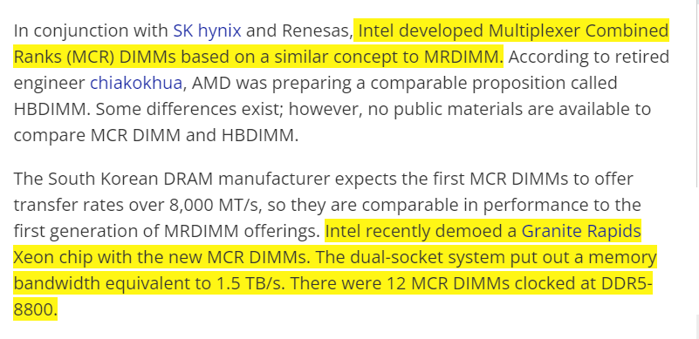

<https://www.tomshardware.com/news/amd-advocates-ddr5-mrdimms-with-speeds-up-to-17600-mts>

Turin – 192 C – Base Frequency 2.7GHz, Turbo -5.0GHz

AVX512b dedicated ports unlike double pumping used in prior generations.

No MRDIMM-compatible IMC will impact memory-hungry workloads like AI, which may show better performance on Xeon6 + MRDIMMs.

AVX512 workloads + high frequency may significantly improve the performance of HPC workloads.

AMX missing, and Low precision type support missing.

High core count double L3 cache, may favor throughput-oriented workloads like SpecJBB-MaxJops, and higher cache may favor latency-sensitive workload mode SpecJBB-crit, BKM available on the SPEC site, any non-engineer can run it after writing a script, why do we need 5 people team for it?? It's the same OS, JVM, and BIOS settings, no rocket science, one just needs to spend one quiet weekend and HW access to get hold of the workload….

17 chaplets.

New OpenJDK Projects: Valhalla, Lilliput, Leyden (TBD)

Compact Object Headers:

=======================

* Klass folds into upper 22 bits of mark word.
* Thereby merging mark and subsequent Klass pointer.

E.g.

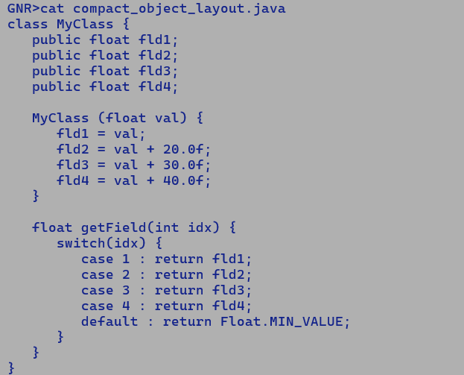

Micro Benchmarking: -

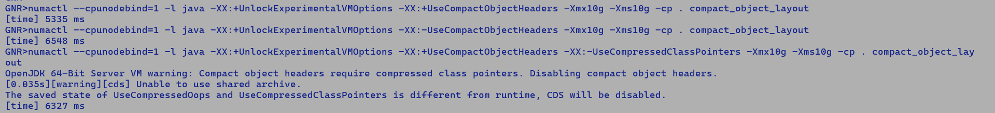

~20% improvement in runtime.

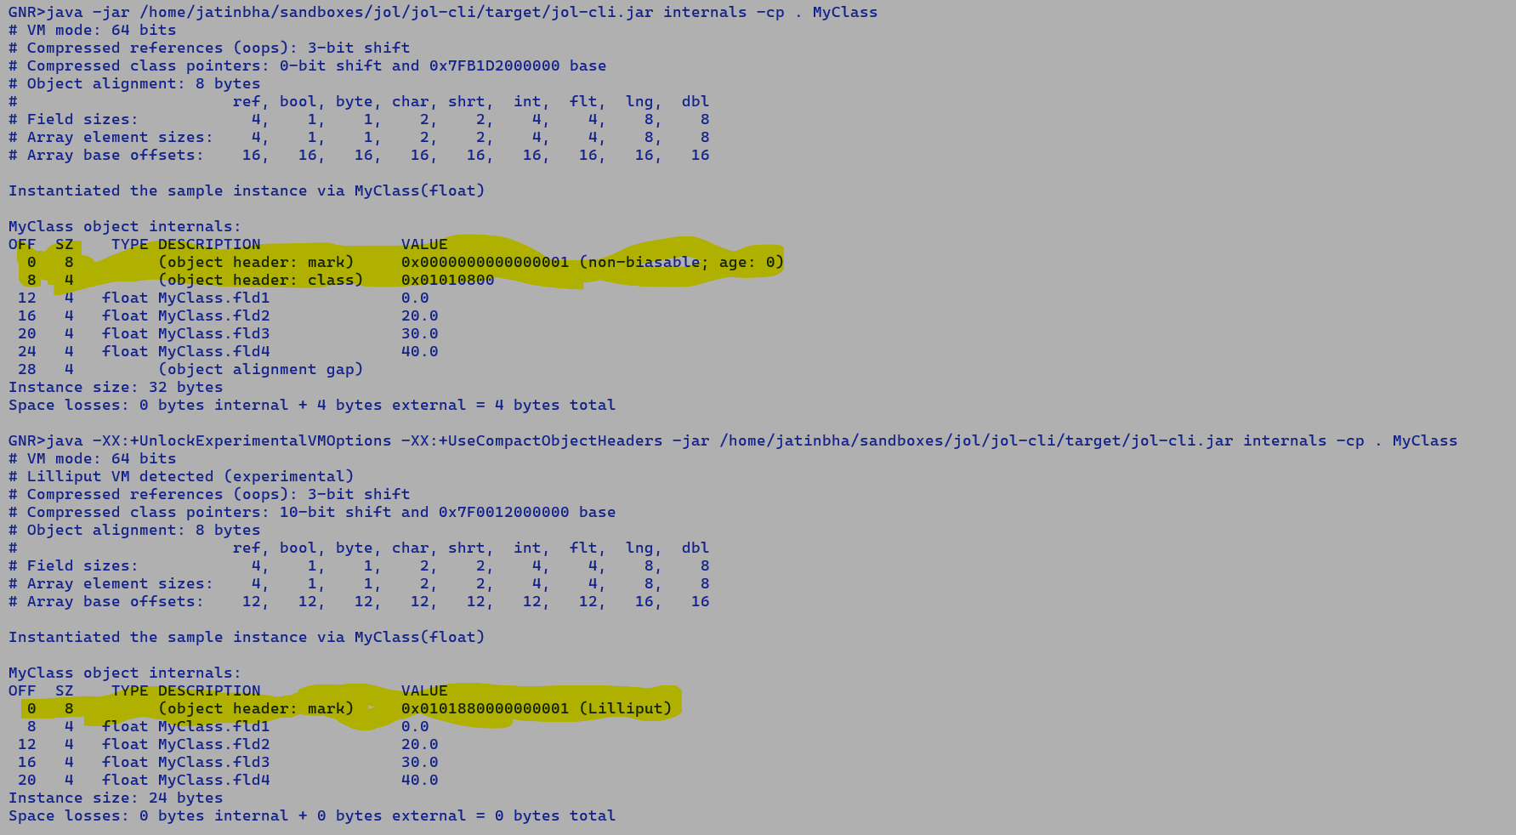

GNR>cat compact_object_layout.java

value class MyClass {

//class MyClass {

public float fld1;

public float fld2;

public float fld3;

public float fld4;

MyClass (float val) {

fld1 = val;

fld2 = val + 20.0f;

fld3 = val + 30.0f;

fld4 = val + 40.0f;

}

float getField(int IDX) {

switch(IDX) {

case 1: return fld1;

case 2: return fld2;

case 3: return fld3;

case 4: return fld4;

default: assert false;

}

Return Float.MAX_VALUE;

}

float accumFields() {

return fld1 + fld2 + fld3 + fld4;

}

}

public class compact_object_layout {

public static float micro(MyClass obj) {

return obj.accumFields();

}

public static void main(String [] args) {

float res = 0.0f;

for (int i = 1; i < 9000000; i++) {

MyClass obj = new MyClass((float)i);

res += micro(obj); // If in-lined EA will eliminate non-escaping allocation and forward field initialization to its users.

}

long t1 = System.currentTimeMillis();

for (int i = 1; i < 9000000; i++) {

MyClass obj = new MyClass((float)i);

res += micro(obj);

}

long t2 = System.currentTimeMillis();

System.out.println("[time] " + (t2 - t1) + " ms");

}

}

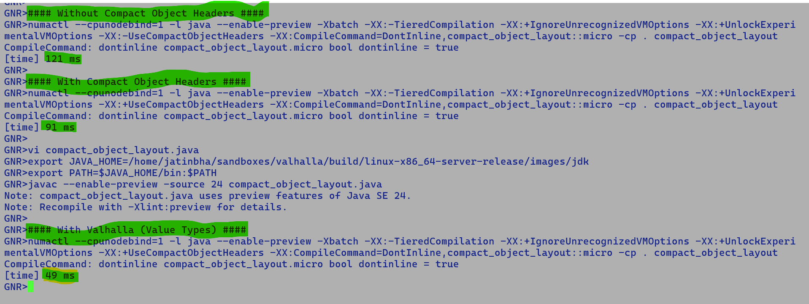

Scalarization of value type arguments saves field loads on the caller side, translating into 2x gain over compact object headers and 3x over jdk-24 baseline.

Amdahl’s law:

============

Expected speedup of application with work w , s% serial execution and %p parallel execution on an n-core processor

W / (S x w

----- + P x w

100 -----

100 x n

e.g.

w = 100 ops

serial execution = 20 %

Parallel execution 80 %

On 10 cores processor

Serial work = 100 ops

Parallel work = 20 + 80 / 10 = 28 ops

Speedup: mix of serial-parallel execution vs 100 % serial execution = 100 / 28 = 3.57x

Speedup with 100% parallel execution vs 100% serial execution = 100 / 10 = 10x

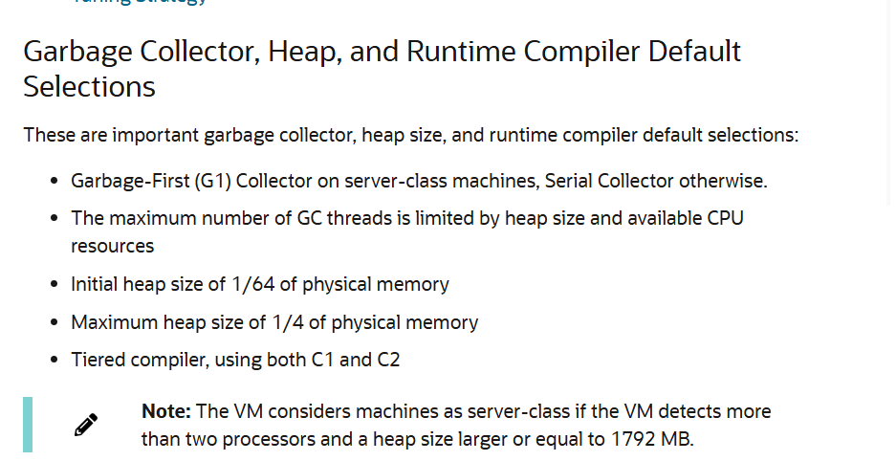

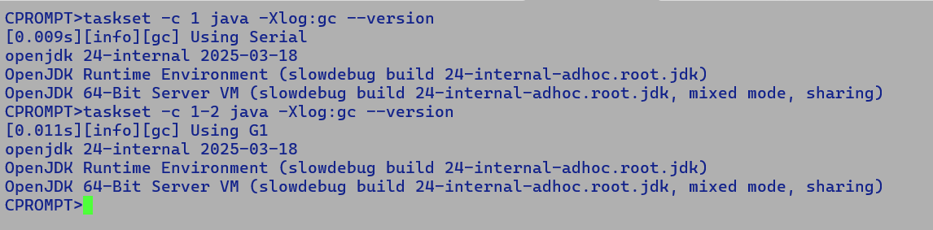

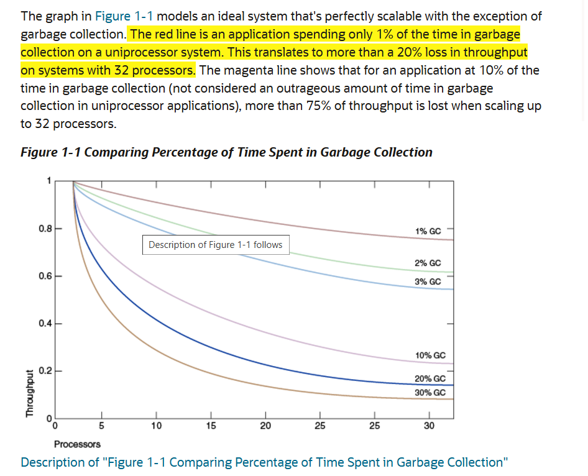

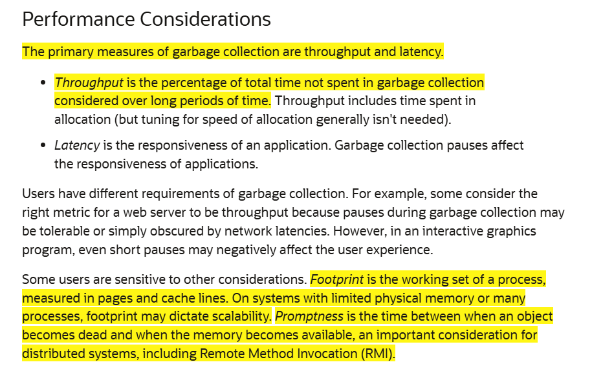

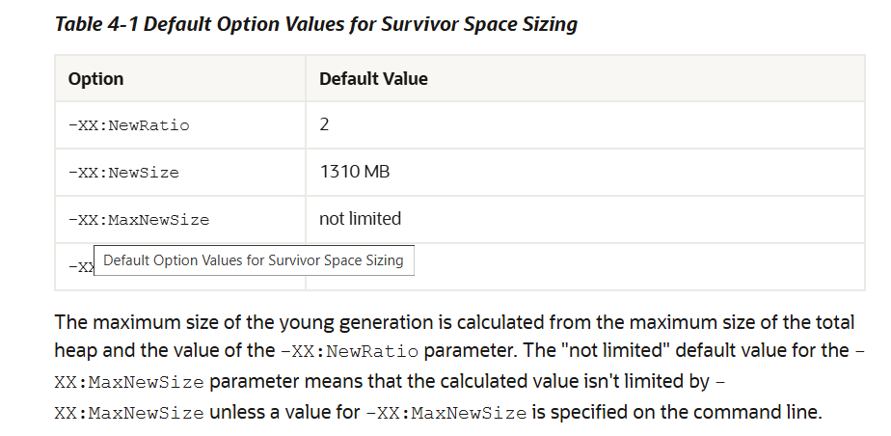

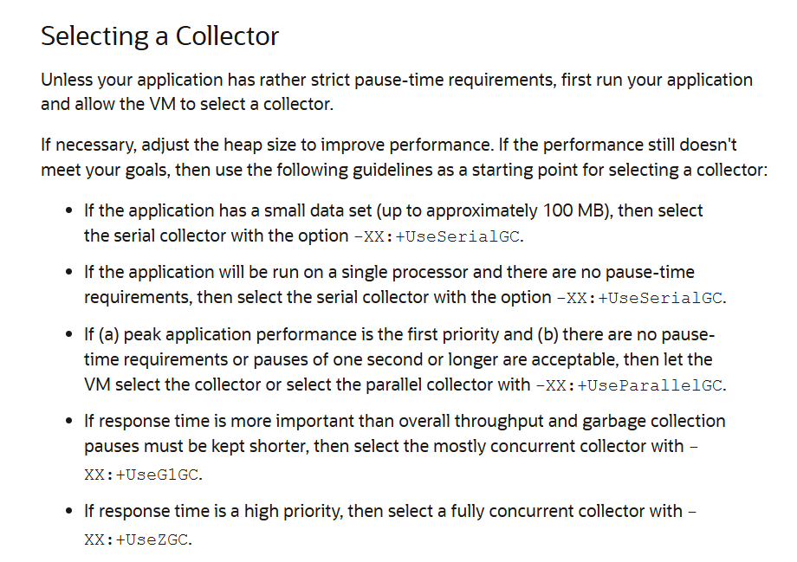

**Parallel Collector Thread Count:-**

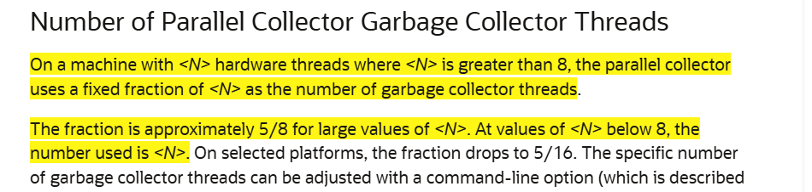

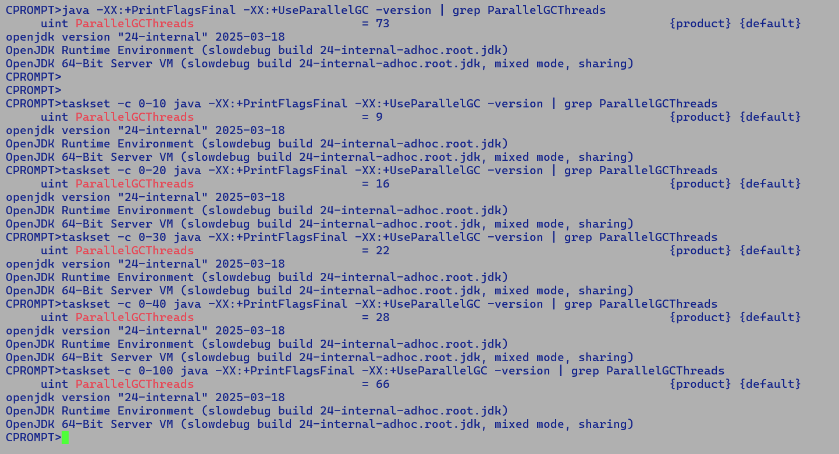



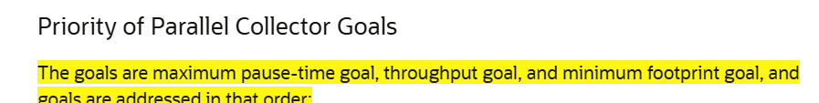

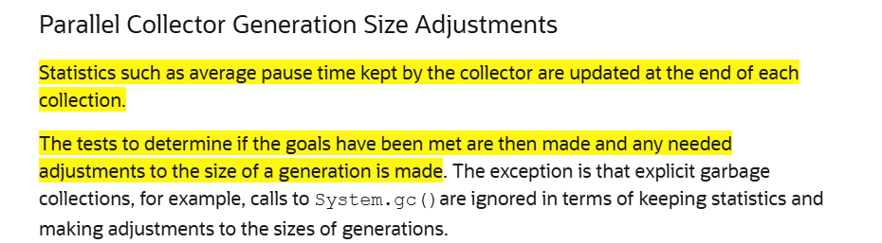

[7.804s][info][gc,start ] GC(116) Pause Young (Allocation Failure)

[7.805s][info][gc,heap ] GC(116) PSYoungGen: 283168K(283648K)->512K(279040K) Eden: 283136K(283136K)->0K(278528K) From: 32K(512K)->512K(512K)

[7.805s][info][gc,heap ] GC(116) ParOldGen: 1572K(1398272K)->1756K(1398272K)

Parallel Scavenging Young Collection

* Mark, sweep and compact.

Parallel Old Generation Collection

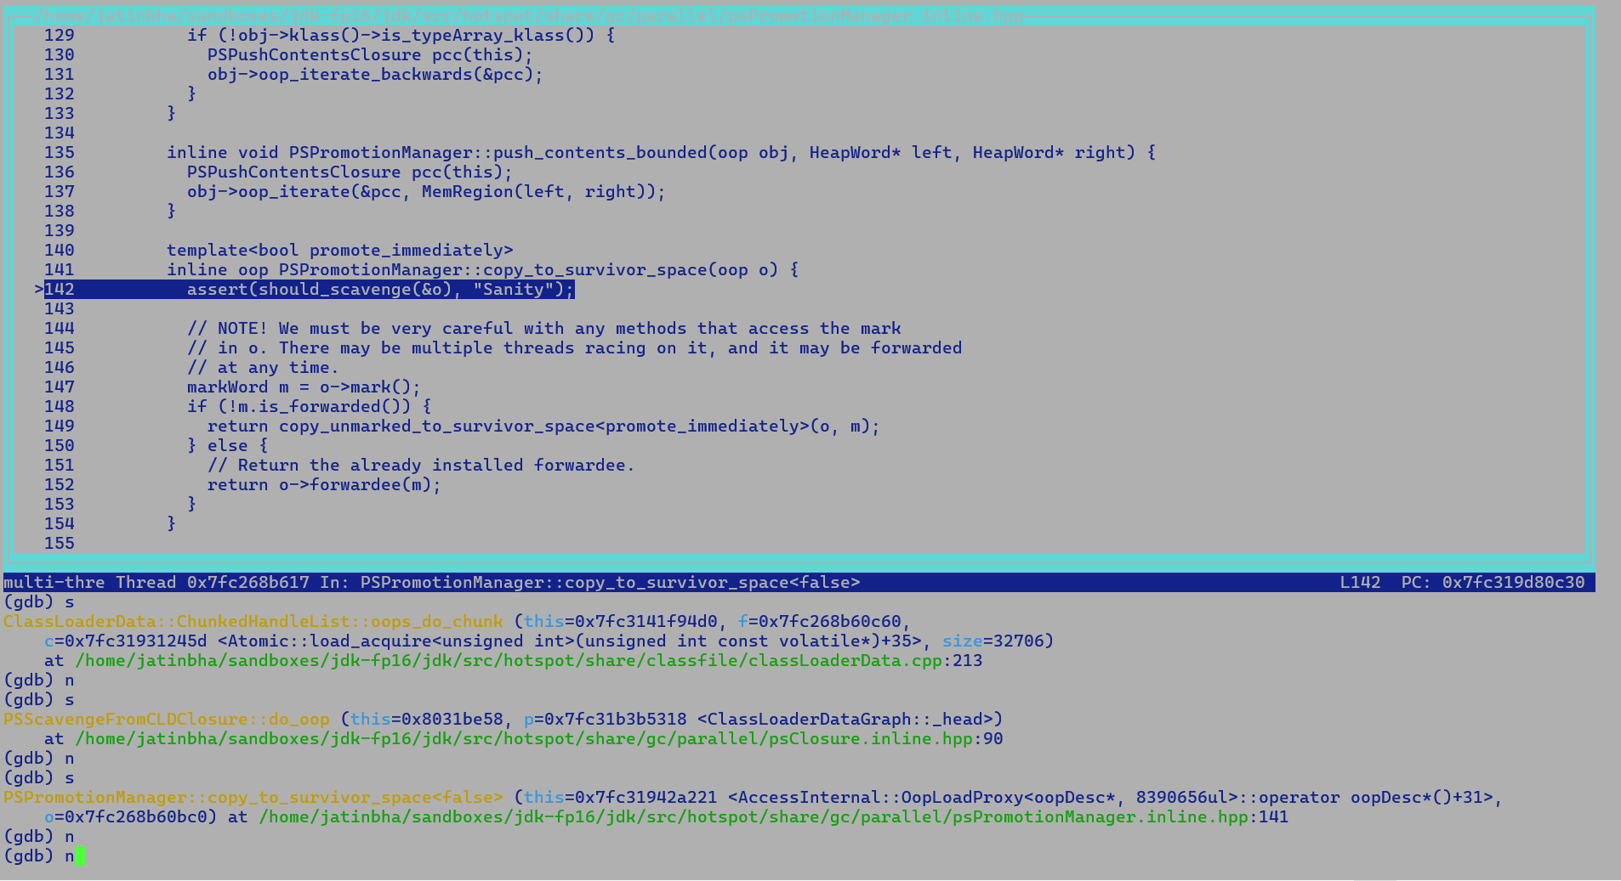

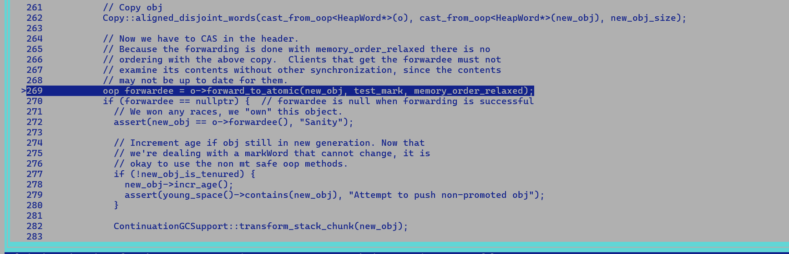

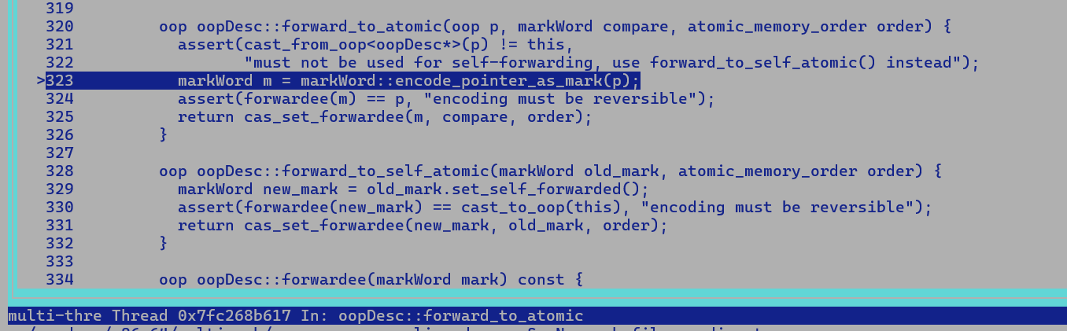

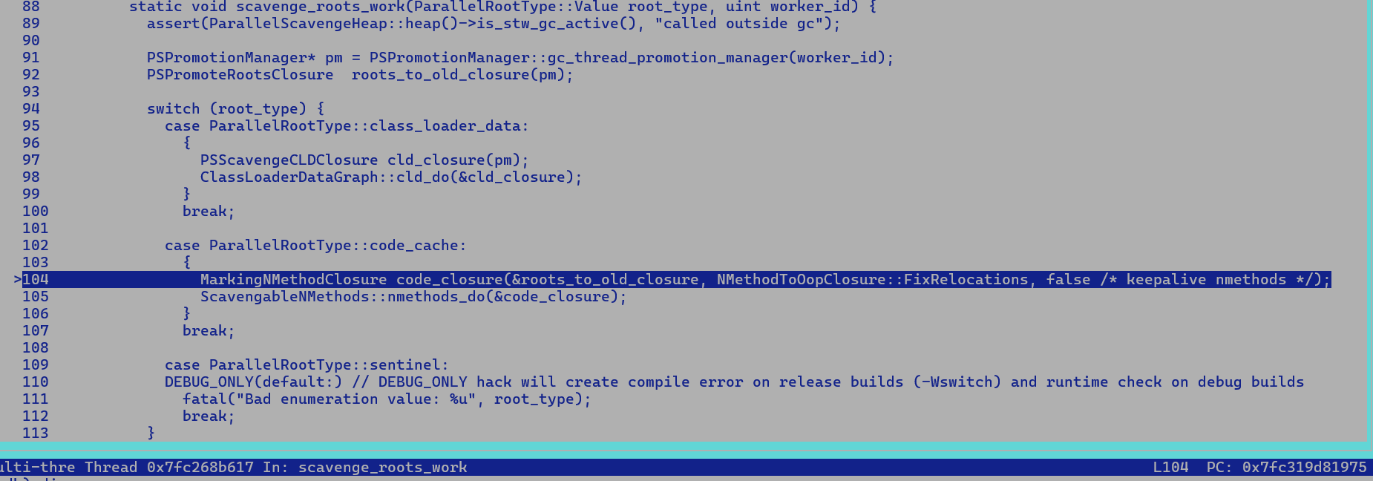

Collection Strategies: -

1. Mark and Sweep
   1. Pros:
      1. Low footprint.
      2. Low latency.
   2. Cons:
      1. Fragmentation.
      2. Need auxiliary DS to maintain segmented free lists.
      3. Future allocation could be costly.
2. Mark and Compaction
   1. Pros:
      1. Faster allocations.
      2. Offers spatial locality benefits.
   2. Cons:
      1. Costly collection vs Sweeping as objects are moved around for compaction.
3. Semi space Copying
   1. Pros:
      1. Faster allocations
   2. Cons:
      1. Operating heap is reduced as portion of heap is reserved for survivors, may lead to increased number of collections.
      2. Costly collection vs sweeping, but better than compaction which may use multiple passes.
4. Reference counting.

CPROMPT>jcmd 1371805 JFR.view allocation-by-class

CPROMPT>jcmd 1371805 JFR.view allocation-by-class

1371805:

Allocation by Class

Object Type Allocation Pressure

------------------------------------------------------------------- -------------------

java.util.HashMap$KeyIterator 53.22%

java.util.stream.IntPipeline$4 15.49%

int[] 4.64%

java.lang.Object[] 4.51%

jdk.jfr.internal.MetadataDescriptor$Attribute 3.15%

java.lang.classfile.constantpool.PoolEntry[] 3.07%

java.lang.Long 2.94%

jdk.internal.ref.CleanerImpl$PhantomCleanableRef 2.54%

java.util.stream.IntPipeline$Head 1.97%

java.lang.String 1.79%

java.lang.invoke.ResolvedMethodName 1.57%

java.util.ArrayList$Itr 1.50%

java.util.Collections$UnmodifiableRandomAccessList 1.47%

byte[] 0.98%

java.util.concurrent.ConcurrentHashMap$Node[] 0.82%

java.lang.StringBuilder 0.05%

java.util.LinkedHashMap$Entry 0.05%

java.util.LinkedHashMap 0.04%

java.lang.Integer 0.03%

jdk.internal.foreign.NativeMemorySegmentImpl 0.03%

MemSegmentsLifetime$$Lambda.0x00007ff6eb000a08 0.03%

java.util.concurrent.locks.AbstractQueuedSynchronizer$ExclusiveNode 0.02%

jdk.jfr.internal.query.ViewFile$ViewConfiguration 0.01%

java.util.HashMap$KeySet 0.01%

jdk.jfr.events.InitialSecurityPropertyEvent 0.01%

Timespan: 11:11:37 - 11:21:37

CPROMPT>

CPROMPT>jcmd 1371805 JFR.view hot-methods

1371805:

Java Methods that Executes the Most

Method Samples Percent

------------------------------------------------------------------------------ ------- -------

java.util.stream.Streams$RangeIntSpliterator.forEachRemaining(IntConsumer) 3,108 56.26%

jdk.internal.foreign.AbstractMemorySegmentImpl.isAlignedForElement(long, long) 2,415 43.72%

jdk.internal.ref.PhantomCleanable.insert() 1 0.02%

Timespan: 11:12:41 - 11:22:41

CPROMPT>

CPROMPT>jcmd 1371805 JFR.view vm-operations

1371805:

VM Operations

VM Operation Average Duration Longest Duration Count Total Duration

------------------------ ---------------- ---------------- ----- --------------

G1CollectFull 22.4 ms 22.8 ms 2 44.9 ms

Timespan: 11:13:48 - 11:23:48

CPROMPT>jcmd 1371805 JFR.view verbose=true vm-operations

1371805:

VM Operations

VM Operation Average Duration Longest Duration Count Total Duration

(operation) (duration) (duration) (startTime) (duration)

------------------ ---------------- ---------------- ----------- --------------

G1CollectFull 22.4 ms 22.8 ms 2 44.9 ms

COLUMN 'VM Operation', 'Average Duration', 'Longest Duration', 'Count',

'Total Duration' SELECT operation, AVERAGE(duration), MAXIMUM(duration),

COUNT(*), SUM(duration) FROM jdk.ExecuteVMOperation GROUP BY operation

Execution: query-validation=0.0657 ms, aggregation=9.37 ms, formatting=1.67 ms

Timespan: 11:14:35 - 11:24:35

**31/12/2024 (ARM parity optimization)**

Benchmarks:-

StoreMaskedIOOBEBenchmark.shortStoreArrayMaskIOOBE

StoreMaskedBenchmark.byteStoreArrayMask

* MASKMOVDQU instruction can be used to improve performance of algorithms that need to merge data on a byte-by-byte basis.
* MASKMOVDQU should not cause a read for ownership; doing so generates unnecessary bandwidth since data is to be written directly using the byte-mask without allocating old data prior to the store.
* RFO – furnishes the most up to data cache line contents to requesting core.
  + Requesting core submits its RFO request into TOR.
* Scenario 1:-
  + Core A stores the data into complete vector.
    - Store is not non-temporal in this case.
  + Core B performs data into same address using another non-temporal store
    - Core be issues a RFO, it receives updated data.
    - In case store size matches with cache line size of 64 bytes, processor does not wait for RFO to complete.
    - On E-core platforms, cache line size is still 64 bytes, but max vector size is 32 bytes.

Hence, above opportunistic RFO optimization is not relevant in E-core context.

* + - RFO completes and core B writes the data to cache line.
* Scenario 2:-
  + Core A performs partial store using predicated vector operation.
    - E-core targets does not support sub-word level predicated memory operations.
    - If we use MASKMOVDQU, a non-temporal store instruction. It does not perform RFO and hence may not receive most updated cache line contents.
    - Since non-temporal stores are not cache coherent, hence processor cannot guarantee any deterministic ordering b/w non-temporal and regular store operation.
    - Different kinds of memory ordering semantics i.e. ACQUIRE, RELEASE, SEQUENTIAL-CONSISTANCY are not relevant in context of non-temporal stores.
  + Core B perform partial store using predicated vector operations.

Notes:-

Since WC buffer is not cache coherent thus not snoop able and not in purview of CHA, hence WC buffer eviction must ensure to invalidate the cache lines holding the data for same store memory address in other cores caches.

When a WC buffer is evicted, the processor must ensure that any cache lines corresponding to the addresses in the WC buffer are invalidated to maintain data consistency. This process typically involves the following steps:

1. **Flushing the WC Buffer**: Before the WC buffer is evicted, its contents must be written to memory. This ensures that all the combined writes are committed to the main memory. The processor issues a write-back operation to flush the WC buffer to memory.
2. **Invalidating Cache Lines**: After the WC buffer is flushed, the processor must invalidate any cache lines that correspond to the addresses in the WC buffer. This is necessary to ensure that any stale data in the caches is not used in future operations. The invalidation process typically involves the following steps:
   * The processor identifies the cache lines that correspond to the addresses in the WC buffer.
   * The processor issues invalidation commands to the caches to mark these lines as invalid.
   * The caches update their status to reflect the invalidation, ensuring that any future accesses to these addresses will fetch the most up-to-date data from memory.
3. **Ensuring Memory Ordering**: To maintain proper memory ordering, the processor may use memory barriers or fences. These instructions ensure that all previous memory operations are completed before any subsequent operations are allowed to proceed. This is particularly important in systems with weak memory consistency models, where the order of memory operations is not strictly enforced by default.

Intel CPU uses write invalidate protocol and ensures that only on of the core hold the modified data, first in modified and later in shared state. Invalidation occurs as the part of RFO… requesting core receives the data and send the invalidation request to all the cores holding the same cache line after consulting the CHA.

CHA holds the directory of cache line address and core IDs holding the same cache line.

Advantage of WC buffer based bulk copy / fill operation, it does not pollute the caches as WC buffers are not cache coherent, this can improve overall cache hit ratio since useful cache lines are not displaced due to cache fill events associated with store operation.

1. So stores to WC buffer with proper fencing can be forced to adhere specific memory ordering semantics like ACQUIRE. In this case core reading the data from the memory location is certain about all the prior stores being committed to memory, and a fence post WC store will ensure this.
2. [iGPT] Yes, stores to a Write-Combining (WC) buffer can be made to adhere to specific memory ordering semantics, such as ACQUIRE, by using proper fencing mechanisms. This ensures that the core reading the data from the memory location can be certain that all prior stores have been committed to memory. Here's how this can be achieved:

* **Write-Combining Buffer Stores**: When data is written to a WC buffer, the writes are combined and eventually flushed to memory. However, because WC buffers are not cache-coherent and do not follow strict memory ordering by default, additional steps are needed to enforce specific memory ordering semantics.
* **Memory Fences**: Memory fences (also known as memory barriers) are special instructions that enforce ordering constraints on memory operations. There are different types of memory fences, such as:
  1. **Store Fence (SFENCE)**: Ensures that all previous store operations are completed before any subsequent store operations.
  2. **Load Fence (LFENCE)**: Ensures that all previous load operations are completed before any subsequent load operations.
  3. **Full Fence (MFENCE)**: Ensures that all previous load and store operations are completed before any subsequent load and store operations.
* **ACQUIRE Semantics**: ACQUIRE semantics ensure that all memory operations before the ACQUIRE are completed before any subsequent operations. This is typically used in synchronization primitives to ensure that a thread acquiring a lock sees all the updates made by the thread that released the lock.
* **Ensuring Memory Ordering with WC Buffers**:
  1. **Before the Store**: To ensure that all prior stores are committed to memory before a store to a WC buffer, a store fence (SFENCE) can be used. This ensures that all previous store operations are completed before the WC buffer store.
  2. **After the Store**: To ensure that the store to the WC buffer is committed to memory before any subsequent operations, another store fence (SFENCE) can be used after the WC buffer store. This ensures that the WC buffer store is completed before any subsequent memory operations.
* **Example Sequence**:
  1. **Step 1**: Perform necessary store operations.
  2. **Step 2**: Issue a store fence (SFENCE) to ensure all prior stores are completed.
  3. **Step 3**: Perform the store to the WC buffer.
  4. **Step 4**: Issue another store fence (SFENCE) to ensure the WC buffer store is committed to memory.
  5. **Step 5**: Perform subsequent operations, such as reading from the memory location.

By using memory fences in this manner, you can enforce specific memory ordering semantics, such as ACQUIRE, even when using WC buffers. This ensures that the core reading the data from the memory location can be certain that all prior stores have been committed to memory, maintaining data consistency and correctness.

In summary, proper use of memory fences around WC buffer stores can enforce specific memory ordering semantics, ensuring that all prior stores are committed to memory and that subsequent operations see the correct data.

**Predicated in-range vector store using VMASKMOVDQU instructions on SRF(sierra-glen core)**

// Only possible for in-range sub-word predicated vector stores. Since VMASKMOVDQU does not

// suppress memory access violations.

__attribute__((noinline))

void micro1(short* dst, short* src, short* mask, int vlen) {

asm volatile(

// On legacy targets mask is propagated through

// vector register, since all the bits of mask vector

// lanes either holds a zero or one value hence

// mask vector corresponding to a short vector can be

// directly used for byte level operations.

"vmovdqu %1, %%ymm0 \n\t"

"vmovdqu %2, %%ymm1 \n\t"

"vextracti128 $1, %%ymm0, %%xmm2 \n\t"

"vextracti128 $1, %%ymm1, %%xmm3 \n\t"

"movq %0, %%rdi \n\t"

"vmaskmovdqu %%xmm1, %%xmm0 \n\t"

"addq $16, %%rdi \n\t"

"vmaskmovdqu %%xmm3, %%xmm2 \n\t"

"sfence \n\t"

: "+r"(dst)

: "m"(*src), "m"(*mask)

: "%ymm0", "%ymm1", "%xmm2", "%xmm3", "%rdi"

);

}

__attribute__((noinline))

void micro2(short* dst, short* src, short* mask, int vlen) {

for(int i = 0; i < vlen; i++) {

if (mask[i] == -1) {

dst[i] = src[i];

}

}

}

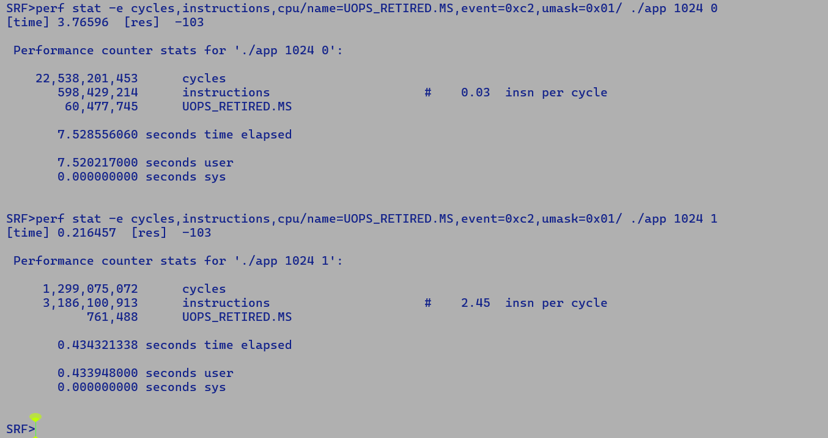

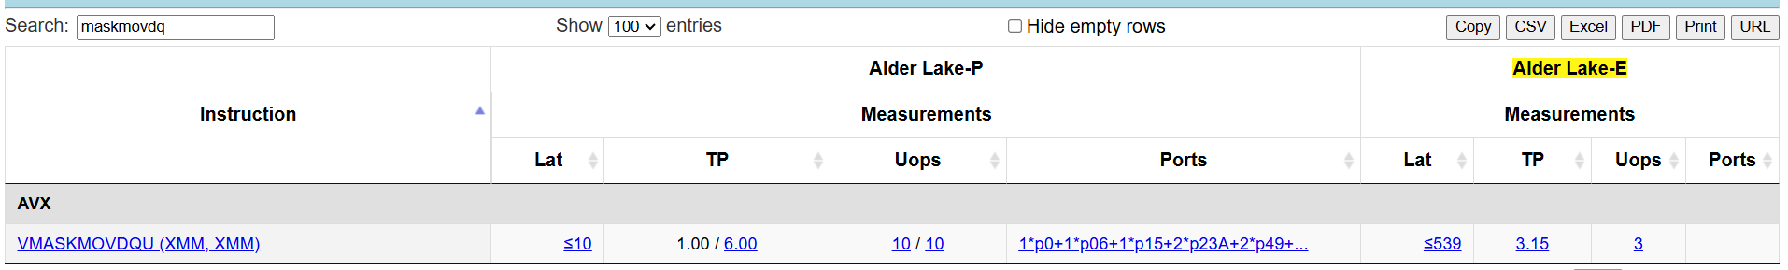

Above vector kernel without sfence show 3x performance gains over scalar implementation

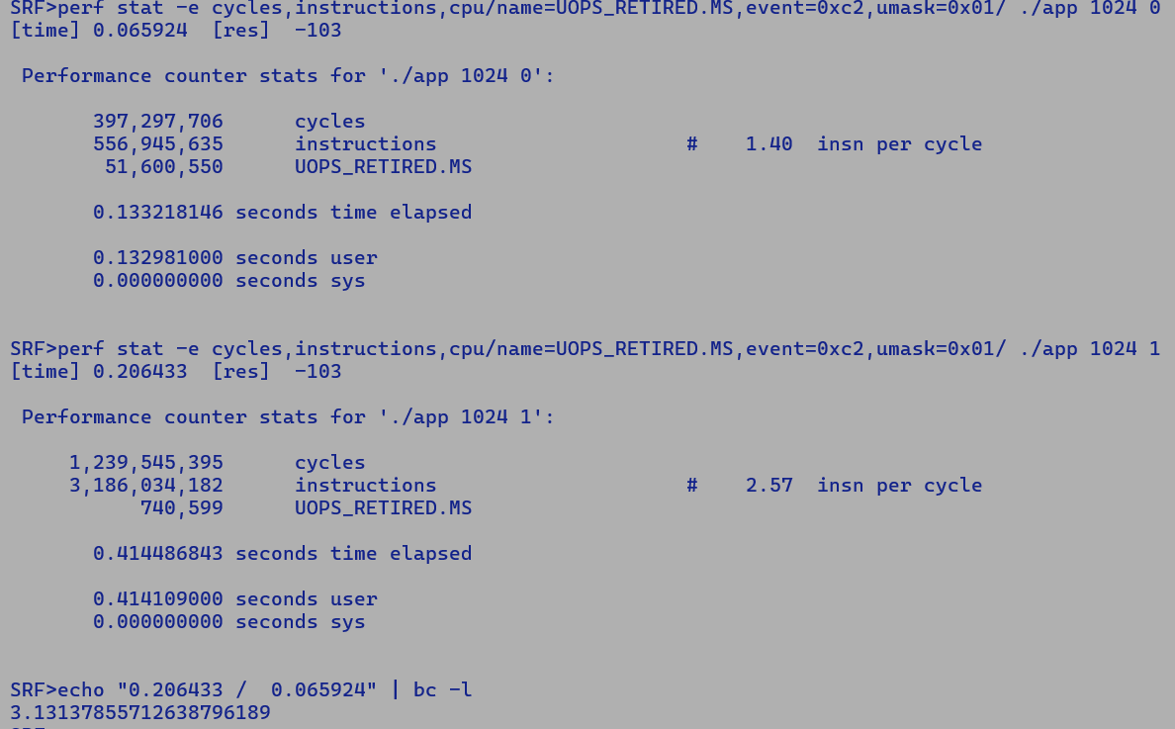

Observations: -

1. We cannot ditch ‘sfence’ here since processor needs to invalidate the cache lines holding the contents of store location at the time WC buffer eviction.
2. Even without ‘sfence’ significant portion of micro-operations are being issued to micro code sequencer, these corresponds to the VMOVEMASKDQU instructions. However, on GNR we don’t see MS activity for same micro benchmark.

This will only be fixed with UC core which has converged ISA. First intercept of E-core UC is Titanlake POR 2028.

Efficient Store loop:-

for (int I = 0; I < MASK_VLEN ; I++) {

Int size = consecutive_one_mask(MASK);

switch(size) {

case 1:

movb (dst, src)

dst += 1;

src += 1;

case 2:

movw (dst, src)

dst += 2;

src += 2;

case 4:

movl (dst, src)

dst += 4;

src += 4;

case 8:

movq (dst, src)

dst += 8

src += 8;

}

}

Cons:

* High branch misprediction.
* Finding consecutive set mask bits may consume cycles per iteration.

Vector Size: 128 bits (16 bytes)

* 8 short values
* Hash table of – 2^8

Or consider 4 mask lane at a time to generate compact hash table of 2^4 – 16 entries.

MASK_REG = VPMOVMSKB MASK_VEC :-

while (MASK_REG) {

switch (MASK_REG & 0xF) {

case 0:

case 1:

case 2:

movb (dst + 1, src + 1) ; // 0010

case 3:

movw (dst, src); // 0011 – only write first two byte

case 4:

movb (dst + 2, src + 2); // 0100 – skip over first two byte, will save additional instructions in looping.

…

case 15:

movl (dst, src);

}

MASK_REG >>= 4;

}

**Above loop may save lost of cycles in looping and mask comparison as we only write the enabled bytes.**

Call - overhead to efficient stub may overshadow gains as we are only dealing with single vector register.

Partial inlining with all the cases will be very costly in terms of code size and may have other side effects which inlining decisions and may impact the performance adversely in real workloads.

Stub is the only viable solution here….

In above case experimental results using c-micro show 2 – 3.5x gain… gains may be able to combat the call overhead to stub…

Short vector optimized stub is roughly 5x performant that existing solution, will definitely be able to absorb stub call overhead penalty.

SRF>./app 1024 -1

[time micro0] 3.83456 [res] -342

[time micro2] 0.24417 [res] -342

[time micro3] 0.0920451 [res] -342

[time micro4] 0.0452041 [res] -342

SRF>echo "0.24 / 0.045" | bc -l

5.33333333333333333333

Interface expects passing vector –

* Two solutions

1. Reserve the space on stack.
2. Java side changes to pass backing storage.

* Currently also intoVector intrinsification fails and we do incur boxing penalty, hence stubi-fication may give benefits anyways.

With additional allocation penalty gain reduced from 5.3x to 4.5x.

SRF>./app 1024 -1

[time micro0] 3.87807 [res] -342

[time micro2] 0.251512 [res] -342

[time micro3] 0.103496 [res] -342

[time micro4] 0.0523426 [res] -342

SRF>echo "0.238 / 0.052" | bc -l

4.57692307692307692307

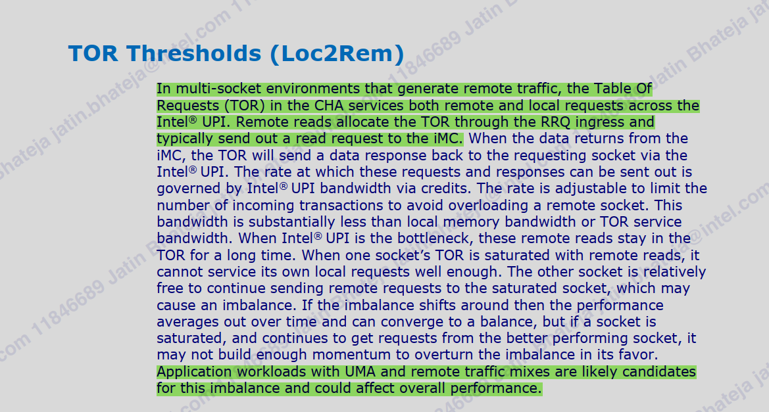

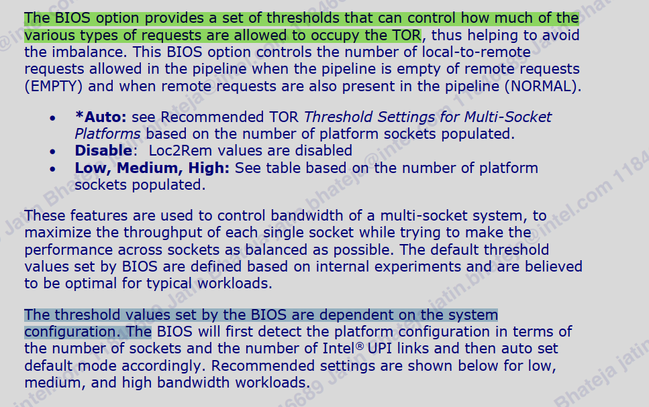

Neoverse V2 :-

* In terms of Vector width, x86 supports 512-bit vectors, while V2 supports only 128-bit vector.
* Dynamic instruction count will be 4 times that of x86.

X86 Vector Add with memory operand

* EVEX (4) + OPC (1) + MOD.RM (1) + SIB (1) + DISP8*Compressed (1) / DISP32 (4)
  + 4 + 1 + 1 + 1 + 1 = 8 bytes
  + 4 + 1 + 1 + 1 + 4 = 11 bytes

ARM SVE Add + Load (ARM being a RISC architecture does not support CISC / memory flavour instruction)

* Uniform – 4 byte LD + 4 byte Vector ADD = 8 bytes.

**Math Transcendental Functions Acceleration:**

1. TANH – (e^x + e^-x) / (e^x – e^-x) = Use as activation function in DNNs, e.g. Jlama inferencing engine.

CPROMPT>which java

/home/jatinbha/softwares/jdk-25//bin/java

CPROMPT>

CPROMPT>java -Xbatch -XX:-TieredCompilation -XX:CompileCommand=PrintIntrinsics,Micro1::apply -cp /home/intel/.m2/repository/net/jafama/jafama/2.3.2/jafama-2.3.2.jar:. perf_tanh 10000 1

CompileCommand: PrintIntrinsics Micro1.apply bool PrintIntrinsics = true

@ 1 java.lang.Math::tanh (5 bytes) (intrinsic)

[time] 756 ms [res] 4730986895511650304

CPROMPT>

CPROMPT>

CPROMPT>

CPROMPT>java -Xbatch -XX:-TieredCompilation -XX:CompileCommand=PrintIntrinsics,Micro2::apply -cp /home/intel/.m2/repository/net/jafama/jafama/2.3.2/jafama-2.3.2.jar:. perf_tanh 10000 2

CompileCommand: PrintIntrinsics Micro2.apply bool PrintIntrinsics = true

[time] 394 ms [res] 4730986895511650304

CPROMPT>

CPROMPT>

CPROMPT>export JAVA_HOME=/home/jatinbha/softwares/jdk-24/

CPROMPT>export PATH=$JAVA_HOME/bin:$PATH

CPROMPT>

CPROMPT>java -Xbatch -XX:-TieredCompilation -XX:CompileCommand=PrintIntrinsics,Micro1::apply -cp /home/intel/.m2/repository/net/jafama/jafama/2.3.2/jafama-2.3.2.jar:. perf_tanh 10000 1

CompileCommand: PrintIntrinsics Micro1.apply bool PrintIntrinsics = true

@ 1 java.lang.Math::tanh (5 bytes) (intrinsic)

[time] 755 ms [res] 4730986895511650304

CPROMPT>

CPROMPT>java -Xbatch -XX:-TieredCompilation -XX:CompileCommand=PrintIntrinsics,Micro2::apply -cp /home/intel/.m2/repository/net/jafama/jafama/2.3.2/jafama-2.3.2.jar:. perf_tanh 10000 2

CompileCommand: PrintIntrinsics Micro2.apply bool PrintIntrinsics = true

[time] 394 ms [res] 4730986895511650304

CPROMPT>

CPROMPT>

CPROMPT>export JAVA_HOME=/home/jatinbha/softwares/jdk-23.0.2/

CPROMPT>export PATH=$JAVA_HOME/bin:$PATH

CPROMPT>

CPROMPT>java -Xbatch -XX:-TieredCompilation -XX:CompileCommand=PrintIntrinsics,Micro1::apply -cp /home/intel/.m2/repository/net/jafama/jafama/2.3.2/jafama-2.3.2.jar:. perf_tanh 10000 1

CompileCommand: PrintIntrinsics Micro1.apply bool PrintIntrinsics = true

@ 1 java.lang.Double::doubleToRawLongBits (0 bytes) (intrinsic)

[time] 151 ms [res] 4730986895511650304

CPROMPT>java -Xbatch -XX:-TieredCompilation -XX:CompileCommand=PrintIntrinsics,Micro2::apply -cp /home/intel/.m2/repository/net/jafama/jafama/2.3.2/jafama-2.3.2.jar:. perf_tanh 10000 2

CompileCommand: PrintIntrinsics Micro2.apply bool PrintIntrinsics = true

[time] 394 ms [res] 4730986895511650304

CPROMPT>

CPROMPT>

CPROMPT>export JAVA_HOME=/home/jatinbha/softwares/jdk-22.0.2/

CPROMPT>export PATH=$JAVA_HOME/bin:$PATH

CPROMPT>

CPROMPT>java -Xbatch -XX:-TieredCompilation -XX:CompileCommand=PrintIntrinsics,Micro1::apply -cp /home/intel/.m2/repository/net/jafama/jafama/2.3.2/jafama-2.3.2.jar:. perf_tanh 10000 1

CompileCommand: PrintIntrinsics Micro1.apply bool PrintIntrinsics = true

@ 1 java.lang.Double::doubleToRawLongBits (0 bytes) (intrinsic)

[time] 151 ms [res] 4730986895511650304

CPROMPT>

CPROMPT>java -Xbatch -XX:-TieredCompilation -XX:CompileCommand=PrintIntrinsics,Micro2::apply -cp /home/intel/.m2/repository/net/jafama/jafama/2.3.2/jafama-2.3.2.jar:. perf_tanh 10000 2

CompileCommand: PrintIntrinsics Micro2.apply bool PrintIntrinsics = true

[time] 394 ms [res] 4730986895511650304

GNR>

GNR>### Minimizing Cache miss penalty - keeping the data size to 2048 to fit in L1D

GNR>for i in 1 2 100 1000 10000 100000; do echo "OPT Value Range +/- $i" ; java -cp . perf_tanh 2048 1 $i; echo "BASELINE Value Range +/- $i" ; java -cp . -XX:+UnlockDiagnosticVMOptions -XX:DisableIntrinsic=_dtanh perf_tanh 2048 1 $i; done

OPT Value Range +/- 1

[time] 2150 ms [res] 4703953473701854056

BASELINE Value Range +/- 1

[time] 2018 ms [res] 4703953473701854056

OPT Value Range +/- 2

[time] 2198 ms [res] 4704833237651253581

BASELINE Value Range +/- 2

[time] 2296 ms [res] 4704833237651253581

OPT Value Range +/- 100

[time] 1116 ms [res] 4702597330634182362

BASELINE Value Range +/- 100

[time] 881 ms [res] 4702597330634182362

OPT Value Range +/- 1000

[time] 866 ms [res] 4701949321365089262

BASELINE Value Range +/- 1000

[time] 544 ms [res] 4701949321365089262

OPT Value Range +/- 10000

[time] 824 ms [res] 4701885239273842268

BASELINE Value Range +/- 10000

[time] 518 ms [res] 4701885239273842268

OPT Value Range +/- 100000

[time] 828 ms [res] 4701360953811046364

BASELINE Value Range +/- 100000

[time] 518 ms [res] 4701360953811046364

SRF>for i in 1 2 100 1000 10000 100000; do echo "OPT Value Range +/- $i" ; java -cp . perf_tanh 1024 1 $i; echo "BASELINE Value Range +/- $i" ; java -cp . -XX:+UnlockDiagnosticVMOptions -XX:DisableIntrinsic=_dtanh perf_tanh 1024 1 $i; done

OPT Value Range +/- 1

[time] 1900 ms [res] 4702864816897695262

BASELINE Value Range +/- 1

[time] 2176 ms [res] 4702864816897695262

OPT Value Range +/- 2

[time] 1905 ms [res] 4703196717820511186

BASELINE Value Range +/- 2

[time] 2402 ms [res] 4703196717820511186

OPT Value Range +/- 100

[time] 1038 ms [res] -4528385163293633597

BASELINE Value Range +/- 100

[time] 990 ms [res] -4528385163293633597

OPT Value Range +/- 1000

[time] 601 ms [res] -4526070134597701909

BASELINE Value Range +/- 1000

[time] 456 ms [res] -4526070134597701909

OPT Value Range +/- 10000

[time] 492 ms [res] -4526160345768562912

BASELINE Value Range +/- 10000

[time] 406 ms [res] -4526160345768562912

OPT Value Range +/- 100000

[time] 504 ms [res] -4525487471878501419

BASELINE Value Range +/- 100000

[time] 402 ms [res] -4525487471878501419

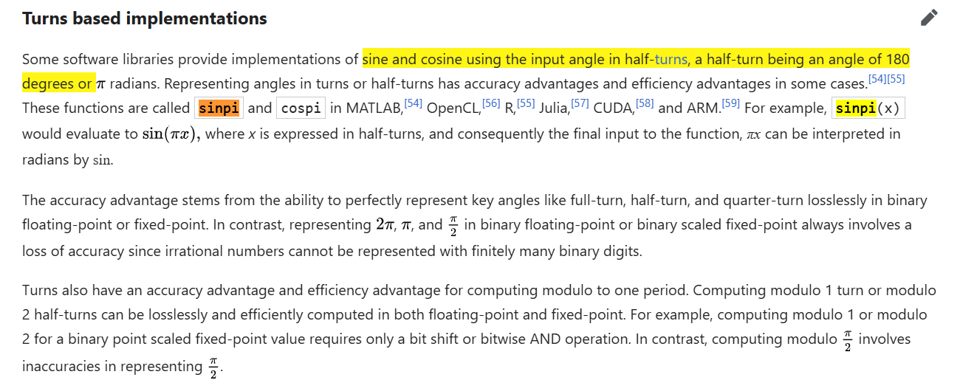

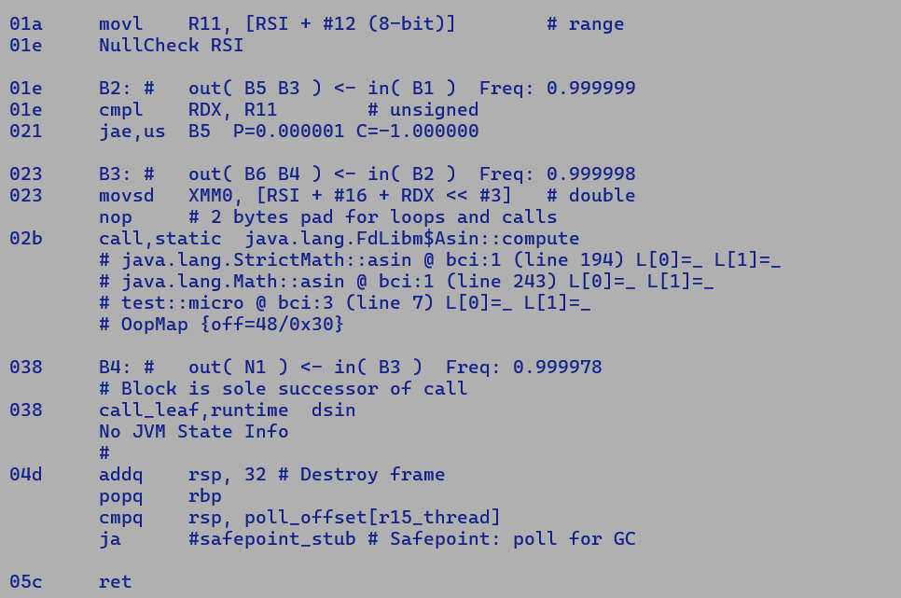

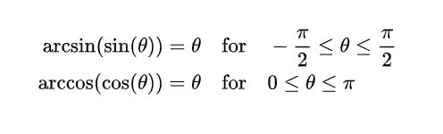

Problem:

* Transcendental stubs calls are agnostic to idealizations.

Solution:

* Creation of idealizable macro nodes, which can be lowered to calls during macro expansion will save redundant call overheads.

**Copy Sign Performance:**

**Sapphire Rapids**

With and wo intrinsic

* SRF>java -XX:+UnlockDiagnosticVMOptions -XX:DisableIntrinsic=_dcopySign -XX:-TieredCompilation -cp . perf_copysign
* [time] 116 ms [res] -Infinity
* SRF>java -XX:+UnlockDiagnosticVMOptions -XX:-TieredCompilation -cp . perf_copysign
* [time] 116 ms [res] -Infinity
* SRF>

Notes: SRF does not support VPTERNLOGD instruction, thus on SRF copySign is not intrinsified.

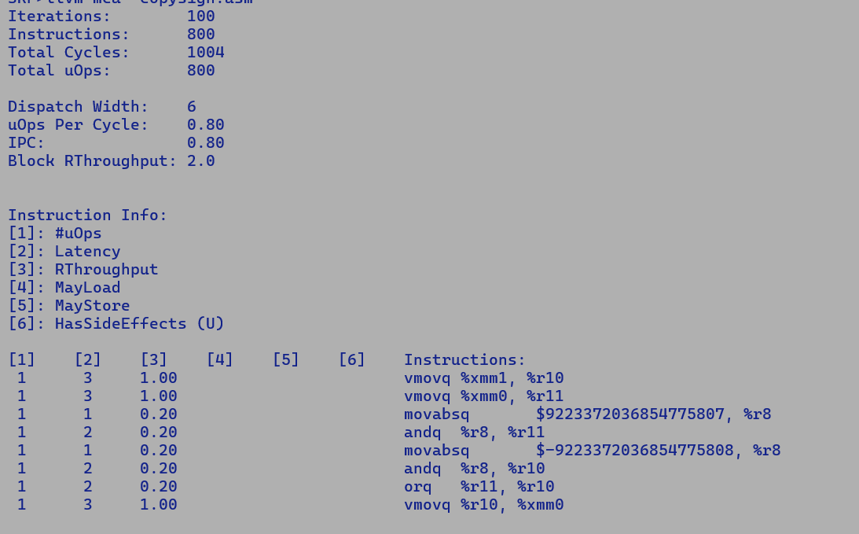

Graviton3

Again, no intrinsification on AARCH64, but still 30% performant compared to SRF

GVT3>java -XX:-TieredCompilation -cp . perf_copysign

[time] 89 ms [res] Infinity

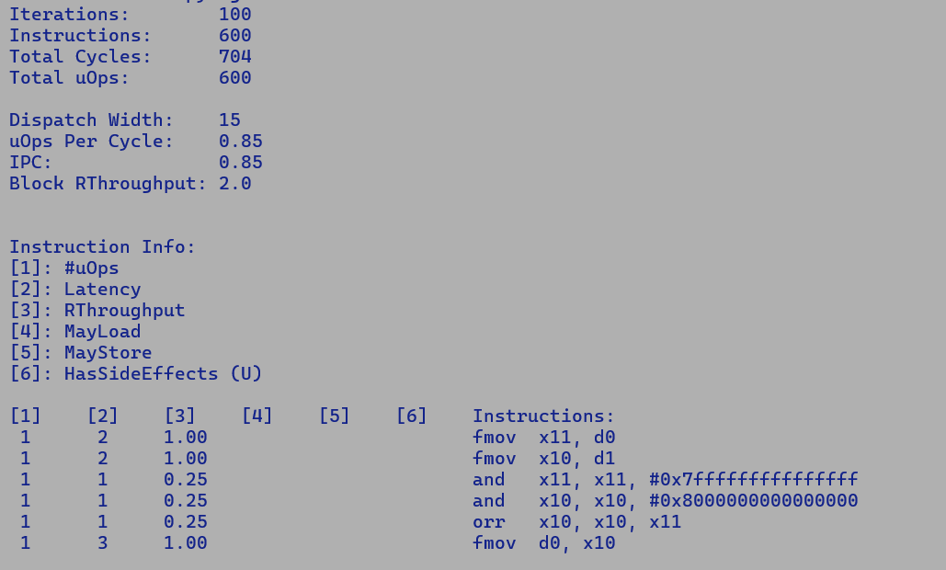

Cumulative latency of instruction sequence as shown with LLVM MAC static characterization is 17 cycles on SRF vs 10 on GVT.

Notes:

* GVT3 operates at 2.5GHz while SRF has base frequency of 2.2GHz and Max turbo of 3GHz.
* At fixed 2.5GHz frequency copysign micro takes 140ms on SRF vs 89ms on GVT3.
* SPR perf runs shows 80 ms with intrinsic and 82 without it. GLC cove is a P-core, while same micro show

As can be seen in the SRF instruction sequence there is an upfront domain cross over penalty of 3 cycles for both inputs where we move the data from XMM to GPR register before executing logic instruction. This can be eliminated by using ANDPS and ANDPD

New instruction sequence consumes 404 cycles vs existing sequence burns 1004 cycles.

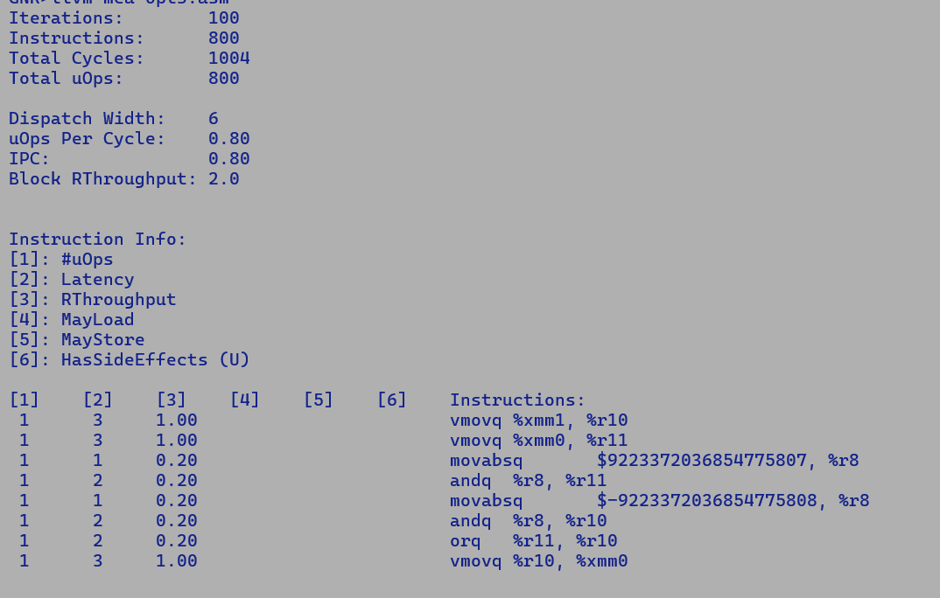



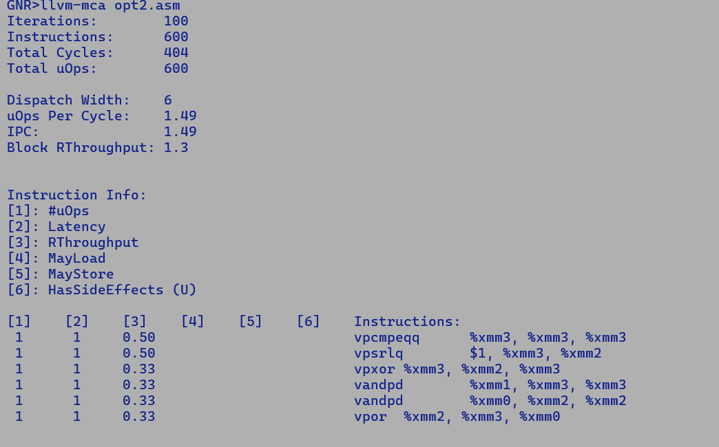



GNR



Baseline AVX512:

Benchmark Mode Cnt Score Error Units

Signum._5_copySignFloatTest thrpt 2 1296.141 ops/ns

Signum._7_copySignDoubleTest thrpt 2 838.954 ops/ns

Withopt :

Benchmark Mode Cnt Score Error Units

Signum._5_copySignFloatTest thrpt 2 940.240 ops/ns

Signum._7_copySignDoubleTest thrpt 2 967.370 ops/ns

Baseline AVX2:

Benchmark Mode Cnt Score Error Units

Signum._5_copySignFloatTest thrpt 2 63.673 ops/ns

Signum._7_copySignDoubleTest thrpt 2 26.898 ops/ns

Withopt :

Benchmark Mode Cnt Score Error Units

Signum._5_copySignFloatTest thrpt 2 785.801 ops/ns

Signum._7_copySignDoubleTest thrpt 2 558.710 ops/ns

SRF

Baseline:

Benchmark (seed) Mode Cnt Score Error Units

o.o.b.java.lang.MathBench.copySignDouble 0 thrpt 2 1194681.914 ops/ms

o.o.b.java.lang.MathBench.copySignFloat 0 thrpt 2 1195280.105 ops/ms

o.o.b.java.lang.StrictMathBench.copySignDouble N/A thrpt 2 632176.649 ops/ms

o.o.b.java.lang.StrictMathBench.copySignFloat N/A thrpt 2 631930.369 ops/ms

o.o.b.vm.compiler.Signum._5_copySignFloatTest N/A thrpt 2 40.528 ops/ns

o.o.b.vm.compiler.Signum._7_copySignDoubleTest N/A thrpt 2 25.101 ops/ns

Withopt:

Benchmark (seed) Mode Cnt Score Error Units

o.o.b.java.lang.MathBench.copySignDouble 0 thrpt 2 1195263.664 ops/ms

o.o.b.java.lang.MathBench.copySignFloat 0 thrpt 2 1176815.608 ops/ms

o.o.b.java.lang.StrictMathBench.copySignDouble N/A thrpt 2 994205.664 ops/ms

o.o.b.java.lang.StrictMathBench.copySignFloat N/A thrpt 2 994112.789 ops/ms

o.o.b.vm.compiler.Signum._5_copySignFloatTest N/A thrpt 2 676.101 ops/ns

o.o.b.vm.compiler.Signum._7_copySignDoubleTest N/A thrpt 2 605.714 ops/ns

Scalar:-

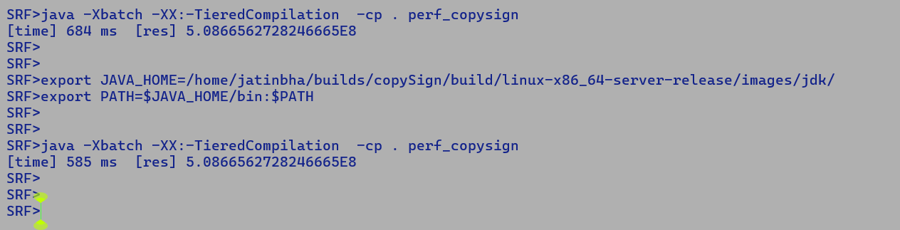

Vector

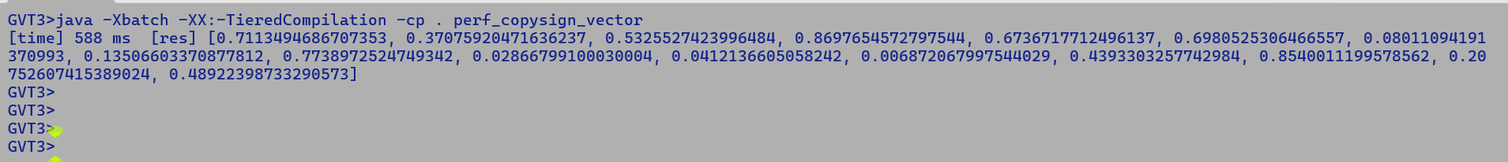

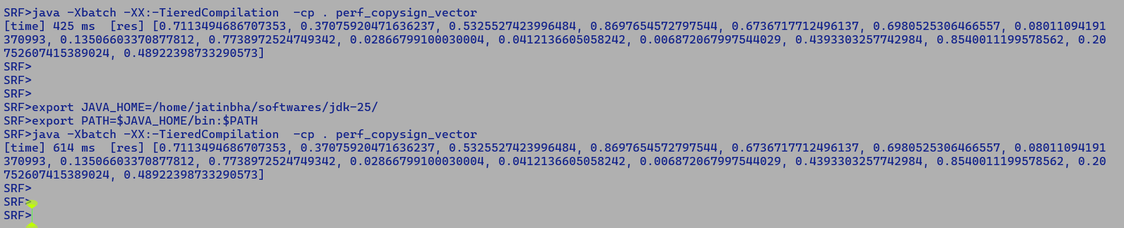

35 MoveD2L === _ 12 [[ 37 ]] !jvms: Math::copySign @ bci:1 (line 2871) perf_copysign::micro @ bci:2 (line 7)

36 ConL === 0 [[ 37 ]] #long:min

37 AndL === _ 35 36 [[ 41 ]] !jvms: Math::copySign @ bci:7 (line 2871) perf_copysign::micro @ bci:2 (line 7)

38 MoveD2L === _ 10 [[ 40 ]] !jvms: Math::copySign @ bci:9 (line 2873) perf_copysign::micro @ bci:2 (line 7)

Problem with AndL (MoveD2L Param0) ConL => AndD Param0 ConD

* ConD will be emitted in constant table dumped before native method body.
* Thus, there will be memory load penalty.

Handling scalar reinterpret nodes MoveD2L, MoveL2D, MoveF2I and ModeL2F during auto-vectorization is relatively straight forward as re-interpretations are noops.

Bottom Line:-

1. AVX512 – Scalar CopySign intrinsic + AutoVectorization.
   1. VPTERNLOG based sequence is performant.
2. AndF transformation will be costly as constant floating point values are dumped in constant table
   1. We want to absorb 3 cycle domain cross over penalty i.e. XMM to GPR move.
   2. Intrinsic looks fine for now.

Nice explanation for

**8323116: [REDO] Computational test more than 2x slower when AVX instructions are used #18503**

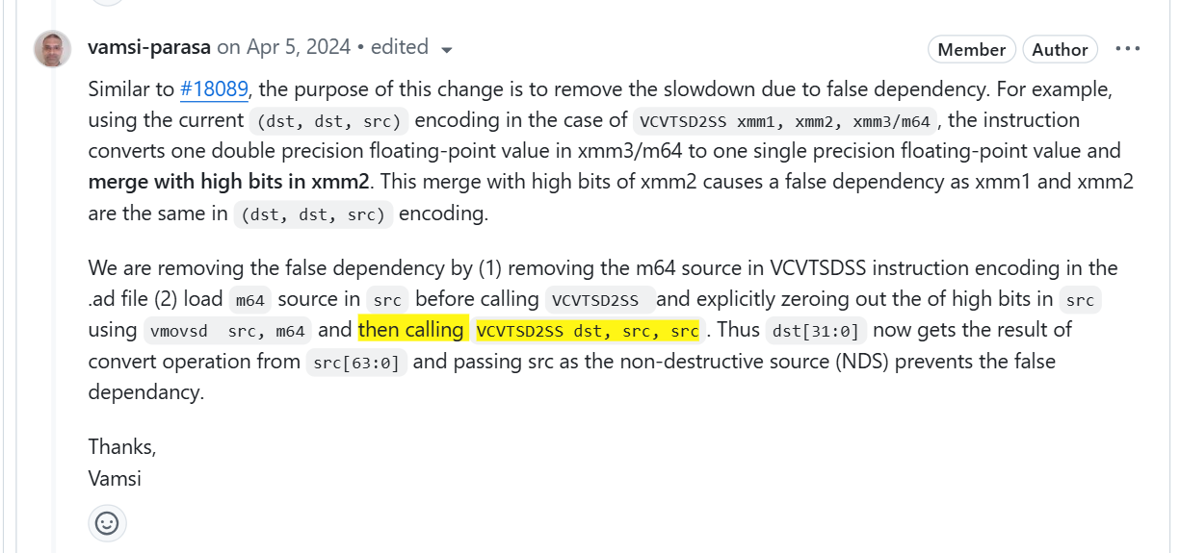

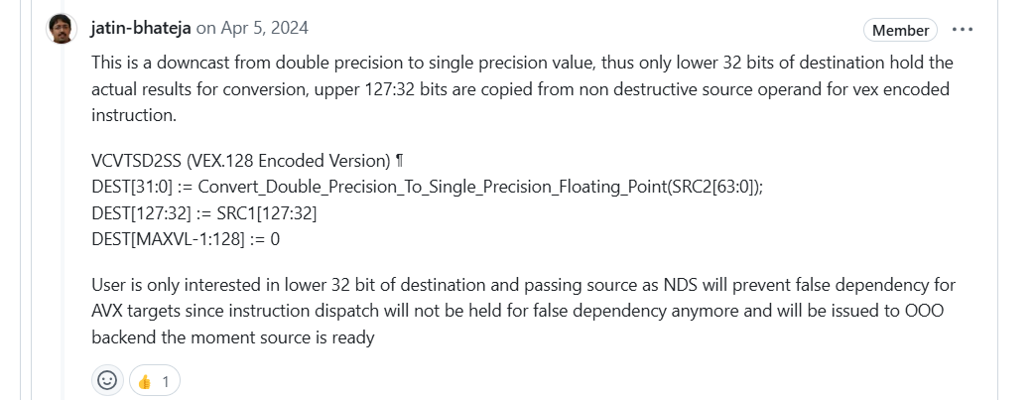

Few additions to above explanation



* False dependency constraints the retirement of VCVTSD2SS despite of REGISTER RENAMING by OOO backend since it needs to wait for retirement of previous instruction writing to DST so that we can merge the upper bits with destination.

VZEROUPPER – Use cases, injecting VZERO upper in AVX2 to SSE transition prevents merge penalties.

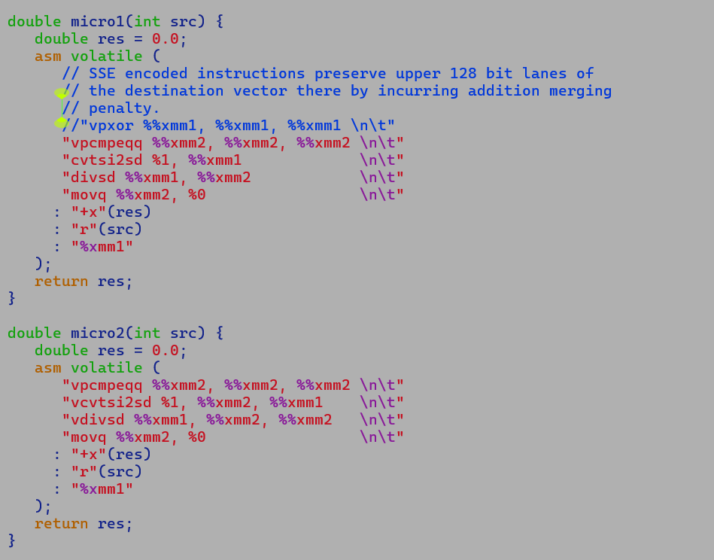

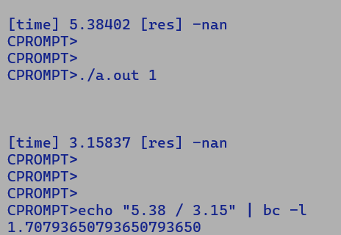

**05/02/2025 ARM Parity (SRF vs GVT3)**

**1) Bit Count**

**=============**

**GVT3**

**Quick Refresher on ARM assembly**

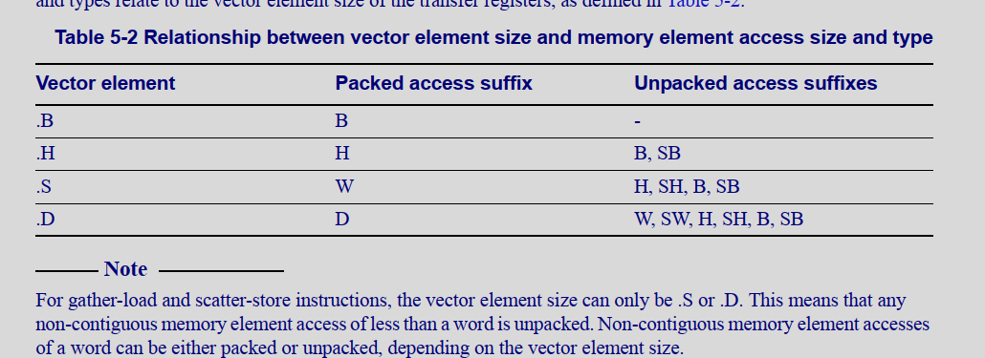

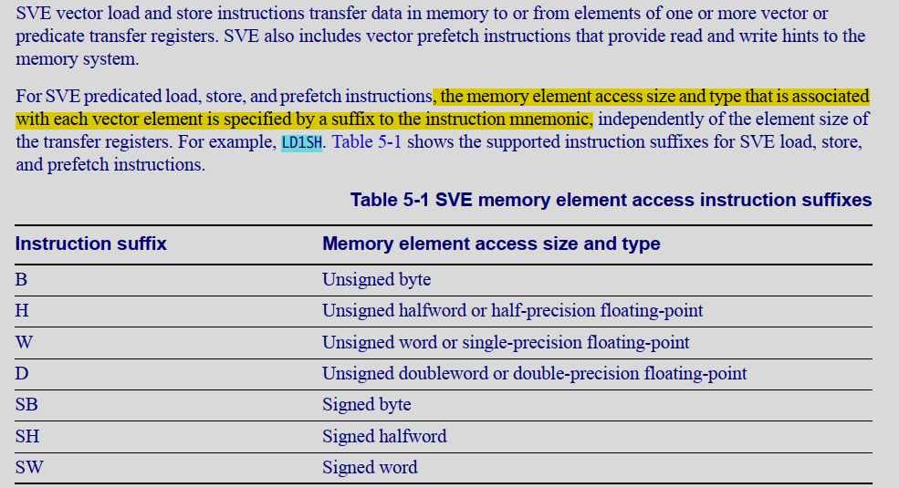

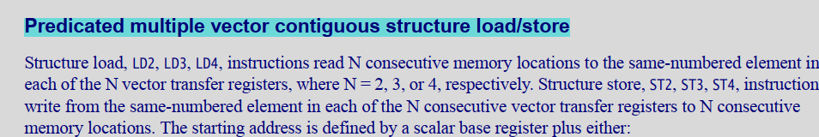

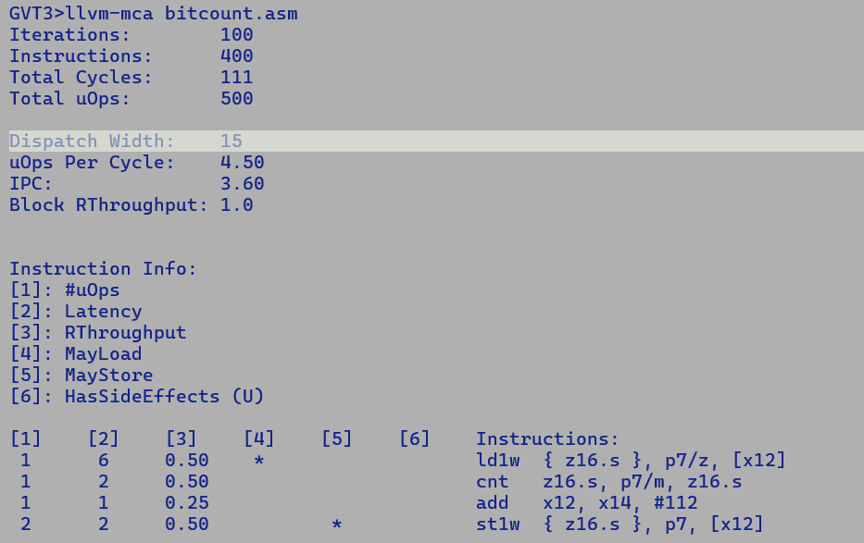

**SRF – Non AVX512 target does not support direct BITCOUNT INSTRUCTION – VPOPCOUNT**

**AVX10.2 converged ISA will extend AVX512 ISA for 256 vector width targets. We may be doing better w.r.t to GVT4 which supports only up to 128 bit vectors. GVT3 with Neoverse V1 support 256 bit vectors and has a vector size parity with Sierra Forest.**

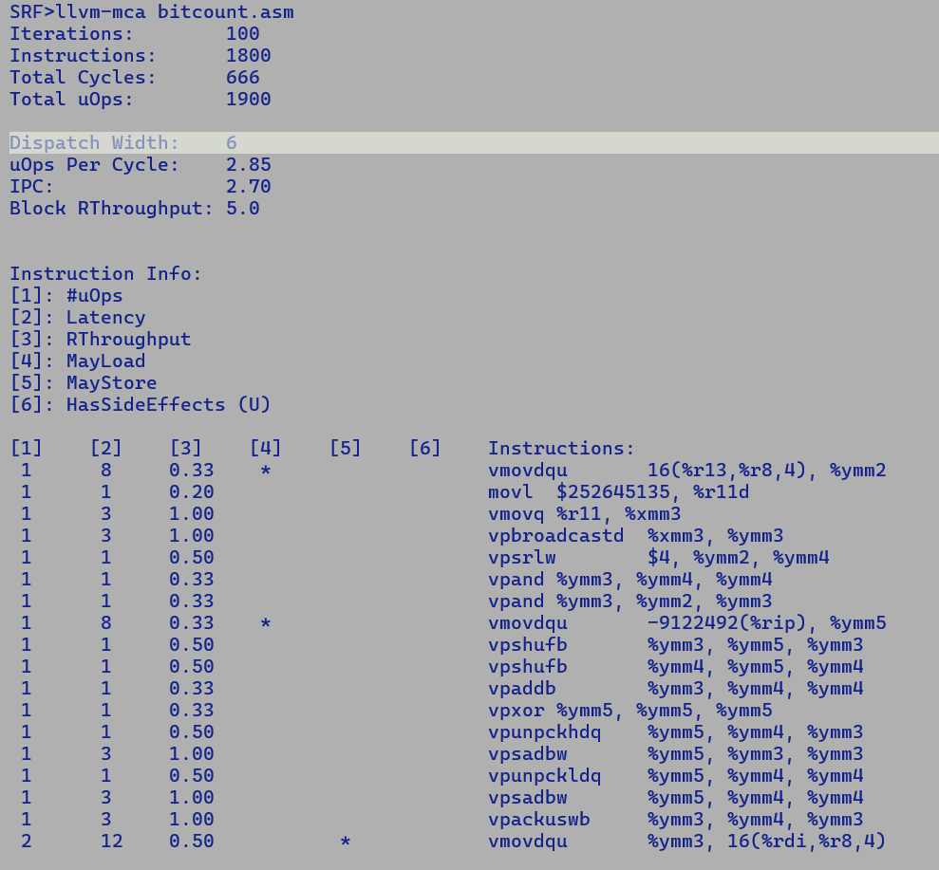

**2) FP Min/Max – Performance.**

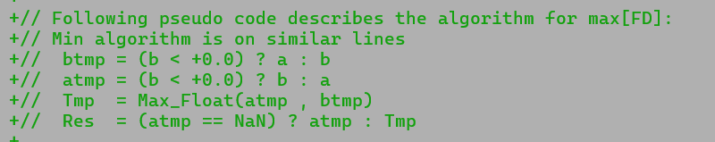

Special case handling for NaN and +/-0.0 values results into bulky instruction sequence on x86 compared to ARM SVE which has a single instruction “FMIN” adhering to Java semantics.

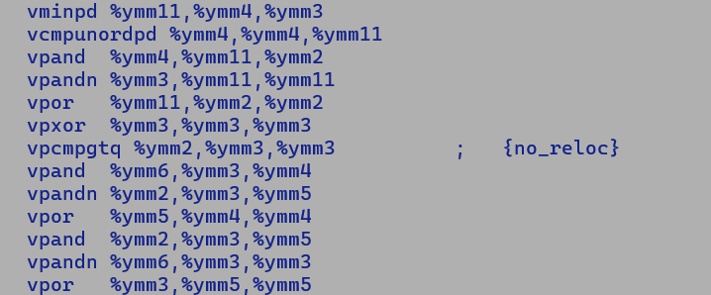

vpand + vpandn + vpor sequence emulates blend which is otherwise costly on E-cores.

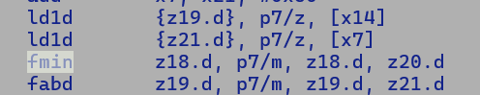

Small Fills below 64 byte are less performant vs AVX2.

GNR>for i in 1 4 8 16 32 64 96 128 256; do echo "SIZE = $i"; java -Xbatch -XX:-TieredCompilation -XX:UseAVX=2 -cp . ByteMatrix $i; java -Xbatch -XX:-TieredCompilation -XX:UseAVX=3 -cp . ByteMatrix $i; done

SIZE = 1

Run.

elapsed: 1349113781

Run.

elapsed: 6520207560

SIZE = 4

Run.

elapsed: 1772088687

Run.

elapsed: 6506770516

SIZE = 8

Run.

elapsed: 2477918993

Run.

elapsed: 6507166582

SIZE = 16

Run.

elapsed: 2753495712

Run.

elapsed: 6654518500

SIZE = 32

Run.

elapsed: 3503449592

Run.

elapsed: 7200327857

SIZE = 64

Run.

elapsed: 8699340657

Run.

elapsed: 2341319386

SIZE = 96

Run.

elapsed: 7332777796

Run.

elapsed: 7262748797

SIZE = 128

Run.

elapsed: 9837441795

Run.

elapsed: 2815066980

SIZE = 256

Run.

elapsed: 10630173370

Run.

elapsed: 7555739001

Without OptimizeFill (Stub)

GNR>for i in 1 4 8 16 32 64 96 128 256; do echo "SIZE = $i"; java -Xbatch -XX:-TieredCompilation -XX:UseAVX=2 -cp . ByteMatrix $i; java -Xbatch -XX:-TieredCompilation -XX:UseAVX=3 -XX:-OptimizeFill -cp . ByteMatrix $i; done

SIZE = 1

Run.

elapsed: 1349078338

Run.

elapsed: 1348925407

SIZE = 4

Run.

elapsed: 1768614017

Run.

elapsed: 1746244560

SIZE = 8

Run.

elapsed: 2450750783

Run.

elapsed: 2432879829

SIZE = 16

Run.

elapsed: 2754119558

Run.

elapsed: 2815326161

SIZE = 32

Run.

elapsed: 3611029103

Run.

elapsed: 3333030676

SIZE = 64

Run.

elapsed: 8700533260

Run.

elapsed: 8985031446

SIZE = 96

Run.

elapsed: 7332627568

Run.

elapsed: 6786500170

SIZE = 128

Run.

elapsed: 9866379227

Run.

elapsed: 10093268601

SIZE = 256

Run.

elapsed: 10628638554

Run.

elapsed: 10632333394

GNR>

Impact of boxing on micro-benchmark performance

Benchmark (ARRAYLEN) Mode Cnt Score Error Units

MaskedLogicOpts.bitwiseBlendOperationLong256 1024 thrpt 2 682.125 ops/s

MaskedLogicOpts.bitwiseBlendOperationLong512 1024 thrpt 2 878.772 ops/s

MaskedLogicOpts.maskedLogicOperationsLong256 1024 thrpt 2 686.235 ops/s

MaskedLogicOpts.maskedLogicOperationsLong512 1024 thrpt 2 883.113 ops/s

MaskedLogicOpts.partiallyMaskedLogicOperationsLong256 1024 thrpt 2 609.664 ops/s

MaskedLogicOpts.partiallyMaskedLogicOperationsLong512 1024 thrpt 2 881.785 ops/s

MaskedLogicOpts_new.bitwiseBlendOperationLong256 1024 thrpt 2 1319.097 ops/s

MaskedLogicOpts_new.bitwiseBlendOperationLong512 1024 thrpt 2 1532.815 ops/s

MaskedLogicOpts_new.maskedLogicOperationsLong256 1024 thrpt 2 1319.710 ops/s

MaskedLogicOpts_new.maskedLogicOperationsLong512 1024 thrpt 2 1505.196 ops/s

MaskedLogicOpts_new.partiallyMaskedLogicOperationsLong256 1024 thrpt 2 1307.883 ops/s

MaskedLogicOpts_new.partiallyMaskedLogicOperationsLong512 1024 thrpt 2 1361.759 ops/s

**Reduction Kernel Performance**

Worklet combinations:-

// Addition

// Int, Long, Float, Double

// Multiplication

// Int, Long, Float, Double

// Min/Max

// Int, Long, Float, Double

// Fma

// Xor/Or/And

// Int Long

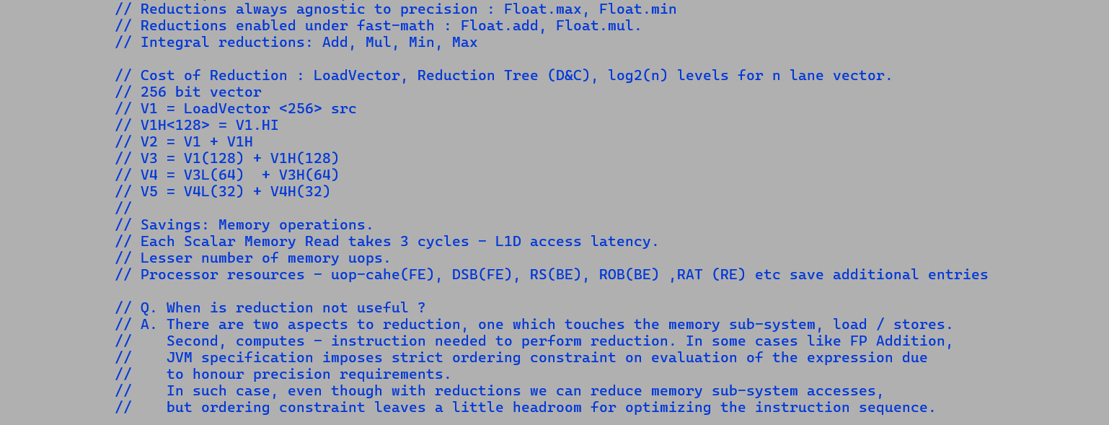

**AARCH64 GRAVITON3**

GVT3>for i in 0 1 2 3 4 5 6 7 8 9 10 11 12 13 14 15 16; do java -Xbatch -XX:-TieredCompilation -XX:-UseSuperWord -cp . test_reduction_perf ${i}; java -Xbatch -XX:-TieredCompilation -XX:+UseSuperWord -cp . test_reduction_perf ${i}; done

[time add int ] 848 ms [res] -735838208

[time add int ] 199 ms [res] -735838208

[time add float] 1572 ms [res] 4.095969E9

[time add float] 1973 ms [res] 4.095969E9

[time add double] 1572 ms [res] 0.0

[time add double] 1577 ms [res] 0.0

[time add long] 836 ms [res] 0.0

[time add long] 396 ms [res] 0.0

[time mul int] 6 ms [res] 0.0

[time mul int] 6 ms [res] 0.0

[time mul float] 2354 ms [res] 0.0

[time mul float] 2369 ms [res] 0.0

[time mul double] 2354 ms [res] 0.0

[time mul double] 2360 ms [res] 0.0

[time mul long] 6 ms [res] 0

[time mul long] 6 ms [res] 0

[time min/max int] 1349 ms [res] 0.0

[time min/max int] 200 ms [res] 0.0

[time min/max float] 1572 ms [res] 2000003.1

[time min/max float] 203 ms [res] 2000003.1

[time min/max double] 1571 ms [res] 0.0

[time min/max double] 397 ms [res] 0.0

[time min/max long] 906 ms [res] 0

[time min/max long] 905 ms [res] 0

[time fma float] 1574 ms [res] 2.717836E9

[time fma float] 1574 ms [res] 2.717836E9

[time fma double] 1573 ms [res] 0.0

[time fma double] 1573 ms [res] 0.0

[time int or] 848 ms [res] -4000000

[time int or] 200 ms [res] -4000000

[time long or] 836 ms [res] 0

[time long or] 397 ms [res] 0

**AARCH64 GRAVITON4**

GVT4>for i in 0 1 2 3 4 5 6 7 8 9 10 11 12 13 14 15 16; do java -Xbatch -XX:-TieredCompilation -XX:-UseSuperWord -cp . test_reduction_perf ${i}; java -Xbatch -XX:-TieredCompilation -XX:+UseSuperWord -cp . test_reduction_perf ${i}; done

[time add int ] 782 ms [res] -735838208

[time add int ] 355 ms [res] -735838208

[time add float] 1454 ms [res] 4.095969E9

[time add float] 2199 ms [res] 4.095969E9

[time add double] 1454 ms [res] 0.0

[time add double] 1456 ms [res] 0.0

[time add long] 780 ms [res] 0.0

[time add long] 781 ms [res] 0.0

[time mul int] 5 ms [res] 0.0

[time mul int] 5 ms [res] 0.0

[time mul float] 2179 ms [res] 0.0

[time mul float] 2199 ms [res] 0.0

[time mul double] 2179 ms [res] 0.0

[time mul double] 2191 ms [res] 0.0

[time mul long] 5 ms [res] 0

[time mul long] 4 ms [res] 0

[time min/max int] 1253 ms [res] 0.0

[time min/max int] 356 ms [res] 0.0

[time min/max float] 1454 ms [res] 2000003.1

[time min/max float] 359 ms [res] 2000003.1

[time min/max double] 1455 ms [res] 0.0

[time min/max double] 726 ms [res] 0.0

[time min/max long] 851 ms [res] 0

[time min/max long] 846 ms [res] 0

[time fma float] 1456 ms [res] 2.717836E9

[time fma float] 1456 ms [res] 2.717836E9

[time fma double] 1455 ms [res] 0.0

[time fma double] 1463 ms [res] 0.0

[time int or] 782 ms [res] -4000000

[time int or] 357 ms [res] -4000000

[time long or] 780 ms [res] 0

[time long or] 780 ms [res] 0

**SIERRA FOREST**

SRF>for i in 0 1 2 3 4 5 6 7 8 9 10 11 12 13 14 15 16; do java -Xbatch -XX:-TieredCompilation -XX:-UseSuperWord -cp . test_reduction_perf ${i}; java -Xbatch -XX:-TieredCompilation -XX:+UseSuperWord -cp . test_reduction_perf ${i}; done

[time add int ] 863 ms [res] -735838208

[time add int ] 234 ms [res] -735838208

[time add float] 2458 ms [res] 4.095969E9

[time add float] 2475 ms [res] 4.095969E9

[time add double] 2458 ms [res] 0.0

[time add double] 2458 ms [res] 0.0

[time add long] 880 ms [res] 0.0

[time add long] 467 ms [res] 0.0

[time mul int] 9 ms [res] 0.0

[time mul int] 9 ms [res] 0.0

[time mul float] 3269 ms [res] 0.0

[time mul float] 3294 ms [res] 0.0

[time mul double] 3269 ms [res] 0.0

[time mul double] 3275 ms [res] 0.0

[time mul long] 9 ms [res] 0

[time mul long] 10 ms [res] 0

[time min/max int] 2583 ms [res] 0.0

[time min/max int] 233 ms [res] 0.0

[time min/max float] 2272 ms [res] 2000003.1

[time min/max float] 2814 ms [res] 2000003.1

[time min/max double] 2389 ms [res] 0.0

[time min/max double] 6099 ms [res] 0.0

[time min/max long] 969 ms [res] 0

[time min/max long] 969 ms [res] 0

[time fma float] 4898 ms [res] 2.717836E9

[time fma float] 4900 ms [res] 2.717836E9

[time fma double] 4898 ms [res] 0.0

[time fma double] 4898 ms [res] 0.0

[time int or] 864 ms [res] -4000000

[time int or] 231 ms [res] -4000000

[time long or] 860 ms [res] 0

[time long or] 465 ms [res] 0

**GRANITE RAPIDS**

GNR>for i in 0 1 2 3 4 5 6 7 8 9 10 11 12 13 14 15 16; do java -Xbatch -XX:-TieredCompilation -XX:-UseSuperWord -cp . test_reduction_perf ${i}; java -Xbatch -XX:-TieredCompilation -XX:+UseSuperWord -cp . test_reduction_perf ${i}; done

[time add int ] 835 ms [res] -735838208

[time add int ] 84 ms [res] -735838208

[time add float] 1629 ms [res] 4.095969E9

[time add float] 2795 ms [res] 4.095969E9

[time add double] 1628 ms [res] 0.0

[time add double] 2709 ms [res] 0.0

[time add long] 835 ms [res] 0.0

[time add long] 146 ms [res] 0.0

[time mul int] 8 ms [res] 0.0

[time mul int] 8 ms [res] 0.0

[time mul float] 2424 ms [res] 0.0

[time mul float] 5295 ms [res] 0.0

[time mul double] 2423 ms [res] 0.0

[time mul double] 2951 ms [res] 0.0

[time mul long] 7 ms [res] 0

[time mul long] 8 ms [res] 0

[time min/max int] 1648 ms [res] 0.0

[time min/max int] 121 ms [res] 0.0

[time min/max float] 2746 ms [res] 2000003.1

[time min/max float] 713 ms [res] 2000003.1

[time min/max double] 2692 ms [res] 0.0

[time min/max double] 1287 ms [res] 0.0

[time min/max long] 950 ms [res] 0

[time min/max long] 951 ms [res] 0

[time fma float] 3223 ms [res] 2.717836E9

[time fma float] 3224 ms [res] 2.717836E9

[time fma double] 3223 ms [res] 0.0

[time fma double] 3224 ms [res] 0.0

[time int or] 836 ms [res] -4000000

[time int or] 60 ms [res] -4000000

[time long or] 832 ms [res] 0

[time long or] 98 ms [res] 0

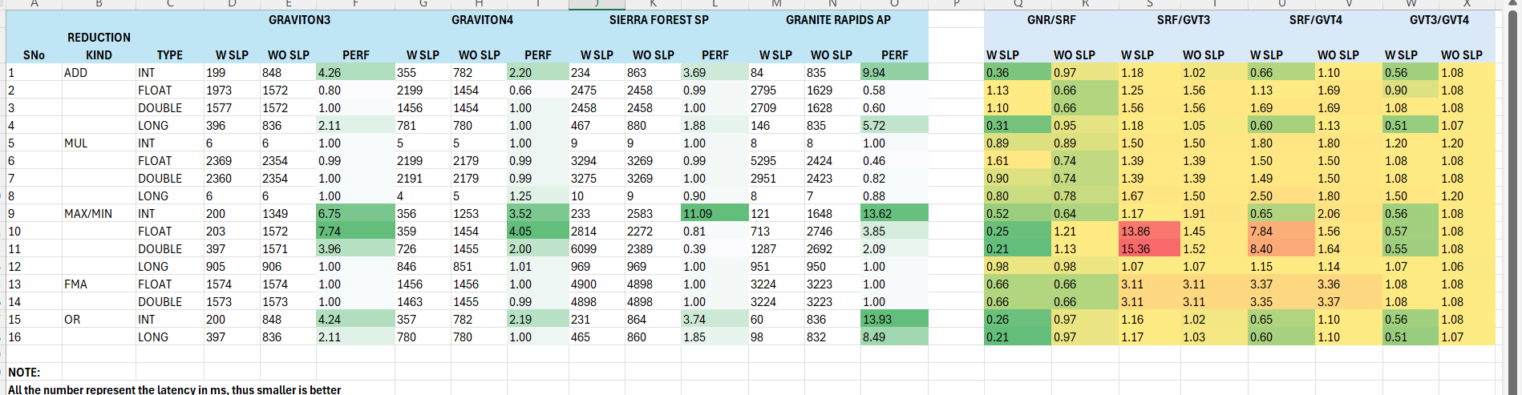

**Optimization of ML-DSA**

**GNR**

**Baseline:**

**Benchmark (algorithm) Mode Cnt Score Error Units**

**MLDSA.keygen ML-DSA-44 avgt 5 1137.559 ± 19.671 us/op**

**MLDSA.keygen ML-DSA-65 avgt 5 2107.100 ± 39.698 us/op**

**MLDSA.keygen ML-DSA-87 avgt 5 3052.448 ± 39.793 us/op**

**MLDSA.siggen ML-DSA-44 avgt 5 5258.574 ± 76.691 us/op**

**MLDSA.siggen ML-DSA-65 avgt 5 8300.726 ± 100.193 us/op**

**MLDSA.siggen ML-DSA-87 avgt 5 13513.774 ± 185.058 us/op**

**MLDSA.sigver ML-DSA-44 avgt 5 1386.668 ± 21.872 us/op**

**MLDSA.sigver ML-DSA-65 avgt 5 2135.918 ± 40.079 us/op**

**MLDSA.sigver ML-DSA-87 avgt 5 3413.049 ± 58.952 us/op**

**WithOpt:**

**Benchmark (algorithm) Mode Cnt Score Error Units**

**MLDSA.keygen ML-DSA-44 avgt 5 741.904 ± 9.134 us/op**

**MLDSA.keygen ML-DSA-65 avgt 5 1508.865 ± 23.729 us/op**

**MLDSA.keygen ML-DSA-87 avgt 5 2115.397 ± 26.050 us/op**

**MLDSA.siggen ML-DSA-44 avgt 5 2110.271 ± 34.070 us/op**

**MLDSA.siggen ML-DSA-65 avgt 5 3241.717 ± 65.371 us/op**

**MLDSA.siggen ML-DSA-87 avgt 5 5244.890 ± 65.938 us/op**

**MLDSA.sigver ML-DSA-44 avgt 5 874.569 ± 10.475 us/op**

**MLDSA.sigver ML-DSA-65 avgt 5 1380.005 ± 21.314 us/op**

**MLDSA.sigver ML-DSA-87 avgt 5 2277.405 ± 39.101 us/op**

Notes: -

Q. What is Module lattice-based cryptography?

A. Lattice-based cryptography represents the public/private keys (points) through an n-dimensional vector.

This differs from ECC cryptography, where point representation is over a curve. Discrete logarithmic problem makes it hard to determine the private key with a known public key, generator, and base points.

RLWE is an extension to vanilla lattice-based cryptography where, instead of representing the points through n-dimensional vectors, we map it over an n-degree polynomial whose coefficients are modulo Z, where Z is a finite field.

Module lattice-based cryptography is generalization of RLWE where points are represented using a vector of points over a polynomial ring, this makes it computationally hard to determine the private key even with quantum computing.

Unlike ECC, where Public (Q) and private [x] is determined using modulo multiplication [1] b/w generator starting from a known initialization point (basis point), for Module lattice, multiplication is performed b/w matrix [2] and vector, since each point is represented as a vector of n-degree polynomial over modulo ring, hence it is represented using a matrix.

[1] Q = [x] G

[2] A. s + e = k

Q. What is ML-DSA?

A. It’s a digital signature-based authentication in modulo lattice space. We first compute the hash value of a plain text using existing digest computations; in this case, it's the SHAKE3 algorithm, which is then encrypted using a private key to generate a signature. This step is called signing the message.

Signing = signature = function (message, private key, Hash_Alog)

The reverse process is performed at the receiver side, who in order to authenticate the sender, uses a verify algorithm.

Verify = function (message, public key, signature, Hash Alog)

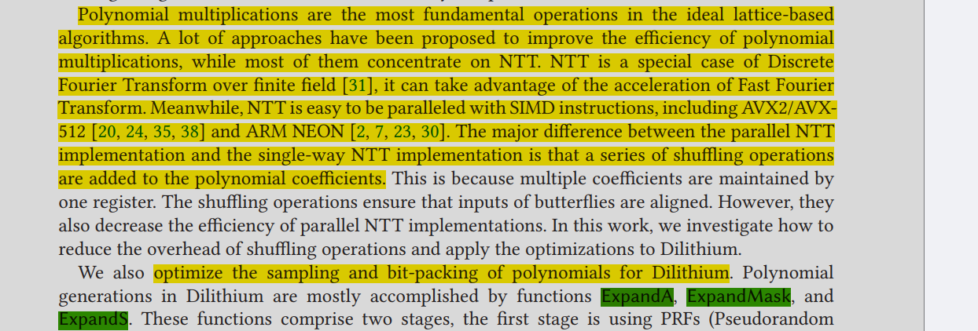

Benchmark performance of algorithm="ML-DSA-87" is dominated by hash computation using SHAKE2.

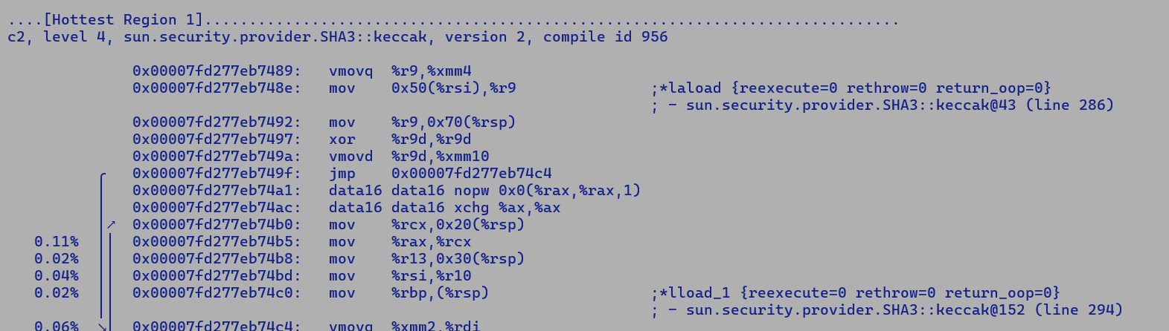

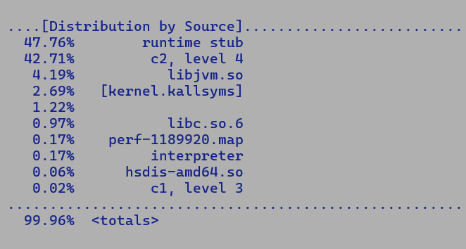

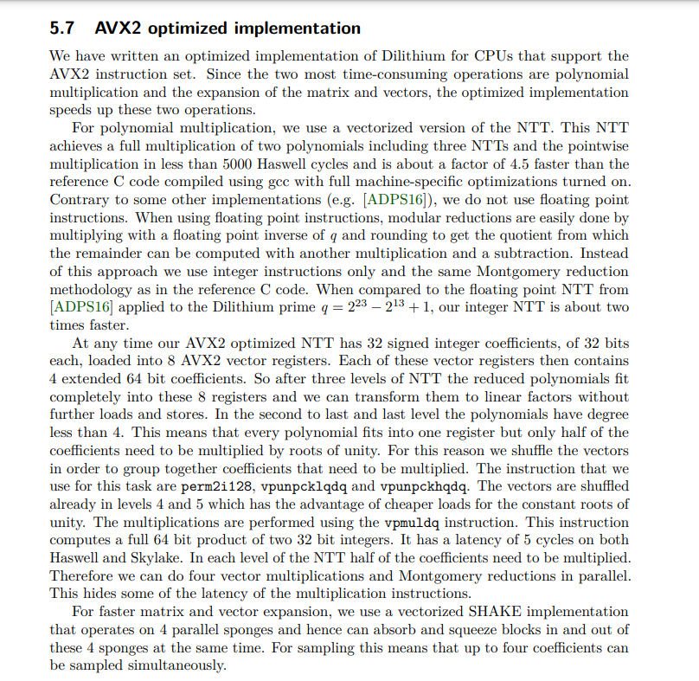



NVL - PNC + ARW

CCF provides a cache coherent fabric to connect multiple cores and provides a Last Level Cache (LLC) for performance. The LLC is sized to 3MB/core and is non-inclusive (there is a feature currently to have dynamic inclusivity still open) of MLC. Only cores on the CPU die allocate into the LLC while other compute engines (e.g. Iceland cores, graphics) do not directly allocate into the LLC.

With HGS (hardware guided scheduling), the operating system enables the shutting down of the C-die completely in many scenarios and the threads execute on the Atom module (Iceland). If the performance requirement of the executing threads go higher, the C-die is powered on and the CCF complex is activated for execution.

Source : <https://docs.intel.com/documents/ClientSilicon/NVL/Overview/NVL_Compute.html>

Panther Lake

* Cougar cove (P-core) , performance cluster – Compute die
* Darkmont (E-core) , performance cluster, QCM (quad core in module),
* Darkmont (E-core), efficiency cluster, on SoC Die.

HSG/HSG+ assist OS to schedule workloads on compute / efficiency cluster based on compute needs.

Like Novalake , cores in compute die falls under the CCF domain, i.e. coherent compute fabric and can access LLC slices.

But E-cores on SoC die may not access LLC

Q. While micro benchmarking for Ecore vs Pcore, how can be select an e-core on SoC vs compute Die?

A) While most of out bencmarking efforts are for cloud instances i.e. P and E core based xeons so we are not concerned about e-cores on low power domains like SoC die or LPE Island on PTL…

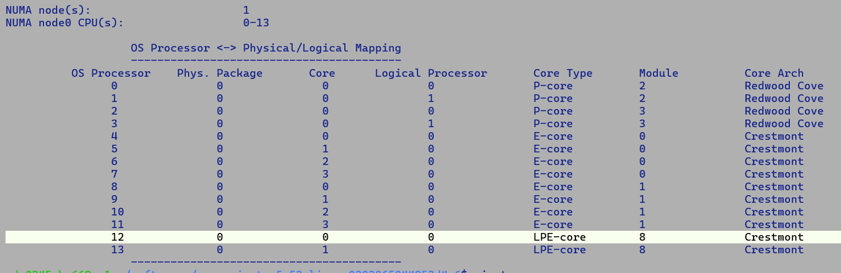

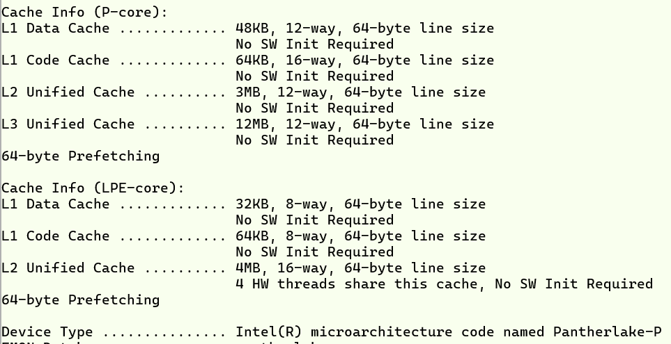

jshell> import java.security.*

jshell> import java.security.spec.*

jshell> var kg = KeyPairGenerator.getInstance("ML-DSA")

kg ==> java.security.KeyPairGenerator$Delegate@68ceda24

jshell> kg.initialize(NamedParameterSpec.ML_DSA_44, new java.security.SecureRandom("KG-SEED".getBytes()))

jshell> var kp = kg.genKeyPair()

kp ==> java.security.KeyPair@35a50a4c

jshell> var sign = Signature.getInstance("ML-DSA")

sign ==> Signature object: ML-DSA<not initialized>

jshell> sign.initSign(kp.getPrivate(), new java.security.SecureRandom("SEED1".getBytes()))

jshell> sign.update("MY-MESSAGE".getBytes())

jshell> var signature = sign.sign()

signature ==> byte[2420] { 72, -124, 112, -119, -127, 21, 5, -5 ... 0, 0, 0, 14, 35, 49, 64 }

jshell> sign.initVerify(kp.getPublic())

jshell> sign.update("MY-MESSAGE".getBytes())

jshell> sign.verify(signature)

$24 ==> true

**FP-class (FPC) operations performance: -**

|  |  |  |  |  |
| --- | --- | --- | --- | --- |
| API  (Float) | Scalar Intrinsic | Auto-Vectorization | CMove Inferencing Pattern 1  dst = FPC? src1: src2 | CMove Inferencing Pattern 2  if (FPC)  dst = SRC1  else  dst = SRC2 |
| isFinite | NO | YES | YES | NO |
| isInfinite | YES | NO | YES | NO |
| isNaN | NO | YES | YES | NO |

|  |  |  |  |  |
| --- | --- | --- | --- | --- |
| API  (Double) | Scalar Intrinsic | Auto-Vectorization | CMove Inferencing Pattern 1  dst = FPC? src1: src2 | CMove Inferencing Pattern 2  if (FPC)  dst = SRC1  else  dst = SRC2 |
| isFinite | NO | YES | YES | NO |
| isInfinite | YES | NO | YES | NO |
| isNaN | NO | YES | YES | NO |

GNR>java -ea -Xbatch -XX:-Tiered pilation -XX:CompileThresholdScaling=0.3 -XX:+TraceNewVectors -XX:+UseVectorCmov -XX:+UseCMoveUnconditionally -cp . is_finite 0 3 | grep time

[time] 67 ms [res isInfinite ternary cond] [64.08636, Infinity, 185.43929, Infinity, 189.26021, Infinity, 196.4586, Infinity, 57.49074, Infinity, 162.36893, Infinity, 54.469826, Infinity, 189.13649, Infinity]

GNR>java -ea -Xbatch -XX:-TieredCompilation -XX:CompileThresholdScaling=0.3 -XX:+TraceNewVectors -XX:+UseVectorCmov -XX:+UseCMoveUnconditionally -cp . is_finite 1 4 | grep time

[time] 30 ms [res isNaN ternary cond] [64.08636, NaN, 185.43929, NaN, 189.26021, NaN, 196.4586, NaN, 57.49074, NaN, 162.36893, NaN, 54.469826, NaN, 189.13649, NaN]

Scalar Performance with intrinsic is almost comparable to the one without intrinsic.

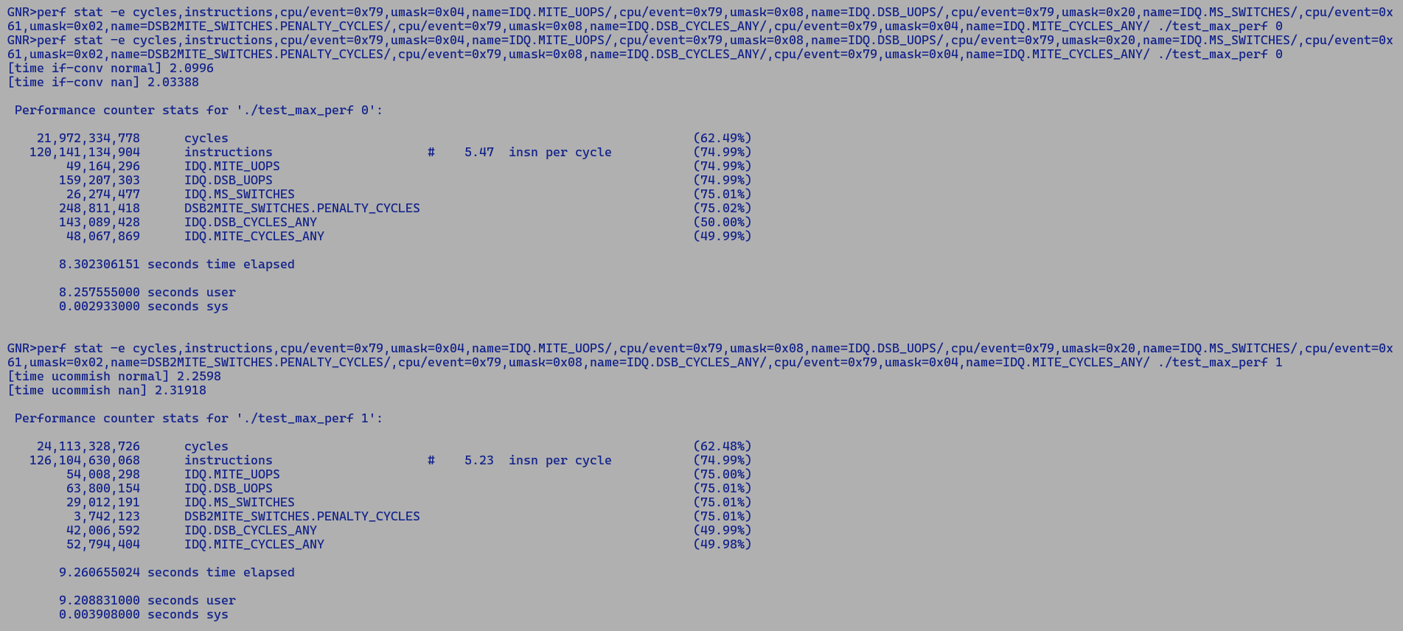

678 1047 1062 680 682 1059 1053 777 778 1059 1048 780 781 1053 1051 783 784 1062 1047 786 788 1055 1052 915 916 917 917 918 919 920 920 921 922 923 923 924 925 926 926 927 928 929 929 930 931 932 932 933 934 935 935 936 938 939 939 ]] #int[int:>=0] (java/lang/Cloneable,java/io/Serializable):NotNull:exact * !jvms: VectorLoadToStoreForwarding::benchmark_20 @ bci:24 (line 199)

invar: none

**ZGC Deep Dive:-**

Theory:-

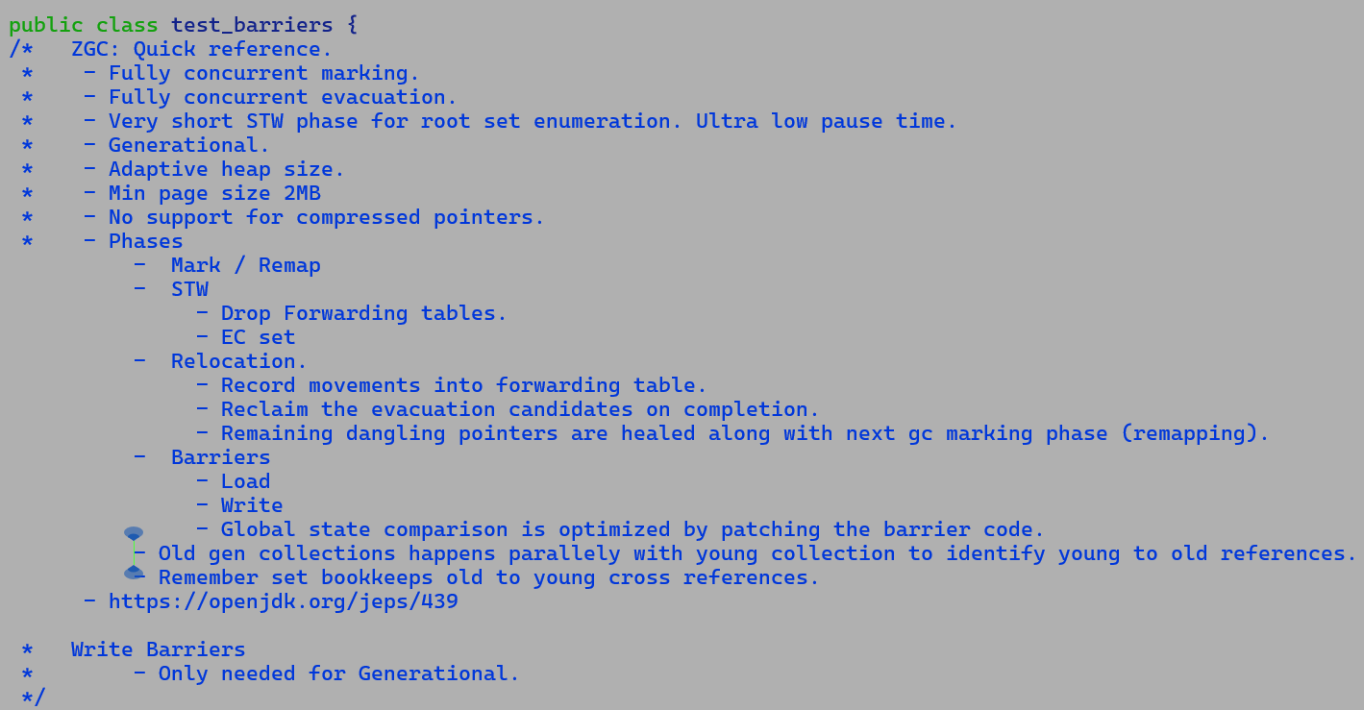

Generational: -

<https://openjdk.org/jeps/439>

Non-Generational: -

"C:\Users\jatinbha\OneDrive - Intel Corporation\My Folder\Books\Java\ZGC-ACM.pdf"

**Vector API – gather performance analysis**

import jdk.incubator.vector.*;

import java.util.stream.IntStream;

import java.util.Arrays;

public class gather_perf {

public static final VectorSpecies<Integer> ISP = IntVector.SPECIES_PREFERRED;

static int [] scratch = new int[ISP.length()];

public static int micro1(int [] src, int idx, int src_idx) {

IntVector.broadcast(ISP, idx).intoArray(scratch, 0);

// Scratch is an escaping memory, hence a costly store

// will be emitted prior to gather, value forwarding may

// still be effective.

return IntVector.fromArray(ISP, src, src_idx, scratch, 0).lane(idx);

}

public static int micro2(int [] src, int idx, int src_idx) {

int [] scratch = new int[ISP.length()]; // Non-escaping memeory

IntVector.broadcast(ISP, idx).intoArray(scratch, 0);

// Index LoadVector should benefit from StoreVector value forwarding - Verified

// Eventually scratch allocation will be eliminated and so does any store to that memory. - not getting eliminated and marked as global escape.

/*

0x00007f9b48e841e2: prefetchw 0x100(%rsi)

0x00007f9b48e841e9: movl $0x1ab980,0x8(%rax) ; {metadata({type array int})}

0x00007f9b48e841f0: prefetchw 0x140(%rsi)

0x00007f9b48e841f7: movl $0x10,0xc(%rax)

0x00007f9b48e841fe: prefetchw 0x180(%rsi)

0x00007f9b48e84205: mov %rax,%rsi

0x00007f9b48e84208: add $0x10,%rsi

0x00007f9b48e8420c: vpxor %ymm0,%ymm0,%ymm0

0x00007f9b48e84210: vmovdqu %ymm0,(%rsi)

0x00007f9b48e84214: vmovdqu %ymm0,0x20(%rsi) ;*newarray {reexecute=0 rethrow=0 return_oop=0}

;; B3: # out( B28 B4 ) <- in( B8 B2 ) Freq: 1

0x00007f9b48e84219: vpbroadcastd (%rsp),%zmm0 ;*invokestatic fromBitsCoerced {reexecute=0 rethrow=0 return_oop=0}

0x00007f9b48e84220: vmovdqu32 %zmm0,0x10(%rax) ;*invokestatic store {reexecute=0 rethrow=0 return_oop=0} // ZMM0 storeVector to scratch array

0x00007f9b48e8422a: mov %rbp,%rdx

0x00007f9b48e8422d: mov 0xc(%rdx),%r8d ; implicit exception: dispatches to 0x00007f9b48e8444b

;; B4: # out( B10 B5 ) <- in( B3 ) Freq: 1

0x00007f9b48e84231: vpbroadcastd %r8d,%zmm1

0x00007f9b48e84237: vpbroadcastd 0x10(%rsp),%zmm2 ;*invokestatic extract {reexecute=0 rethrow=0 return_oop=0}

0x00007f9b48e8423f: vpaddd %zmm2,%zmm0,%zmm2 ;*invokestatic binaryOp {reexecute=0 rethrow=0 return_oop=0} // ZMM0 is value forwarded.

*/

/* Arrays is marked as non-escaping but not scalar replacible.

JavaObject(5) NoEscape(NoEscape) NSR [ 75F [ 110 95 ]] 36 AllocateArray === 63 64 37 10 1 (65 66 67 68 69 70 71 72 1 ) [[ 92 58 14 122 8 110 ]] rawptr:NotNull ( int:>=0, java/lang/Object:NotNull *, bool, int, bool ) allocationKlass:[I gather_perf::micro2 @ bci:8 (line 20) !jvms: gather_perf::micro2 @ bci:8 (line 20)

*/

return IntVector.fromArray(ISP, src, src_idx, scratch, 0).lane(idx);

}

public static int micro3(int [] src, int idx, int src_idx) {

int [] scratch = new int[ISP.length()]; // Non-escaping memeory

Arrays.fill(scratch, idx);

// Arrays.fill performs elementwise store, thus even though alias type of

// scalar store i.e int [] does match with load vector's alias type int []

// but the offsets of store and load address don't match, this prevents

// any value forwarding, which is why we emit a vpaddd with a memory operand

// which reads from scratch array - No value forwarding here.

// - No elimination of array allocation,

/*

0x00007fad64510588: mov %ecx,0x10(%rax)

0x00007fad6451058b: mov %ecx,0x14(%rax)

0x00007fad6451058e: mov %ecx,0x18(%rax)

0x00007fad64510591: mov %ecx,0x1c(%rax)

0x00007fad64510594: mov %ecx,0x20(%rax)

0x00007fad64510597: mov %ecx,0x24(%rax)

0x00007fad6451059a: mov %ecx,0x28(%rax)

0x00007fad6451059d: mov %ecx,0x2c(%rax)

0x00007fad645105a0: mov %ecx,0x30(%rax)

0x00007fad645105a3: mov %ecx,0x34(%rax)

0x00007fad645105a6: mov %ecx,0x38(%rax)

0x00007fad645105a9: mov %ecx,0x3c(%rax)

0x00007fad645105ac: mov %ecx,0x40(%rax)

0x00007fad645105af: mov %ecx,0x44(%rax)

0x00007fad645105b2: mov %ecx,0x48(%rax)

0x00007fad645105b5: mov %ecx,0x4c(%rax) ;*newarray {reexecute=0 rethrow=0 return_oop=0}

0x00007fad645105b8: mov %rbp,%rdx ;*invokestatic extract {reexecute=0 rethrow=0 return_oop=0}

0x00007fad645105bb: mov 0xc(%rdx),%r8d ; implicit exception: dispatches to 0x00007fad645107d3

;; B4: # out( B10 B5 ) <- in( B3 ) Freq: 1

0x00007fad645105bf: vpbroadcastd 0x10(%rsp),%zmm0 ;*invokestatic extract {reexecute=0 rethrow=0 return_oop=0}

0x00007fad645105c7: vpaddd 0x10(%rax),%zmm0,%zmm2 ;*invokestatic binaryOp {reexecute=0 rethrow=0 return_oop=0}

*/

/* Arrays is marked as non-escaping but not scalar replacible.

JavaObject(5) NoEscape(NoEscape) NSR [ 75F [ 110 95 ]] 36 AllocateArray === 63 64 37 10 1 (65 66 67 68 69 70 71 72 1 ) [[ 92 58 14 122 8 110 ]] rawptr:NotNull ( int:>=0, java/lang/Object:NotNull *, bool, int, bool ) allocationKlass:[I gather_perf::micro2 @ bci:8 (line 20) !jvms: gather_perf::micro2 @ bci:8 (line 20)

*/

return IntVector.fromArray(ISP, src, src_idx, scratch, 0).lane(idx);

}

public static void main(String [] args) {

int res = 0;

int algo = Integer.parseInt(args[0]);

int [] src = IntStream.range(0, 4096).toArray();

if (algo == 0 || algo == -1) {

for (int i = 0, j = 0; i < 1000000; i++, j += ISP.length()) {

res += micro1(src, i & (ISP.length() -1), j & 4095);

}

long t1 = System.currentTimeMillis();

for (int i = 0, j = 0; i < 5000000; i++, j += ISP.length()) {

res += micro1(src, i & (ISP.length() -1), j & 4095);

}

long t2 = System.currentTimeMillis();

System.out.println("[time micro1] " + (t2 - t1) + " ms [res] " + res);

}

if (algo == 1 || algo == -1) {

for (int i = 0, j = 0; i < 1000000; i++, j += ISP.length()) {

res += micro2(src, i & (ISP.length() -1), j & 4095);

}

long t1 = System.currentTimeMillis();

for (int i = 0, j = 0; i < 5000000; i++, j += ISP.length()) {

res += micro2(src, i & (ISP.length() -1), j & 4095);

}

long t2 = System.currentTimeMillis();

System.out.println("[time micro2] " + (t2 - t1) + " ms [res] " + res);

}

if (algo == 2 || algo == -1) {

for (int i = 0, j = 0; i < 1000000; i++, j += ISP.length()) {

res += micro3(src, i & (ISP.length() -1), j & 4095);

}

long t1 = System.currentTimeMillis();

for (int i = 0, j = 0; i < 5000000; i++, j += ISP.length()) {

res += micro3(src, i & (ISP.length() -1), j & 4095);

}

long t2 = System.currentTimeMillis();

System.out.println("[time micro2] " + (t2 - t1) + " ms [res] " + res);

}

}

}

**Action Item:**

* Write-only non-escaping memory should be eliminatable; the existing EA must be extended to cover this case.

**Micro Path:**

* 10.223.246.96: /home/jatinbha/code/java/vector-api/JVector

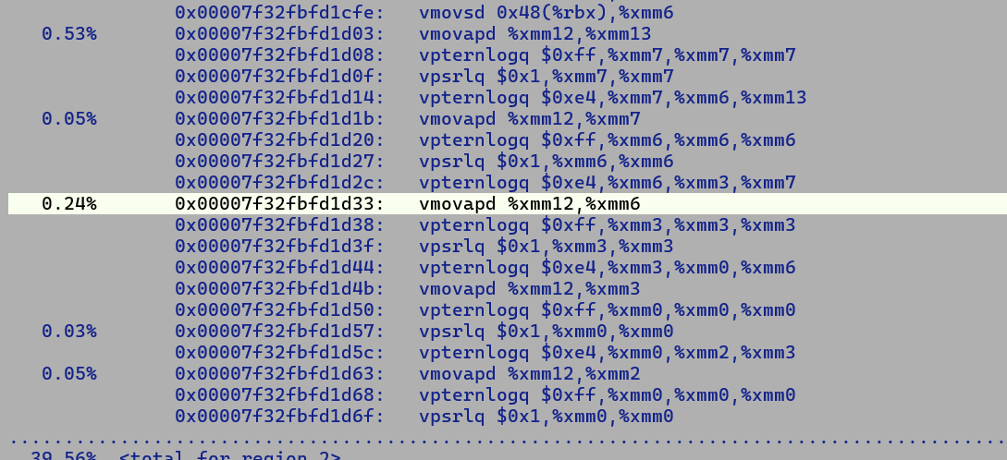

**Reperted all one sequence in the loop, this is right candidate of phase lowering so that any common sequenst is factored out out of loop.**

* **Constant folding missing**